MAKUDAM TURMERIC FED FARMER PRODUCER COMPANY LIMITED
Makudam Turmeric Fed Farmer Producer Company Limited Promoted by Erode Precision Farm Producer Company Limited and NAFED is working with the main Objective to provide farmers with better market linkage.The FPO is situtated in kalingarayan belt its also Known as Manjal Nagaram.
Year of Registration | 20.07.2021
State | TamilNadu
District | Erode
Block | Kodumudi
CBBO | Erode Precision Farm Producer Company Limited
Shareholder Farmers (Nos) | 302
 | Small Farmers: 145 Marginal Farmers: 65
 | Women Farmers: 92 Tribal Farmers: -
State Category | Plain Area(1236 )
Share Capital (INR- Lakh) | 604000/-
Business Activities (Summary) | 13lakhs Turnover
Area of Success*: | Supply of Quality Agri Inputs, Bio Fertilizer ,Tarpaluins, Battery Sprayers and Post –Harvest Machinery like Tuermeric Polisher
Board of Directors | Male: 9 Female:1

Background
The region is mainly dependent on agriculture. Turmeric is main crop cultivated in our region. Lack of better price realization and challenges in access to market commodity are some challenges. There are poor infrastructure in Harvesting and processing the turmeric like boiling & polishing.

Focus Areas
Adoption of higher income generation activities, the FPC was formed in 2021.This Identifying the need for market linkage and better price for Turmeric. Our FPC has the shareholders about 302 members covering Kodumudi block & near by it.

Strategic Interventions undertaken
FPC aimed to achieve its objectives by using collectivization techniques and participation of the benefiting community, including rural farmers. The MTFFPCL members decided to explore other markets with assistance from the NCDEX service provider to help the farmers expand their market in search for better prices and trade terms. They also decided to facilitate aggregated sale of Turmeric.

Success Mantra
FPC with the support of CBBO has demonstrated the impact of collectivization of small and marginal farmers to leverage economies of scale in Production and marketing.
- FPC done total business of Rs. 13 lakhs within the year of establishment benefiting 120 member farmers and 40 non-member farmers,
- Increase in farmer incomes by 10%.
- Market intelligence to connect buyer with better price realization.

Recognition
Nil

Benefits of the scheme
FPC has availed matching equity grant of 6.04 Lakh under the “Central Sector Scheme for Formation and Promotion of 10,000 Farmer Producer Organizations (FPOs)” on 1st January 2022.

Convergence with other Central and State government schemes
MTFFPCL has applied Tuermeric polisher (1800kg capacity tractor mound Turmeric polish M/C) & got from Spice Board under the scheme of Quality Gap Brindging Group with 50% subsidy.

Lessons learnt\
The FPO model is creating huge improvement in socio-economic conditions of small and marginal farmers with their increasing participation in the decision making thus making them empowered in farming

Way forward
The FPC is planning to Large scale Agri input shop to increase the farmers income by selling Bio-organic, Pesticides, Fertilizer with low margin in our shop. Value added product in Turmeric.

High Quality Imageswith caption
MTFFPCL Meeting
. 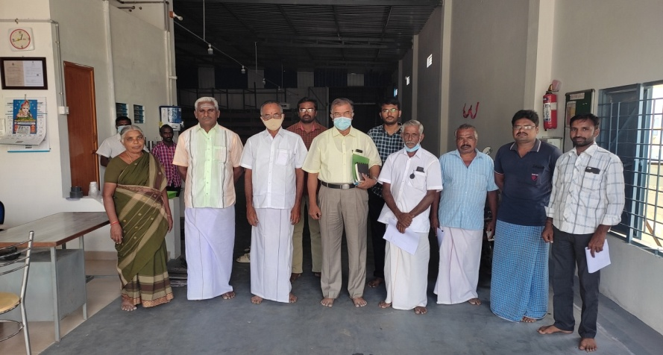

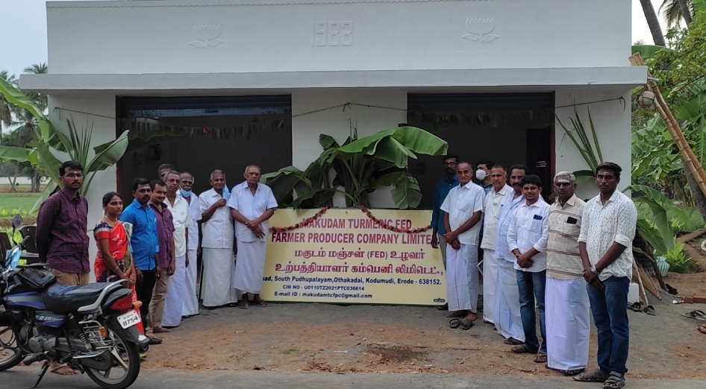
MTFFPCL office innaguration
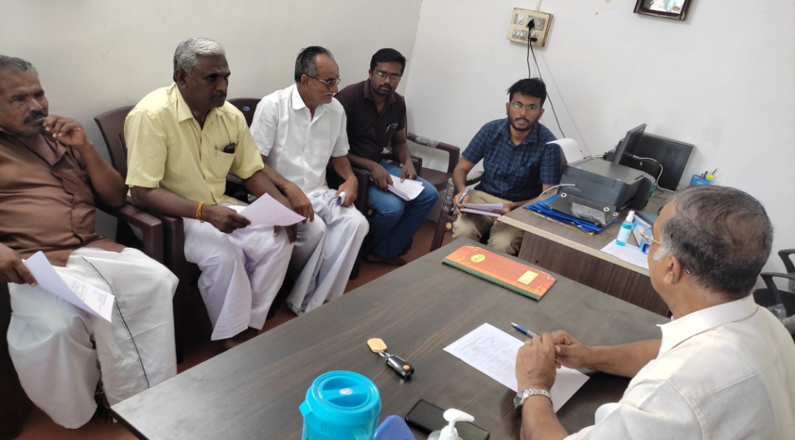
BoD’s Meeting

Name and Contact Number
- Chairman BoD, FPO:Dhakshinamurthi(9443431920)
- CEO, FPO: S.Balaramanan(9751183839)
- CBBO Point of contact:Dr.E.Vadivel(9443720160)

