DWARAKA PALM OILFED PRODUCER COMPANY LIMITED
DWARAKA PALM OILFED PRODUCER COMPANY LIMITED promoted by ACCESS Development Services and NAFED is working with the main objective to provide member farmers with better market access opportunities.

Year of Registration | 04-05-2021
State | Andhra Pradesh
District | Westgodavari
Block | Dwarakatirumala
CBBO | ACCESS Development Services
Shareholder Farmers (Nos)
 | Small Farmers: 214 Marginal Farmers:17
 | Women Farmers: 69 Tribal Farmers:
State Category | Plain Area
Share Capital (INR- Lakh) | 3,06,000.00
Business Activities (Summary) | 5,20,000/-Turnover (Input Sales  Machinery Services)
Area of Success*: | Supply of Quality Agri Inputs, Access to Production and Post-Harvest Machinery, Market Linkages
Board of Directors | Male: 4 Female: 1

*Area of Success: Supply of Quality Agri Inputs, Access to Production and Post-Harvest Machinery, Access to Value Addition Facilities, Adoption of Higher Income Generation Activities, Access to Market Intelligence, Credit Linkages, Market Linkages, etc.

Background
The region is heavily dependent on agriculture with poor infrastructure facilities. oil palm growing farmers for effective participation in identifying challenges in palm oil cultivation, field management, value chain & Marketing. Input in labour management and implementation of management to reduce cost of management and enhance the income of FPO.

Focus Areas
Identifying the need for market linkages and better price discovery, the FPC was formed in 2021. FPC has today has increased its outreach to 310 shareholder farmers covering 10 Panchayats.

Strategic Interventions undertaken

FPC aimed to achieve its objectives by using collectivization techniques and participation of the benefiting community, including rural farmers, and panchayat.

FPC is bringing to its member farmers the benefit of direct procurement from the market players for intercrops in oilpalm like Vegetables ,Coco, coconut, Banana, Maize. FPC has developed demand planning and forecasting system under the leadership of BODs.

FPC has established input shops for the farmers and provided inputs like Fertilizers,Trapers,Tillge Tooles,Tarpaulins, High yielding seeds varieties and also provided power tiller and tractor accessories to the farmers based on the demand.

Success Mantra

FPC with the support of CBBO has demonstrated the impact of collectivization of small and marginal farmers to leverage economies of scale in Production and marketing.

FPC done total business of Rs. 5,20,000/- within the year of establishment benefiting 150-member farmers and 50 non-member farmers,

Market intelligence to connect buyer with better price realization.

Benefits of the scheme

FPC has applied for matching equity grant of 3 Lakh under the “Central Sector Scheme for Formation and Promotion of 10,000 Farmer Producer Organizations (FPOs)”

Convergence with other Central and State government schemes
FPC has applied for Agri Infrastructure fund to start the collection centre for vegetables.

Lessons learnt

The FPO model is creating huge improvement in socio-economic conditions of small and marginal farmers with their increasing participation in the decision making thus making them empowered.

Way forward
. Going forward the FPC to diversify into value added products and set up a collection center under AIF(Agriculture Infrastructure Fund) and avail Credit guarantee Fund.

High Quality Images with caption

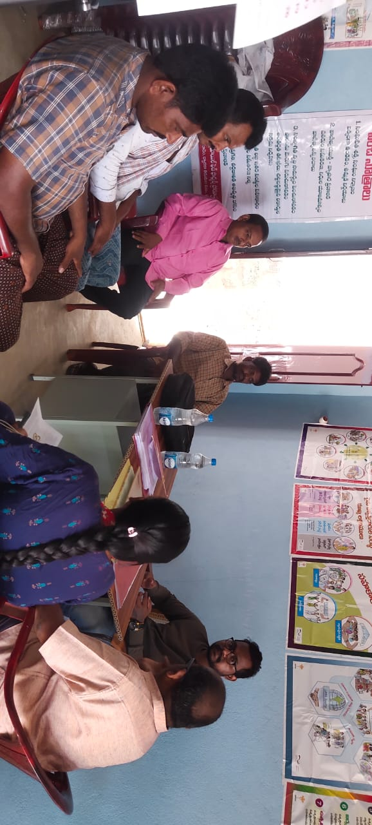

BOD’s meeting

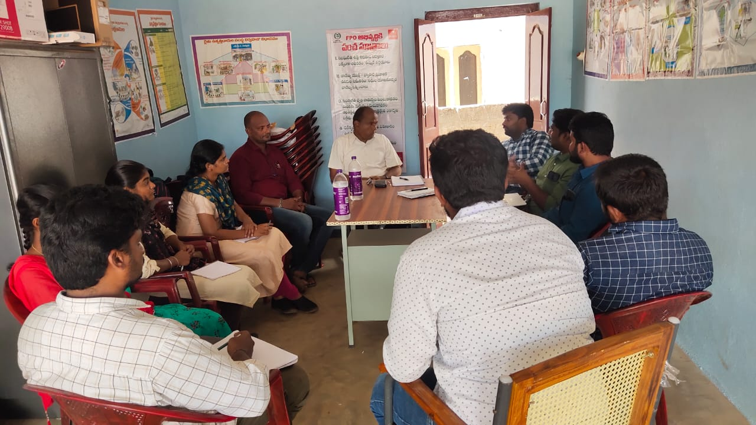

Meeting with input marketing companies

Name and Contact Number
- Chairman BoD, FPO: Nallajarla Nagaraju, 9398879941
- CEO, FPO: Prasanna V, 9133693167
- CBBO Point of contact: M.S.Subba rao, 9885735563

