

National Agricultural Cooperative Marketing Federation of India Ltd.
Regd. Office: NAFED House, Siddhartha Enclave
Ring Road, Ashram Chowk, New Delhi-110014
Telephone EPABX: 011-26340019, 26344153
Website: www.nafed-india.com
Ref No.: NAFED/HO/P&OS/2025 Dated: 6th May, 2025

CORRIGENDUM FOR EOI NO NAFED/HO/P&OS/2025 DATED 21.04.2025

Corrigendum to the EOI Notice No. NAFED/HO/P&OS/2025 DATED 21.04.2025 with reference to the Expression of Interst (EOI) for empanelment of surveyor agencies is hereby modified with following conditions mentioned as corrigendum for additional information.
EOI Head | Existing Clause | Modified Clause
Criteria of Evaluation | Only those Applicants whose Technical Proposals get a score of 60 (Fifty) marks or more out of 100 (one hundred) shall qualify for further consideration and shall be ranked from highest to the lowest based on their technical score. | Only those Applicants whose Technical Proposals get a score of 60 (Sixty) marks or more out of 100 (one hundred) shall qualify for further consideration.
Criteria of Evaluation | The applicant shall be evaluated as per below parameters  1. National Accreditation Board for Testing and Calibration Laboratories (NABL)  (a) 01 NABL Lab – 2 Marks  (b)02 NABL Lab -3 Marks  2. ISO 22000 (Food Safety Management): 03 Marks  3. FSSAI Certificate for survey (Food Safety and Standards Authority of India) -03 Marks  4. GAFTA certificate -10 Marks | The applicant shall be evaluated as per below parameters  1. National Accreditation Board for Testing and Calibration Laboratories (NABL)  (a) 01 NABL Lab – 3 Marks  (b) 02 NABL Lab -6 Marks  2. ISO 22000 (Food Safety Management): Deleted  3. FSSAI Certification for Survey Audit Conducted on Behalf of FSSAI or for PAN India Surveillance under FSSAI (Food Safety and Standards Authority of India) – 03 Marks  4. GAFTA certificate (Superintendent Certificate) (Supervise and inspection of agricultural commodities) -10 Marks
EOI Head | Existing Clause | Modified Clause
Criteria of Evaluation | Average Revenues from survey, sampling and analyzing during the 3 (three) financial years (Average), FY 2021-22, FY 2022-23 and FY 2023-24  (a) Rs. 5-10 crores : 3 Marks  (b) Rs. 10-15crores : 5 Marks  (c) Rs. 15-20 crores : 8 Marks  (d) > 20 crores : 10 Marks | Gross Turnover of company in survey, sampling and analyzing during the 3 (three) financial years FY 2021-22, FY 2022-23 and FY 2023-24  (a) Rs. 25 to 35 crores : 3 Marks  (b) Rs. 36- 45crores : 5 Marks  (c) Rs. 46-60 crores : 8 Marks  (d) > 60 crores : 10 Marks
Duties and responsibility of Quality Controller/Surveyor. | The Fair Average Quality (FAQ) specifications of various Pulses and Oilseeds including Copra are given at Annexure ‘AA’ – Not enclosed | The Fair Average Quality (FAQ) specifications of various Pulses and Oilseeds including Copra are given at Annexure ‘AA’ –enclosed
Criteria of Evaluation (Real time Data and digital/AI Capability – 10 Marks) | - Real-time tracking of survey & analysis work  - Comprehensive Videography and Photography with Geo-tagging  - Real-time updation of data onto the servers  - Concurrent monitoring of data quality  - Automated rules/algorithms for flagging of data anomalies for review  - Random checking of record  - Automated detecting of patterns in data submission and flagging for review | - Real-time tracking of survey & analysis work – 02 Marks  - Comprehensive Videography and Photography with Geo-tagging – 02 Marks  - Real-time updation of data onto the servers -01 Marks  - Concurrent monitoring of data quality -01 Marks  - Automated rules/algorithms for flagging of data anomalies for review -01  - Random checking of record -01  - Automated detecting of patterns in data submission and flagging for review -02

EOI Head | Existing Clause | Modified Clause
Declaration Regarding Non-Blacklisting for EOI Submission | I/We, the undersigned, representing [Name of the Company/Individual], having registered office at [Address of the Company/Individual], hereby declare that, as on the date of submission of this Expression of Interest (EOI), we have not been blacklisted or debarred by any Central/State Government, Semi-Government, Government Agency, Public Sector Undertaking (PSU), or any other regulatory authority in India or abroad. | I/We, the undersigned, representing [Name of the Company/Individual], having registered office at [Address of the Company/Individual], hereby declare that, as on the date of submission of this Expression of Interest (EOI), we have not been blacklisted or debarred by any Central/State Government, Semi-Government, Government Agency, Public Sector Undertaking (PSU), or any other regulatory authority in India or abroad in agriculture domain.
Declaration of Non-Involvement in Corrupt and Fraudulent Practices | I/We, [Name of the Company/Individual], having registered office at [Address of the Company/Individual], hereby solemnly declare that as on the date of submission of this Expression of Interest (EOI), neither our company nor any of its directors, partners, or key personnel have been involved in any corrupt, fraudulent, collusive, or coercive practices, as defined under applicable law and regulations.  I/We declare that no action of blacklisting, suspension, or debarment has been taken or is pending against us by any government, semi-government, or public sector organization on grounds of involvement in corrupt or fraudulent practices. | I/We, [Name of the Company/Individual], having registered office at [Address of the Company/Individual], hereby solemnly declare that as on the date of submission of this Expression of Interest (EOI), neither our company nor any of its directors, partners, or key personnel have been involved in any corrupt, fraudulent, collusive, or coercive practices, as defined under applicable law and regulations in agriculture domain.  I/We declare that no action of blacklisting, suspension, or debarment has been taken or is pending against us by any government, semi-government, or public sector organization on grounds of involvement in corrupt or fraudulent practices in agriculture domain.

Various crucial dates and times relating to the EOI call notice have been extended as follows:
Particulars | Date & Time
Last Date for Submission of EOI | 12.05.2025 upto 1.00 PM
Date of opening of tender | 12.05.2025 at 2.00 PM

All other terms and conditions of the original EOI remain unchanged. This corrigendum shall form an integral part of the EOI document. For any further clarification, please refer to the official NAFED website: https://www.nafed-india.com/tenders
Note:
Participating agencies are required to produce their original certificates/documents at the time of tender opening for verification. In the event that any certificate or document submitted is found to be forged, fabricated, or false at any stage, the concerned agency shall be blacklisted, and appropriate legal action will be initiated. Further, any losses incurred due to such misrepresentation shall be recovered from the defaulting agency.

Joint Managing Director (P&OS)

National Agricultural Cooperative Marketing Federation of India Ltd.
Regd. Office: NAFED House, Siddhartha Enclave
Ring Road, Ashram Chowk, New Delhi-110014
Telephone EPABX: 011-26340019, 26344153
Website: www.nafed-india.com
Dated: 21st April, 2025 Ref No.: NAFED/HO/P&OS/2025

INVITATION FOR EXPRESSION OF INTEREST (EOI)

Empanelment of Surveyor Agencies
The National Agricultural Cooperative Marketing Federation of India Ltd. (NAFED), a Central Nodal Agency for the procurement of Pulses, Oilseeds, and Copra under the Price Support Scheme (PSS) and procurement of Pulses for Buffer under the Price Stabilization Fund (PSF) Scheme of the Government of India, invites Expression of Interest (EOI) from reputed and experienced Surveyor Agencies for empanelment to carry out Sampling, Assaying, and Testing of Agri-commodities.
Interested agencies may download the detailed terms & conditions and prescribed application format from the NAFED website: https://www.nafed-india.com/tenders
The duly filled-in EOI, along with all relevant documents, must be submitted in a sealed envelope clearly superscribed: “Expression of Interest for Empanelment of Surveyor Agencies” and addressed to:
The Tender Committee
NAFED Head Office
(Pulses & Oilseed Division)
NAFED House, Sidhartha Enclave
Ashram Chowk, Ring Road
New Delhi - 110014
The EOI must reach the above address on or before 12 ^{th} May 2025 by 13.00 hrs.
NAFED reserves the right to accept or reject any or all EOIs without assigning any reason whatsoever.

Joint Managing Director (P&OS)

DISCLAIMER

- The information contained in this Tender or subsequently provided to intending Applicant(s) whether verbally or in documentary form by or on behalf of National Agricultural Cooperative Marketing Federation of India Ltd. (NAFED) or any of its employees or officers (referred to as “NAFED Representative”) is provided on the terms and conditions set out in this Tender document and all other terms and conditions subject to which such information is provided.

- No part of this tender and no part of any subsequent correspondence by NAFED, or NAFED representatives shall be taken neither as providing legal, financial, or other advice nor as establishing a contract or contractual obligations. Contractual obligations would arise only if and when definitive agreements have been approved and executed by the appropriate parties having the authority to enter into and approve such agreements.

- The Tender document has been prepared solely to assist prospective Applicants in making their decision to place their applications against this Tender. NAFED does not purport this information to be all-inclusive or to contain all the information that a prospective Applicant may need to consider in order to submit an application. The data and any other information wherever provided in this Tender is only indicative and neither NAFED, nor NAFED Representatives, will make or will be deemed to have made any current or future representation, promise or warranty, express or implied as to the accuracy, reliability or completeness or the information contained herein or in any document or information, whether written or oral, made available to an Applicant, whether or not the aforesaid parties know or should have known of any errors or omissions or were responsible for its inclusion in or omission from this Tender.

- Neither NAFED nor NAFED Representatives make any claim or give any assurance as to the accuracy or completeness of the information provided in this Tender. Interested parties are advised to carry out their own investigations and analysis of any information contained or referred to herein or made available at any stage in the bidding process in relation to this Tender Notice. Applicants have to undertake their own studies and provide their applications.

- This Tender document is provided for information purposes only and upon the express understanding that such parties will use it only for the purpose set forth above. It does not purport to be all-inclusive or contain all the information about the proposal in relation to which it is being issued.

- The information and statements made in this Tender document have been made in good faith. Interested parties should rely on their own judgments in participating in the said Project. Any liability is accordingly expressly disclaimed even if any loss or damage is caused by any act or omission on part of the aforesaid, whether negligent or otherwise.

- The Tender document has not been filed or approved in any jurisdiction. Recipients of this document should inform themselves of and observe any applicable legal requirements. NAFED makes no representation or warranty and shall incur no liability under any law, statute, rules or regulations as to the accuracy, reliability or completeness of the Tender document.

- NAFED reserves the right to reject all or any of the Applications submitted in response to this Tender at any stage without assigning any reasons whatsoever.

- All Applicants are responsible for all costs incurred by them when evaluating and responding to this document and any other costs incurred by the applicant thereafter.

- NAFED may at its sole discretion proceed in the matter it deems appropriate which may include deviation from its expected evaluation process, the waiver of any documents and the request for additional information.

- Unsuccessful Applicants will have no claim whatsoever against neither NAFED nor its employees, officers.

- NAFED reserves the right to modify, suspend, change or supplement this Tender at any stage. Any change to the Tender Notice will be notified on NAFED website by way of corrigendum.

- Mere submission of an application does not ensure selection of the Applicant as Successful Applicant or applicant.

- National Agricultural Cooperative Marketing Federation of India Ltd., is an apex level Cooperative Marketing Organization, registered under the relevant provisions of the Multi State Cooperative Societies Act, 2002 (as amended up-to-date), having its Head Office at NAFED House, Siddhartha Enclave, Ashram Chowk, New Delhi-110014, (hereinafter referred to as the "NAFED").

Important Dates & Time

Particulars | Date & Time
Date of Publishing / uploading of tender documents on NAFED’s Website | 21.04.2025 at 2.00 PM
Pre-EOI Submission Meeting: | 29.04.2025 at 3:00 PM
Last Date for Submission of EOI | 12.05.2025 upto 1.00 PM
Date of opening of tender | 12.05.2025 at 2.00 PM

- INTRODUCTION AND BACKGROUND:

- NAFED is a Central Nodal Agency for procurement of Pulses, Oilseeds and Copra under Price Support Scheme (PSS) and procurement of Pulses for Buffer under Price Stabilization Fund (PSF) Scheme of Government of India. NAFED also procures agricultural commodities under several other schemes and on commercial basis.
- Nafed is a leading entity in agricultural procurement and quality management, invites Expression of Interest (EOI) from reputed and experienced Surveyor Agencies for empanelment on a Quality Based Selection (QBS) basis. The empanelled agencies will check the quality of agricultural stock during procurement operations at various locations across.
- The purpose of this empanelment is to ensure quality standards are adhered to, safeguarding both the purchaser and buyers involved in the agricultural supply chain.
- NAFED invites quote from experienced and reputed assaying agencies having experience and eligibility as per this tender document.

- OBJECTIVE:

The objective of this EOI is to solicit applications from qualified agencies that can provide quality inspection services for various agricultural commodities during procurement. The selected agencies will be responsible for ensuring that all agricultural stocks procured meet the defined quality standards, with accurate assessments of moisture content, grade, and other essential parameters.

The Tender document is intended to empanelment of Surveyors for a period of three years for quality inspection/assessment of agri. Commodities.

3. SCOPE OF WORK:
The empaneled agencies will be responsible for:
- Conducting pre-procurement and post procurement (at storage point) quality inspections of agricultural stock, including but not limited to grains, pulses, oilseeds copra and other perishables as per the requirement of Nafed in the States of all over India.
- Assessing Fair Average Quality (FAQ) parameters such as moisture content, foreign matter, damaged or discolored grains, and other specific criteria per commodity.
- Conducting sampling & analyzing the sample. Prepare detail reports on the quality of stock as per quality parameters and real time digitally uploads at Nafed e-Samrdhi Portal with digital signature.
- Ensuring compliance with the defined quality standards set by Government of India/Nafed or relevant regulatory bodies.
- Providing timely and unbiased inspection reports to ensure smooth and transparent procurement operations as per defined quality standard.
- Use of scientific and standardized methods for testing and assessment, including laboratory analysis where required.

4. ELIGIBILITY CRITERIA:
Interested agencies must meet the following eligibility criteria:

- Existence: The Agency should have been in existence for a period of at least 03 years as of March, 2025.
- Experience: A minimum of three years (03) of experience in survey methods, scientific sampling, quality assessment, and data analysis in agricultural domain.
- Technical Expertise: Demonstrated experience in utilizing advanced techniques and equipment for quality control, sampling, data analysis, and laboratory testing of agricultural commodities. The agency shall upload state- and warehouse-wise real-time test reports on the NAFED-Samriddhi Portal or another authorized NAFED portal, with a digital signature.
- NABL accredited testing and analytical laboratory: The agency should have at least one own NABL accredited testing and analytical laboratory in India.
- Personnel: The agency must have a qualified team of experts, including quality controllers, scientific sampling professionals and laboratory technicians with experience in agricultural commodity inspection, sampling, and sample analysis. The agency should specify the state or cluster in which it intends to operate, based on its available infrastructure and workforce in that region. Additionally, the agency must meet the following minimum manpower requirements:

Minimum manpower (On Payroll of the company) (All over India)

- 20 Key Personnel: Must be on payroll with a minimum of 5 years of experience.
- 2 Senior Analysts: Must have at least 3 years of experience.
- 50 Samplers and Assayers for Quality Checking: Should possess a B.Sc. in Agriculture (Hons.) from an ICAR-recognized/accredited institute or university, with a minimum of 1 year of experience in survey methods, scientific sampling, quality assessment, and data analysis in agricultural commodities.
- Alternatively, graduates with a diploma or certificate in scientific sampling, quality checking, quality control, or quality assurance along with at least 1 year of relevant experience or graduates with 02 year agri sampling, assaying & testing experience in reputed company or Govt Institutions are also eligible.
- Office: The Agency must have at-least one office in that State/Cluster where agency wants to work.
- Certifications: The agency should have valid accreditations or certifications in quality management (e.g., ISO certifications) relevant to the agricultural sector.
- Financial Strength: The agency must have a minimum gross turnover of ₹25 crore over the last three financial years in survey, sampling, and quality assessment. To support this criterion, a Chartered Accountant certificate and audited financial statements (including the audited balance sheet and Profit & Loss accounts for the three years) must be submitted.
- Net Worth: The agency should have the positive net worth. The Chartered Accountant certificate should be provided in support.
- Statutory Document : Agency should have statutory document like PAN number, GST number, PF and ESI number, wherever applicable in its own name.
- Legal Status: The intending agency shall be a Company/Proprietorship firm/Cooperative organization/Partnership firm duly registered under the relevant act in force. In case of Partnership Firm, the intending agency shall submit a self-attested copy of partnership deed along with authorization in favour of signatory of the bidder documents. In case of a Company, the Intending agency shall submit Certificate of Incorporation, Memorandum or Articles of Association and an authorization from head of the company in favour of authorized signatory, duly certified by a Company Secretary.
- Blacklisting: Agency shall have satisfactory/dispute free performance for survey methods, scientific sampling, quality assessment, and data analysis in agricultural domain and not black listed by any organization. Agency has to provide a self-declaration in this regard.
- Declaration of ineligibility for corrupt or fraudulent practices : The Agency shall not be under a declaration of ineligibility for corrupt or fraudulent practices as on date of submission of bid and also not blacklisted or under litigation by any State/Central/UTs Government at the time of submission of application. A self declaration of this nature shall be provided by the interested bidder.
- Surveyor agencies currently empanelled with NAFED are eligible to participate in the tender, provided they meet the specified requirements.
- The interested agency will provide all documents alongwith application form and receipt of Processing Fee deposited in NAFED.

- WORKING STATE/REGION:

The details of the region and states where services of surveyors will be required are as under:-

North : Rajasthan/ Punjab/ Haryana/ Uttar Pradesh/ Delhi.
South : Karnataka/ Andhra Pradesh/ Telangana/ Tamil Nadu/ Kerala.
East : West Bengal/ Odisha/ Bihar/ Jharkhand/ Assam/ Chhattisgarh.
West : Gujarat/ Maharashtra/ Madhya Pradesh
Island : Lakshadweep and Andaman & Nicobar

- DOCUMENTS TO BE SUBMITTED:
Interested agencies are required to submit the following documents:
- Application form with stamp and signature of authorized representative ( Annexure –A)
  - Copy of incorporation/registration certificates and relevant licenses.
  - Self-Certified with stamp, the copy of PAN number, GST number, PF and ESI number
  - CA Certified turnover certificate along with audited financial statement for the last 3 years. (Both audited balance sheet and Profit & Loss A/Cs for 03 years)
  - CA Certified Net worth Certificate
  - Location & Address of NABL Accredited Lab
  - Experience Certificate and details of experience in handling similar projects, including client names, project scope, and outcome.
  - Certifications related to quality inspection, if any (GAFTA, ISO, NABL, APEDA, EIA, FSSAI, BIS etc.).
  - IT related software certificate for real time data and digital/AI Capability.
  - State-wise Office details with address
  - Assignment with Central Government Department/Undertaking and Export Houses. (Project name etc)
  - Blacklisting self declaration on company letter head with stamp
  - Self Declaration of ineligibility for corrupt or fraudulent practices on company letter head with stamp
  - Stamped and authorized signatory signed copy of EOI document

- Detailed company profile including organizational structure, mission, and areas of specialization. ANNEXURE B
- CVs of key personnel and others proposed for the assignment. ANNEXURE C

- DUTIES AND RESPONSIBILITIES OF QUALITY CONTROLLER/SURVEYOR:

The scope of work for assaying agencies will include the following:

- The Agency shall deploy required number of competent technically qualified Assayers & Quality Controller staff with proper equipments at the procurement / storage points as informed by NAFED. The assaying staff would be well trained and should possess a B.Sc. in Agriculture (Hons.) from an ICAR-recognized/accredited institute or university, with a minimum of 1 year of experience in survey methods, scientific sampling, quality assessment, and data analysis in agricultural commodities.
- Alternatively, graduates with a diploma or certificate in scientific sampling, quality checking, quality control, or quality assurance along with at least 1 year of relevant experience or graduates with 02 year agri sampling, assaying & testing experience in reputed company or Govt Institutions are also eligible.

The personal details will be used by Nafed to create login credentials on portal to upload daily report. The surveyor agency has to give proper sampling and assaying training to assayers/surveyors before deployment at centre/Storage Points during the procurement operation with intimation to Nafed.

- The agency shall intimate the names, designations and the contact numbers along with specimen signature of its technical staff to be deployed at the storage points in advance to NAFED’s concerned branches/Regional Head for better coordination so that work does not suffer.

- Agency shall depute at least one technical staff at each procurement centre / warehouse or both at procurement and warehouse point identified by NAFED as the need may be and will provide additional number of surveyors at the same procurement / storage point depending upon the requirement. In case of failure of the Agency to provide the required number of technical staff with proper equipment at the storage points as required by NAFED, a penalty of Rs. 1000/- per day per manpower or 50% of per day per manpower whichever is higher will be imposed on the agency for the shortfall in the number of manpower. In such case of default, NAFED reserves the right to hire the services of other technically sound and qualified agencies. The technical staff of the Agency will, in case of Pulses and Oilseeds inspect stock, draw random composite samples from each truck/lot (minimum 10% of the total bags) at designated storage point, analyze the sample in accordance with prescribed quality specifications issued by Govt. of India and submit the test reports immediately so that the stocks may be accepted or rejected accordingly. The Fair Average Quality (FAQ) specifications of various Pulses and Oilseeds including Copra are given at Annexure ‘AA’.

- In case of Copra, to draw minimum 2% random samples from each lot of farmer’s stock offered by SLS at the designated godown and 100% weighment at the designated warehouse at the time of storage of the stock in NAFED’s name.

- The Assayer/Surveyor must record the commodity details, warehouse information, procuring agency, farmer's name, and bag numbers along with their respective codes. The surveyor’s report should be uploaded to the NAFED-designated portal with a digital signature, clearly showing the details of accepted and rejected stock on a warehouse-wise basis.

- The agency shall submit a daily report to NAFED, detailing truck-wise, lot-wise, and warehouse-wise inspections conducted, samples drawn, samples analyzed, and test reports showing the truck-wise and lot-wise results. This report must be submitted digitally on real time. In cases where surveyors reject stocks, the reasons for rejection must be clearly stated in the test report. The agency is also responsible for maintaining proper records of these daily reports.

- In the event of any default, NAFED reserves the right to deduct an amount equivalent to the monetary value of the damage caused from the agency's security deposit and the total bill submitted by the agency.

- The agency and its employees are prohibited from sharing, publishing, displaying, or passing on any information to any third party without prior notification and consent from NAFED.
- The agency will be fully accountable for the accuracy of the samples analyzed and the test reports submitted regarding the acceptance or rejection of stocks. If any test reports provided by the agency are found to be faulty, the agency will bear full responsibility for the consequences.
- The appointed agency is strictly prohibited from transferring or subcontracting the work, either in full or in part, to any other firm, company, or individual. If it is discovered that the agency has subcontracted the work to another entity or person, the agency will be blacklisted by NAFED, legal action will be initiated against the agency, and the cost of any inferior stock deposited in the warehouse will be recovered from them.
- In order to complete the process of procurement in the e-portal, the assayers to be deputed by the agency at warehouse point shall ensure that the stock to be received at the warehouse is checked as per the FAQ specification/ provided specifications and entries are made about the status (acceptance/ rejection) of the stock on the e-portal.
- The Agency shall ensure payment to the deployed surveyor as per the minimum wages act of the concern state and comply the statutory requirement as per law.

8. SUBMISSION OF APPLICATION

- Intending parties shall submit application in the prescribed format (dully filled) in all respect and sealed tender will be dropped in tender box. .

- The application must be accompanied processing fees (non-refundable) of INR 10,000/- (Rupees Ten Thousand only), inclusive of all taxes, by way of RTGS / NEFT/ ELECTRONIC MODE to the NAFED in the following account prior to submission of tender:

    - Name of the beneficiary - NAFED
    - Name of the account number - 10053416672
    - Name of bank - IDFC First Bank
    - Address of the bank - New Friends Colony, South Delhi.
    - IFSC Code - IDFB0020102
    - Copy of above transaction as proof should be placed inside envelope.

9. TERMS & CONDITIONS:
- Submission of an EOI does not guarantee empanelment.
- The decision of the NAFED regarding empanelment will be final and binding.
- Tender received after due date and time will be rejected.
- No eraser, cuttings, overwriting and correcting fluid in the tender will be accepted.
- Tender documents submitted incomplete in any respect and/or without processing fees shall be summarily rejected. Further, NAFED reserves the right to accept or reject any or all tenders without assigning any reason thereof.

- The address given by the Agency in the tender documents shall be considered to be the proper and complete business address of the Agency and any correspondence sent to such address will deemed to have been delivered to the Agency.

- The terms and conditions of the tender documents will form part of the agreement to be executed between NAFED and successful bidder.

- Each page of the tender documents must be signed by the authorized
signatory of the bidder along with company stamp in token of acceptance of the terms and conditions of the tender documents and placed along with Technical Bid.

- The Non-Disclosure Agreement and Integrity Pact shall also be the part of the Tender Notice documents, which is enclosed at ANNEXURE – D & E.

- In case of any corrigendum to the tender, it will be published only on the official Nafed website.

10. SELECTION PROCESS:
The selection process will be conducted based on the Quality Based Selection (QBS) method, and the evaluation criteria will focus on:

- Quality Certification (42 Marks)
- Operational Strength & Qualified Manpower (20 Marks)
- Real time Data and digital/AI Capability (10 Marks)
- Pan-India Presence (10 Marks)
- Financial (10 Marks)
- Assignment with Central Government Departments/ Undertakings and Export Houses (05 Marks)
- Filed Survey Experience (03 Marks)
Agencies that meet the minimum qualifying score of 60 % will be shortlisted for further discussions.

11. CRITERIA OF EVALUTION:

The criteria for evaluation of Technical Proposal for Empanelment are given as under:

The Technical Proposal for Empanelment will be evaluated based on Applicant’s experience, its understanding, its survey capabilities and competence, and the strength and experience of the Key Personnel.

Only those Applicants whose Technical Proposals get a score of 60 (Sixty) marks or more out of 100 (one hundred) shall qualify for further consideration. The self-certified (with company stamp) annexures shall be included as supporting documents with the Technical Proposal.

The scoring criteria to be used for evaluation shall be as follows:

S.No. | Parameter | Weightage | Criteria | Annexure
1. | Quality Certification | 42 Marks | The applicant shall be evaluated as per below parameters  - National Accreditation Board for Testing and Calibration Laboratories (NABL)  - 1 NABL Lab – 3 Marks  - 2 NABL Lab -6 Marks  - GAFTA certificate (Superintendent Certificate) (Supervise and inspection of agricultural commodities) -10 Marks  - NABCB Certificate-08 Marks  - ISO 9001 (Quality Management Systems) – 03 Marks  - Agricultural and Processed Food Products Export Development Authority (APEDA) Certification – 03 Marks  - EIA (Export Inspection Agency) Certification -03 Marks  - FSSAI Certification for Survey Audit Conducted on Behalf of FSSAI or for PAN India Surveillance under FSSAI (Food Safety and Standards Authority of India) – 03 Marks  - Bureau of Indian Standards (BIS) Certification -03 Marks  - Certification in Good Agricultural Practices (INDGAP or GLOBALG.A.P.) - 03 Marks | I
2. | Operational Strength & Qualified Manpower | 20 Marks | Key Personnel Capacity  Total Number of Key Personnel on Payrolls of Applicant Institution.  - Below 20 – 0 Marks  - 20 to 30- 03 Marks  - 30 to 50 – 05 Marks  - 50 to 100 – 07 Marks  - Above 100 - 10 Marks  Total Number of Key Personnel with PhD on Payrolls of Applicant Institution  1 to 05 – 03 Marks  06 to 10 -04 Marks  Above 10 -05 Marks  Average Work Experience of Key Personnel on Payrolls of Applicant Institution  Below 02 years -0 Marks  2-5 Years – 03 Marks  Above 05 years – 05 Marks | II
3. | Real time Data and digital/AI Capability | 10 Marks | - Real-time tracking of survey & analysis work – 02 Marks  - Comprehensive Videography and Photography with Geo-tagging – 02 Marks  - Real-time updation of data onto the servers -01 Marks  - Concurrent monitoring of data quality -01 Marks  - Automated rules/algorithms for flagging of data anomalies for review -01  - Random checking of record -01  - Automated detecting of patterns in data submission and flagging for review -02 | III
4. | Pan-India Presence | 10 Marks | Pan-India Presence (Previous Projects Portfolio preferably with government / PSUs/ recognized organizations or quality monitoring agencies )- 1 mark per State | IV
5. | Assignment with Central Government Departments/ Undertakings and Export Houses | 05 Marks | Sampling & analysis Assignment with Central Government Departments/ Undertakings -03 Marks  Sampling & analysis Assignment with Export Houses -02 Marks | V
6. | Filed Survey Experience | 03 Marks | Years since commencement of field survey, sampling and analyzing the samples  Below 03 Year – 0 Marks  03 to 05 Years- 02 Marks  Above 05 Years -03 Marks | VI
7. | Financial | 10 Marks | - Gross Turnover of company in survey, sampling and analyzing during the 3 (three) financial years FY 2021-22, FY 2022-23 and FY 2023-24  Rs. 25 to 35 crores : 3 Marks  Rs. 36- 45crores : 5 Marks  Rs. 46-60 crores : 8 Marks  > 60 crores : 10 Marks | VII

12. AWARD OF WORK
- On verification of documents submitted by the interested parties, Nafed will finalize the list of successful parties for empanelment.

- Intimation regarding selection of party and validity of empanelment will be sent by Nafed on the business address of the party or through e-mail.

- Successful parties will be informed regarding empanelment. List of empanelled surveyor agencies may also be displayed on Nafed website.

NAFED, HO or concerned branch of NAFED shall invite quotations from all its empanelled Service providers as and when Nafed will undertake procurement of any of PSS / PSF commodity or require surveyors for other works like quality inspection of stored stock etc. All interested empanelled Service providers will furnish their quotation alongwith interest free Security Deposit of Rs.5,00,000/-. The lowest quotation from empanelled Service provider would be awarded the work, however, Nafed may engage multiple surveyor agencies in a region or State.

- The Security Deposit of Rs.5,00,000/- would be refunded to unsuccessful Service provider within 30 days from the date of finalization of appointment of Service provider without any interest. Security Deposit to successful Service Provider will be refunded without interest only after successful and satisfactory completion of the assigned job.

- NAFED reserves the right to accept or reject any or all EOIs without assigning any reasons.
- The period of validity of empanelment shall be 3 (three) years from the Effective Date of Empanelment. After the expiry of 3 (three) years period, the Authority may choose to renew the empanelment for additional 2 (two) years (subject to renewal for one year at a time, with maximum of two years) on the request of the empaneled Survey Institution and furnishing of requisite documents as decided by the Nafed.

13. EXECUTION OF AGREEMENT:

Separate agreements for award of work shall be executed between concerned NAFED branch or Nafed HO and the agency on Non-Judicial Stamp Paper of Rs. 100.00, to be provided by the agency on award of work. The terms and conditions enumerated in the Tender shall form the part of the agreement. However, the terms and conditions of proposed agreement shall prevail over the Tender document if such terms and conditions are in contradiction with Tender document viz-a-viz NAFED.

14. FOREFEITURE OF SECURITY/EARNEST MONEY:

If the Agency fails or neglects to observe or perform any of his obligations under the Tender, it shall be lawful for the NAFED to forfeit either in whole or in part, in its absolute discretion, the Security Deposit/Earnest Money in or towards the satisfaction of any sum due to be claimed for any damages, losses, charges, expenses or costs etc. that may be suffered or incurred by the NAFED.

15. INDEMNITY:

The Agency shall indemnify NAFED and keep indemnified against any loss or damage, claims, compensation, penalty, fine, levies, etc. on account of slackness, deficiency, failure to observe any obligations under the contract, failure to comply with statutory/ mandatory provisions pertaining to the contract by the Agency in respect of the services provided etc., whatsoever.

16. CONFIDENTIALITY:

The Agency and its employees shall undertake to maintain absolute Confidentiality and shall not divulge in any way any information relating to the conversations, events, ideas, concepts, know-how, techniques, data, facts, figures and all information concerning or relating to agency of Govt. of India and its affairs to which the Agency / their employees etc have access, in the course of performance of the contract.

17. TERMINATION:

In case the performance of the agency is not found to be satisfactory during the currency of the agreement, NAFED can prematurely terminate the award of work agreements after giving 01 month notice. NAFED at its discretion can debar/blacklist the agency firm participation in any tenders floated by NAFED. The condition for debar/blacklist is Consistent Poor Performance, Breach of Contract Terms, Financial Irregularities, Unethical or Unprofessional Conduct, Failure to Address Corrective Actions, Legal Violations and Subcontracting without permission.

18. FORCE MAJEURE:

- Force Majeure means any event or combination of events or circumstances beyond the control of the parties hereto which cannot (a) by the exercise of reasonable diligence, or (b) despite the adoption of reasonable precaution and/ or alternative measures, be prevented, or caused to be prevented, and which adversely affects the abilities of the parties to perform obligations under this Agreement, which shall include but not be limited to: (a) Acts of God i.e. fire, drought, flood, earthquake, epidemics, natural disasters; (b) Explosions or accidents, air crashes and shipwrecks, act of terrorism; (c) Strikes or lock outs, industrial dispute; (e) War and hostilities of war, riots, bandh, act of terrorism or civil commotion; (f) The promulgation of or amendment in any law, rule or regulation or the issue of any injunction, court order or direction from any Governmental Authority that prevents or restricts a party from complying with any or all the terms and conditions as agreed in this Agreement; (h) Any event or circumstances analogous to the foregoing.
- It is agreed between the parties that the performance of obligations under this contract is subject to Force Majeure condition which shall mean any event or combination of events or circumstances beyond the control of the parties hereto.
- Neither party will be liable for performance delays or for non-performance due to causes beyond its reasonable control, except for payment obligations.
- During the continuance of the Force Majeure, NAFED reserves the right to alter or vary the terms and conditions of this Contract or if the circumstances so warrant, the NAFED may also suspend the agreement for such period as is considered expedient, Agency agree and consent that they shall have no right to raise any claim, compensation of any nature whatsoever for or with regard to such suspension.
- The Agency agree and understand that if the Force Majeure condition continues for a long period, then the NAFED in its own judgment and discretion may terminate this Agreement and in such case Agency agree that the they shall have no right or claim of any nature whatsoever and NAFED shall be released and discharged of all its obligations and liabilities under this Agreement.

19. ARBITRATION

- This Tender Document shall be constituted and the legal relation between the parties hereto shall be determined and governed according to the laws of Republic of India and only courts at Delhi and the High Court at Delhi shall have the jurisdiction in all matters arising out of / touching and/or concerning this tender document and parties to this tender process agree to irrevocably submit to the exclusive jurisdiction of those courts for purposes of any such proceeding. The aforementioned exclusive and irrevocable jurisdictions of aforesaid courts are irrespective of place of occurrence of any cause of action pertaining to any dispute between the parties.
- All or any disputes arising out or touching upon or in relation to the terms of this tender document and process thereof including the interpretation and validity of the terms thereof and the respective rights and obligations of the parties shall be settled amicably by mutual discussion failing which the same shall be settled through arbitration. The arbitration proceedings shall be governed by the Arbitration and Conciliation Act of 1996 (as amended up to date) or any statutory amendments/ modifications thereof for the time being in force. The seat & venue of the arbitration shall be at New Delhi, India and language of arbitration shall be English.
- Nothing contained in this clause shall prevent the NAFED from seeking interim injunctive relief against the intending bidders in the courts having jurisdiction over the parties.

20. INFORMATION TO THE APPLICANT(S):

- NAFED reserves the right to accept or reject any / all applications without assigning any reason whatsoever. Further information regarding extension of date of opening, amendments, etc., if any, shall be posted on NAFED website https://www.nafed-india.com only, by way of corrigendum.
- NAFED reserves the right to allow other parties to match the lowest bid and issue work order to multiple parties if deemed necessary. Eligible bidders who has submitted lowest financial bid may be awarded the Work Order. However, NAFED reserves the right to accept or reject any or all bids without assigning any reason thereof.
- All Applicants are responsible for all costs incurred by them when evaluating and responding to this Tender Notice and any negotiation costs incurred by the recipient thereafter.
- NAFED reserves the right to modify, suspend, change or supplements this Tender Notice at any stage of the process. Any change to the Tender Notice will be notified through the above mentioned NAFED website. This Tender Notice Information document is provided for information purposes only and upon the express understanding that such parties will use it only for the purpose set forth above. It does not purport to be all-inclusive or contain all the information about the Project in relation to which it is being issued. Mere submission of applications under this Tender Notice does not ensure selection of the Applicant as Successful Applicant.
- The applications should be complete in all respects. Incomplete and unsigned applications not in prescribed format and/or without documents will summarily be rejected without assigning any reason.
- After scrutiny of Technical documents in accordance with the terms & conditions of this Tender Notice, NAFED shall shortlist the eligible participators fulfilling eligibility criteria and inform them accordingly.
- In case of differences arising in the terms and conditions of the Tender Notice documents with the firm(s), the decision of NAFED shall final and binding upon all.
- Applications, which are vague/conditional/incomplete/not confirming to the laid down procedure in any respect, will be rejected.
- The applicant should sign on each page of the Tender Notice documents.
- NAFED reserves the rights to call any additional information/documents from applicant(s) and same shall be submitted by the applicant to NAFED within given time period.

21. HOLIDAY LISTING:

Nafed’s policy for Holiday-listing, which is available on the website of NAFED must be acceptable to the bidders. Notwithstanding anything contained in this Agreement, Nafed’s Policy of Holiday listing is mutandis applies to this and in the event, the agency (s) while discharging its obligations under this tender/agreement or otherwise, come(s) within the ambit of the said policy, Nafed at its sole discretion reserves the right to suspend/discontinue dealings or take any curative measures with agency (s) in accordance with the policy in force.

22. INTERGRITY PACT (IP)

- The bidders are to sign integrity pact of NAFED as per Annexure- E and submit the same along with bid documents. Bids without signed integrity pact are liable for rejection. It will be assumed that the bidder have gone through the integrity Pact and have no objections whatsoever in signing the contract.

23. DECLARATIONS AND UNDERTAKINGS:
- It shall be incumbent upon all applicants/intending bidders to submit following declarations on the letter head of their entity(ies) while submitting their applications:

- The intending bidder(s)/applicant(s) is/are/was/were neither in litigation with Nafed at any point of time regarding any business and trade activity of Nafed nor was/were it/they ever blacklisted by Nafed on account of such litigation(s) or otherwise.

- Any of the present and past directors/ proprietor/ partners/ promoters etc of intending bidder(s)/applicant(s) was/were or is/are not part of such other and separate entity(ies) which was/were/ is/are in litigation with Nafed in present or past or/and such other entity (ies) has/have/had ever been blacklisted by Nafed in the past for any reason.

- If intending bidder(s)/applicant(s) is/are/was/were in litigation (s) with Nafed in present/past, it shall be incumbent upon such bidder(s)/applicant(s) to furnish the details of such litigation(s) and consequent blacklisting, if any, on the letter head of the entity (ies). In such scenario, the declaration as mandated above at (a&b) shall not be required.

- If any of the applicant(s) /intending bidder(s) or their promoters are found involved in litigation(s) with Nafed whether in past and present or they have/had been blacklisted by Nafed or/and any of the promoters of intending applicant(s)/bidder(s) was/were part of the management of such other and separate entity(ies) which was/were/ is/are in litigation(s) with Nafed in present or past or/and such other entity (ies) has/have/had ever been blacklisted by Nafed in the past for any reason, Nafed shall have sole discretion to decide on the selection of such applicant(s)/bidder(s) even if such applicant(s)/bidder(s) fulfilling eligibility criteria and Nafed’s decision either to select or reject such applicants/bidders shall be final and binding and no further communication/grievance against such decision shall be entertained in this regard.

*********************************

APPLICATION LETTER

To,
The Managing Director,
NAFED, Head Office
Siddhartha Enclave, Ashram Chowk Ring Road, New Delhi -110014.

Ref. EOI vide no.

Dear Sir,

I/We, submit processing fee Rs. 10000/- (non-refundable) (RTGS/NEFT/IMPS No & Date--------------------) inclusive of all taxes for empanelment as service provider for provide the quality inspection services for various agricultural commodities.
I/We have thoroughly examined and understood all the terms and conditions as contained in the Expression of Interest (EOI) and agree to abide by them.
I/We hereby offer to provide the quality inspection services for various agricultural commodities during procurement on the requirement of Nafed.

Yours faithfully,

Authorized Signatory

ANNEXURE A
Application form
S No. | Particulars | Details
1 | Name of Organization
2 | Type of firm | (Private Limited/ Public Limited/ Cooperative/ Proprietorship)
3 | Registered office address
4 | Landline number
5 | Website
6 | Name of Authorized Signatory
7 | Designation
8 | Email Id
9 | Mobile number
10 | Date of incorporation
11 | PAN Number
12 | GST Number | Office Address |  |  | GST No and Date of Registration |  |  |  |  |  | Man Power details
13 | ESI & PF Number
14 | Name of the Region/State(s) for which applying for Quality Assessment
15 | Financial Turnover for last 3 financial years (in Rs. Crore) - (attach last 3 years audited Financial Statement as supporting) (Both audited balance sheet & Profit & Loss A/Cs for 03 years) | FY |  |  |  |  |  | Total Turnover  (Rs. Crore) |  |  |  |  | Turnover from survey, sampling and quality assessment  (Rs. Crore)
 |  | 2021-22
 |  | 2022-23
 |  | 2023-24
16 | Net worth Certificate (from Charted accounted)
17 | Location and address of NABL accredited labs | (attach NABL accreditation certificate)
18 | Number of years of relevant experience ( enclose self certified copy of experience certificate ) | Project |  | Client |  |  |  |  |  |  |  | Project Scope |  |  | Value of Project
19 | Key Personnel & other employee details ( on Payroll) ( Please enclose CVs) | Designation |  |  |  |  | Qualification |  |  |  |  | Role |  | No. of employees
20 | Certification for quality (ex. GAFTA, ISO, APEDA etc) | Certificate |  |  |  |  | Issuing Authority |  | Validity
21 | IT related Software & Server Details for real time data upload
22 | State wise office details | State |  |  |  | Address |  |  |  |  | Contact Person
23 | Assignment with Central Government Deptt/Undertaking and Export House | Project Name |  |  |  | Department |  |  |  |  | Value |  |  | Operating Area
24. | Blacklisting Self Declaration (On Company Letter Head with stamp & Signature)
25. | Self Declaration of ineligibility for corrupt and fraudulent practices ( On company Letter Head with stamp & Signature)
26 | Stamped & Signed copy of EOI Document

*************
TURNOVER CERTIFICATE

Certificate from Chartered Accountant/ Statutory Auditor regarding financial turnover
Certified that M/s __________________ having its Registered Office at ____ __________ _________ _______________ has been having minimum gross turnover of ₹25 crore over the last three financial years ( i.e. 2021-22, 2022-23 & 2023-24) in survey, sampling, and quality assessment. The details are as under:

Financial Year | Total turnover  (Rs. Crore) | Turnover from survey, sampling and analyzing  (Rs. Crore)
2021-22

2022-23
2023-24
Further, the company is engaged in offering services of Analysis, Supervision, sampling, Survey and related activities in different locations in India since year ________
This certificate is issued based on documentary evidences and audited Accounts produced to me and copies of which are available with me which I shall be able to produce if required by the NAFED. The certificate is true and correct to the best of my knowledge and belief.
Signature:
Name of the person signing:
Designation: | Chartered Accountant
Name of the firm:
Registration No./Membership No.
Address
Email address:
Contact Numbers:
Date:
Place:

ANNEXURE B

DETAILED COMPANY PROFILE

- Company Name & Logo
  - Full Legal Name:
  - Company Logo:
- Contact Information
  - Address: Provide the physical location of your headquarters or primary office.
  - Phone Number: Include the main contact number.
  - Email Address: General or specific email for EOI correspondence.
  - Website: Link to your official website (if applicable).
  - Primary Contact Person: Name, position, phone, and email for a designated contact.
- Company Overview
  - Year Established: Mention the founding year of your company.
  - Legal Structure: Clarify the business type (e.g., private company, public company, partnership).
  - Ownership: Mention if the company is privately owned or part of a larger group.
  - Size of Company: Provide details on the number of employees and operational capacity.
- Mission, Vision & Core Values
  - Mission Statement: A short statement outlining the company’s purpose and goals.
  - Vision Statement: What the company aims to achieve in the long term.
  - Core Values: The guiding principles and ethics that drive the company’s operations.
- Business Activities & Capabilities
  - Primary Services or Products: Describe the core offerings of your company.
  - Specializations: Highlight any specialized services, skills, or expertise that align with the EOI.
  - Technology & Tools: Outline the technical resources and tools the company uses to deliver services.
- Relevant Experience
  - Industry Experience: Briefly describe the company’s experience in relevant industries.
  - Project Portfolio: Provide examples of previous projects, especially those relevant to the EOI scope.
  - Client Base: List key clients or partnerships with other businesses or governments.
- Key Personnel & Expertise
  - Executive Team: Provide names, titles, and brief biographies of key leadership.
  - Technical Staff: Highlight experts or specialists related to the EOI project.
  - Certifications & Qualifications: Mention relevant certifications or qualifications of the team.

- Quality & Compliance
  - Quality Management System: Describe any quality assurance frameworks or certifications (e.g., ISO 9001).
  - Health & Safety: Information on the company’s health and safety policies and compliance with regulations.
  - Environmental & Sustainability Practices: Describe any sustainability initiatives or certifications (e.g., ISO 14001).
- Financial Standing
  - Turnover/Revenue: Provide a summary of the company’s financial performance over the last few years.
  - Profitability & Growth: Briefly discuss profitability or growth trends, if applicable.
  - Financial Stability: Mention any strong financial standing or liquidity, especially for large projects.
- Certifications & Accreditations
- List relevant industry certifications or accreditations (e.g., ISO standards, industry-specific credentials).
- References
- Include testimonials or references from previous clients or partners.
- Please mention contact details for references,.

ANNEXURE –C

Certificate Regarding Key Personnel and others proposed for assignment

Certified that M/s________________________________ having its Registered Office at _____________________________________ is having technical manpower for assaying of agricultural commodities on roll as on (dd/mm/yyyy) as specified in table below.

Designation | Profile | No. of employees on roll

This certificate is issued based on documentary evidences and audited Accounts produced to me and copies of which are available with me which I shall be able to produce if required by the NAFED. The certificate is true and correct to the best of my knowledge and belief.

Signature:
Name of the person signing:
Designation: | Company Secretary/ Chartered Accountant
Name of the firm:
Registration No./Membership No.
Address
Email address:
Contact Numbers:

Date:

Place:

Certificate Regarding Branch offices of Agency

Certified that M/s __________________ having its Registered Office at ____ __________ _________ _______________ has following branch offices in the states as on date he intend to work :-
S No. | State | State office address | GST registration number*
1
2
3
4
5
*A copy of GST certificate to be provided

This certificate is issued based on documentary evidences produced to me and copies of which are available with me which I shall be able to produce if required by the NAFED. The certificate is true and correct to the best of my knowledge and belief.
Signature:
Name of the person signing:
Designation: | Company Secretary/Chartered Accountant
Name of the firm:
Registration No./Membership No.
Address
Email address:
Contact Numbers:
Date:
Place:

NETWORTH CERTIFICATE
(On the letterhead of the Chartered Accountant)
Date:
To Whom It May Concern:

Subject: Net Worth Certificate for [Company]
This is to certify that I/we have reviewed the books of accounts and other relevant documents of [Name of Individual/Company] having its registered office at [Address] as on [Date]. Based on the verification of the documents provided and the information furnished by the individual/company, the net worth of [Name of Individual/Company] as on [Date] is calculated as follows:

1. Assets:
- Fixed Assets (Land, Building, Machinery, etc.): ₹ [Amount]
- Investments (Shares, Bonds, etc.): ₹ [Amount]
- Current Assets (Cash, Bank Balances, Debtors, etc.): ₹ [Amount]
- Other Assets (Loans, Advances, etc.): ₹ [Amount]
- Total Assets: ₹ [Total Assets Amount]

2. Liabilities:
- Current Liabilities (Sundry Creditors, Loans, etc.): ₹ [Amount]
- Long-Term Liabilities (Loans, Mortgage, etc.): ₹ [Amount]
- Other Liabilities: ₹ [Amount]
- Total Liabilities: ₹ [Total Liabilities Amount]

3. Net Worth Calculation:
- Net Worth = Total Assets - Total Liabilities
- Net Worth: ₹ [Net Worth Amount in Words] only.
This certificate is issued at the request of [Name of Individual/Company] for the purpose of [mention purpose, e.g., submission for EOI in response to the tender no. [Tender No.]] or any other purpose they deem fit.

Declaration:
This certificate is based on the information and records provided by [Name of Individual/Company] and reflects a true and fair assessment of their financial standing as of [Date

Self-Declaration Certificate
(On Company Letterhead)
Date:
To,
[Name of the Authority/Organization]
[Address of the Authority/Organization]

Subject: Declaration Regarding Non-Blacklisting for EOI Submission
Dear Sir/Madam,
I/We, the undersigned, representing [Name of the Company/Individual], having registered office at [Address of the Company/Individual], hereby declare that, as on the date of submission of this Expression of Interest (EOI), we have not been blacklisted or debarred by any Central/State Government, Semi-Government, Government Agency, Public Sector Undertaking (PSU), or any other regulatory authority in India or abroad in agriculture domain.
I/We further declare that:
- We have not been convicted or penalized in any criminal or civil case related to any business activity in India or abroad.
- No blacklisting or disciplinary action is currently pending against us in any legal authority.
This declaration is made in compliance with the requirements for submission of EOI for [mention the specific tender/EOI name, reference number], and we fully understand that any false declaration or misrepresentation in this regard could lead to disqualification from participating in the bidding process.

Details of the Company/Individual:
- Name of the Company/Individual:
- Registered Office Address:
- Contact Details: [Insert Contact Number and Email ID]
- CIN/Registration Number (if applicable): [Insert CIN or Registration Number]
- Authorized Signatory Name: [Insert Name]
- Designation: [Insert Designation]
I/We declare that the statements made above are true and correct to the best of our knowledge and belief. Should any discrepancy be found in the information provided, we understand that it may result in immediate disqualification from the EOI process.
Thank you for your consideration.
Yours faithfully,
[Signature of Authorized Signatory]
[Name of Authorized Signatory]
[Designation]
[Name of the Company]
[Company Seal]

Notes:
- The certificate must be signed by the Authorized Signatory of the company or individual submitting the EOI.
- Ensure the company's letterhead is used with the official seal for authenticity.
- The certificate should be dated and include all relevant information about the company/individual.

Self-Declaration Certificate
(On Company Letterhead)
Date:
To,
[Name of the Authority/Organization]
[Address of the Authority/Organization]

Subject: Declaration of Non-Involvement in Corrupt and Fraudulent Practices
Dear Sir/Madam,
I/We, [Name of the Company/Individual], having registered office at [Address of the Company/Individual], hereby solemnly declare that as on the date of submission of this Expression of Interest (EOI), neither our company nor any of its directors, partners, or key personnel have been involved in any corrupt, fraudulent, collusive, or coercive practices, as defined under applicable law and regulations in agriculture domain.
I/We further declare that:
- Corrupt Practices: I/We have not offered, given, received, or solicited, directly or indirectly, anything of value to influence the actions of a public official in the procurement process or in contract execution.
- Fraudulent Practices: I/We have not misrepresented facts or provided false information in order to influence a procurement process or the execution of a contract to the detriment of the procuring entity.
- Collusive Practices: I/We have not entered into any arrangement with any other bidder(s) with an aim to manipulate the outcome of the procurement process.
- Coercive Practices: I/We have not threatened or acted to harm or influence another party in relation to the procurement process or contract execution.
I/We declare that no action of blacklisting, suspension, or debarment has been taken or is pending against us by any government, semi-government, or public sector organization on grounds of involvement in corrupt or fraudulent practices in agriculture domain.
This declaration is made in compliance with the requirements of the EOI submission for [mention the specific tender/EOI name, reference number], and I/we fully understand that any false declaration or misrepresentation of the facts may result in immediate disqualification from the EOI process.

Details of the Company/Individual:
- Name of the Company/Individual: [Insert Name]
- Registered Office Address: [Insert Address]
- Contact Details: [Insert Contact Number and Email ID]
- CIN/Registration Number (if applicable): [Insert CIN or Registration Number]
- Authorized Signatory Name: [Insert Name]
- Designation: [Insert Designation]
I/We declare that the statements made above are true and correct to the best of our knowledge and belief, and we fully understand the consequences of providing any false information.
Thank you for your consideration.
Yours faithfully,
[Signature of Authorized Signatory]
[Name of Authorized Signatory]
[Designation]
[Name of the Company]
[Company Seal]

APPLCATION FORM FOR TECHNICAL PROPOSAL
(TO BE SUBMITTED IN SEPARETE ENVELOPE WITH APPLICABLE ANNEXURES)
Please tick the criteria that the agency fulfills along with Authorized Representative certified (with company stamp) supporting documents as Annexures:
S.No. | Parameter | Weightage | Criteria | Annexure
1. | Quality Certification | 42 Marks | The applicant shall be evaluated as per below parameters  - National Accreditation Board for Testing and Calibration Laboratories (NABL)  - 1 NABL Lab – 3 Marks  - 2 NABL Lab -6 Marks  - GAFTA certificate (Superintendent Certificate) (Supervise and inspection of agricultural commodities) -10 Marks NABCB Certificate-08 Marks  - ISO 9001 (Quality Management Systems) – 03 Marks  - Agricultural and Processed Food Products Export Development Authority (APEDA) Certification – 03 Marks  - EIA (Export Inspection Agency) Certification -03 Marks  - FSSAI Certification for Survey Audit Conducted on Behalf of FSSAI or for PAN India Surveillance under FSSAI (Food Safety and Standards Authority of India) – 03 Marks  - Bureau of Indian Standards (BIS) Certification -03 Marks  - Certification in Good Agricultural Practices (INDGAP or GLOBALG.A.P.) - 03 Marks | I
2. | Operational Strength & Qualified Manpower | 20 Marks | Key Personnel Capacity  Total Number of Key Personnel on Payrolls of Applicant Institution.  - Below 20 – 0 Marks  - 20 to 30- 03 Marks  - 30 to 50 – 05 Marks  - 50 to 100 – 07 Marks  - Above 100 - 10 Marks  Total Number of Key Personnel with PhD on Payrolls of Applicant Institution  1 to 05 – 03 Marks  06 to 10 -04 Marks  Above 10 -05 Marks  Average Work Experience of Key Personnel on Payrolls of Applicant Institution  Below 02 years -0 Marks  2-5 Years – 03 Marks  Above 05 years – 05 Marks | II
3. | Real time Data and digital/AI Capability | 10 Marks | - Real-time tracking of survey & analysis work – 02 Marks  - Comprehensive Videography and Photography with Geo-tagging – 02 Marks  - Real-time updation of data onto the servers -01 Marks  - Concurrent monitoring of data quality -01 Marks  - Automated rules/algorithms for flagging of data anomalies for review -01  - Random checking of record -01  - Automated detecting of patterns in data submission and flagging for review -02 | III
4. | Pan-India Presence | 10 Marks | Pan-India Presence (Previous Projects Portfolio preferably with government / PSUs/ recognized organizations or quality monitoring agencies )- 1 mark per State | IV
5. | Assignment with Central Government Departments/ Undertakings and Export Houses | 05 Marks | Sampling & analysis Assignment with Central Government Departments/ Undertakings -03 Marks  Sampling & analysis Assignment with Export Houses -02 Marks | V
6. | Filed Survey Experience | 03 Marks | Years since commencement of field survey, sampling and analyzing the samples  Below 03 Year – 0 Marks  03 to 05 Years- 02 Marks  Above 05 Years -03 Marks | VI
7. | Financial | 10 Marks | - Gross Turnover of company in survey, sampling and analyzing during the 3 (three) financial years FY 2021-22, FY 2022-23 and FY 2023-24  Rs. 25 to 35 crores : 3 Marks  Rs. 36- 45crores : 5 Marks  Rs. 46-60 crores : 8 Marks  > 60 crores : 10 Marks | VII

ANNEXURE-D
NON-DISCLOSURE AGREEMENT

THIS RECIPROCAL NON-DISCLOSURE AGREEMENT (the “Agreement”) is made at New Delhi by and between:
National Agricultural Cooperative Federation of India Ltd., an apex level Cooperative Marketing Organization, registered under Multi State Cooperative Societies Act, 2002, having its Head Office at Nafed House, Siddhartha Enclave, Ashram Chowk, New Delhi-110014, through............................... (hereinafter referred to as the “NAFED” which expression shall unless excluded by or repugnant to the subject or context or meaning thereof be deemed to mean and include its representatives, nominees, affiliates, successors in business and permitted assigns.) of the first part
AND
M/S. ____________________, Partnership Firm registered under Indian Partnership Act or a company registered under the provisions of Companies Act of 1956 or 2013 or LLP registered under the provision of Limited Liability Partnership Act of 2008, having its office at _____________________________________________________, through its Director/Proprietor _______________________________________resident of ________________________________________, duly authorized (hereinafter referred to as “Service Provider” which expression shall unless otherwise repugnant to the context or meaning thereof include and always be deemed to include its successors and assignees) of the second part.
WHEREAS
M/S. ____________________________ is carrying on business of __________________________________________________________________.

For purposes of advancing their business relationship, the parties would need to disclose certain valuable confidential information to each other. Therefore, in consideration of covenants and agreements contained herein for the mutual disclosure of confidential information to each other, and in-tending to be legally bound, the parties agree to terms and conditions as set out hereunder.

NOW IT IS HEREBY AGREED BY AND BETWEEN THE PARTIES AS UNDER:
Confidential Information and Confidential Materials:
- “Confidential Information” means non-public information that Disclosing Party designates as being confidential or which, under the circumstances surrounding disclosure ought to be treated as confidential. “Confidential Information” includes, without limitation, information relating to installed or purchased Disclosing Party software or hardware products, the information relating to general architecture of Disclosing Party’s network, information relating to nature and content of data stored with-in network or in any other storage media, Disclosing Party’s business policies, practices, methodology, policy design delivery, and information received from others that Disclosing Party is obligated to treat as confidential. Confidential Information disclosed to Receiving Party by any Disclosing Party Subsidiary and/ or agents is covered by this agreement.
- Confidential Information shall not include any information that: (i) is or subsequently becomes publicly available without Receiving Party’s breach of any obligation owed to Disclosing party; (ii) becomes known to Receiving Party prior to Disclosing Party’s disclosure of such information to Receiving Party; (iii) became known to Receiving Party from a source other than Disclosing Party other than by the breach of an obligation of confidentiality owed to Disclosing Party; or (iv) is independently developed by Receiving Party.
- “Confidential Materials” shall mean all tangible materials containing Confidential Information, including without limitation written or printed documents and computer disks or tapes, whether ma-chine or user readable.
Restrictions:
- Each party shall treat as confidential the Contract and any and all information (“confidential in-formation”) obtained from the other pursuant to the Contract and shall not divulge such information to any person (except to such party’s own employees and other persons and then only to those employees and persons who need to know the same) without the other party’s written consent provided that this clause shall not extend to information which was rightfully in the possession of such party prior to the commencement of the negotiations leading to the Contract, which is already public knowledge or becomes so at a future date (otherwise than as a result of a breach of this clause). Receiving Party will have executed or shall execute appropriate written agreements with its employees and consultants specifically assigned and/or otherwise, sufficient to enable it to comply with all the provisions of this Agreement.
- Receiving Party may disclose Confidential Information in accordance with judicial or other governmental order to the intended recipients (as detailed in this clause), provided Receiving Party shall give Disclosing Party reasonable notice prior to such disclosure and shall comply with any applicable protective order or equivalent. The intended recipients for this purpose are:
- The statutory auditors of the Customer and
- Regulatory authorities regulating the affairs of the Customer and inspectors and supervisory bodies thereof.
- The foregoing obligations as to confidentiality shall survive any termination of this Agreement.
- Confidential Information and Confidential Material may be disclosed, reproduced, summarized or distributed only in pursuance of Receiving Party’s business relationship with Disclosing Party, and only as otherwise provided hereunder. Receiving Party agrees to segregate all such Confidential Material from the confidential material of others in order to prevent mixing.
- Receiving Party may not reverse engineer, decompile or disassemble any software disclosed to Receiving Party.
Rights and Remedies
- Receiving Party shall notify Disclosing Party immediately upon discovery of any unauthorized used or disclosure of Confidential Information and/ or Confidential Materials, or any other breach of this Agreement by Receiving Party, and will cooperate with Disclosing Party in every reasonable way to help Disclosing Party regain possession of the Confidential Information and/ or Confidential Materials and prevent its further unauthorized use.
- Receiving Party shall return all originals, copies, reproductions and summaries of Confidential Information or Confidential Materials at Disclosing Party’s request, or at Disclosing Party’s option, certify destruction of the same.
- Receiving Party acknowledges that monetary damages may not be the only and / or a sufficient remedy for unauthorized disclosure of Confidential Information and that disclosing party shall be entitled, without waiving any other rights or remedies (as listed below), to injunctive or equitable relief as may be deemed proper by a Court of competent jurisdiction.
- Suspension of access privileges
- Change of personnel assigned to the job.
- Financial liability for actual, consequential or incidental damages d. Termination of contract.

- Disclosing Party may visit Receiving Party’s premises, with reasonable prior notice and during normal business hours, to review Receiving Party’s compliance with the term of this Agreement.
Miscellaneous:
- All Confidential Information and Confidential Materials are and shall remain the property of Disclosing Party. By disclosing information to Receiving Party, Disclosing Party does not grant any ex-pressed or implied right to Receiving Party to disclose information under the Disclosing Party pa-tents, copyrights, trademarks, or trade secret information.
- Any software and documentation provided under this Agreement is provided with RESTRICTED RIGHTS.
- Neither party grants to the other party any license, by implication or otherwise, to use the Confidential Information, other than for the limited purpose of evaluating or advancing a business relationship between the parties, or any license rights whatsoever in any patent, copyright or other intellectual property rights pertaining to the Confidential Information.
- The terms of Confidentiality under this Agreement shall not be construed to limit either party’s right to independently develop or acquire product without use of the other party’s Confidential In-formation. Further, either party shall be free to use for any purpose the residuals resulting from access to or work with such Confidential Information, provided that such party shall maintain the confidentiality of the Confidential Information as provided herein. The term “residuals” means information in non-tangible form, which may be retained by person who has had access to the Confidential Information, including ideas, concepts, know-how or techniques contained therein. Neither party shall have any obligation to limit or restrict the assignment of such persons or to pay royalties for any work resulting from the use of residuals. However, the foregoing shall not be deemed to grant to either party a license under the other party’s copyrights or patents.
- This Agreement constitutes the entire agreement between the parties with respect to the subject matter hereof. It shall not be modified except by a written agreement dated subsequently to the date of this Agreement and signed by both parties. None of the provisions of this Agreement shall be deemed to have been waived by any act or acquiescence on the part of Disclosing Party, its agents, or employees, except by an instrument in writing signed by an authorized officer of Disclosing Party. No waiver of any provision of this Agreement shall constitute a waiver of any other provision(s) or of the same provision on another occasion.
- In case of any dispute, same will be dealt in accordance to dispute resolution clause and SLA.
- Subject to the limitations set forth in this Agreement, this Agreement will inure to the benefit of and be binding upon the parties, their successors and assigns.
- If any provision of this Agreement shall be held by a court of competent jurisdiction to be illegal, invalid or unenforceable, the remaining provisions shall remain in full force and effect.
- All obligations created by this Agreement shall survive change or termination of the parties‟ business relationship.

Suggestions and Feedback
(a) Either party from time to time may provide suggestions, comments or other feedback to the other party with respect to Confidential Information provided originally by the other party (hereinafter “feedback”). Both party agree that all Feedback is and shall be entirely voluntary and shall not in absence of separate agreement, create any confidentially obligation for the receiving party. However, the Receiving Party shall not disclose the source of any feedback without the providing party’s con-sent. Feedback shall be clearly designated as such and, except as otherwise provided herein, each party shall be free to disclose and use such Feedback as it sees fit, entirely without obligation of any kind to other party. The foregoing shall not, however, affect either party’s obligations hereunder with respect to Confidential Information of other party.
Dated this _____ day of _______, 2023 at New Delhi.
For NAFED For M/S___________________________

(Authorized Signatory) (Authorized Signatory)

Witness

- 1.

- 2.

ANNEXURE: E
INTEGRITY PACT

Between

National Agricultural Cooperative Marketing Federation of India Ltd. (NAFED) an apex level Cooperative Marketing Organization, registered under Multi State Cooperative Societies Act, 2002, having its Head Office at Buyer House, Siddhartha Enclave, Ashram Chowk, New Delhi-110014,hereinafter referred to as “NAFED”,
And
_________________________________,a Limited/Private/Partnership Firm/Sole/Proprietorship/ Cooperative society registered under the provisions of Companies Act of 1956 and/or 2013/ Partnership Act, 1932, having its Regd. Office at ____________________________________ through its (Designation), (Name) , resident of ______________________________________ duly authorized (hereinafter referred to as “Bidder ”) which expression shall unless otherwise repugnant to the context or meaning thereof include and always be deemed to include its successors and assignees) of the second part.

Preamble
NAFED is an apex organization of marketing cooperatives in India. NAFED is also one of the central nodal agencies for procurement of notified agricultural commodities under Price Support Scheme (PSS). NAFED is also procuring Pulses for Buffer Stocking under Price Stabilization Fund (PSF) Scheme of Government of India.

NAFED has invited Tender for Empanelmentof Surveyor for Quality Inspection/Assessment of Agri Commodities procured under PSS/PSF Scheme of Government of India.

In order to achieve these goals, NAFED has appointed Independent External Monitors (IEMs), who will monitor the tender process and the execution of the contract for compliance with the principles mentioned above.

Section 1 – Commitments of NAFED

1. NAFED commits itself to take all measures necessary to prevent corruption and to observe the following principles: -

No employee of NAFED, personally or through family members, will in connection with the tender for or the execution of the contract, demand, take a promise for or accept, for self or third person, any material or immaterial benefit which he/she is not legally entitled to.

NAFED will, during the tender process treat all bidder(s)/contractor(s) with equity and reason. NAFED will in particular, before and during the tender process, provide to all bidders/contractors the same information and will not provide to any bidder(s) confidential/additional information through which the bidder(s) could obtain an advantage in relation to the tender process or the contract execution.

NAFED will exclude from the process all known prejudiced persons.
2. If NAFED obtains information on the conduct of any of its employees which is a criminal offence under the Indian Penal Code (IPC) or Prevention of Corruption (PC) Act, or if there is a substantive suspicion in this regard, NAFED will inform its Chief Vigilance Officer and initiate disciplinary actions as per laid down procedures.

Section 2 – Commitments of the Bidder/Contractor

1. The Bidder/Contractor commits to take all measures necessary to prevent corruption and to observe the following principles during participation in the tender process and during the contract execution.

The Bidder/Contractor will not, directly or through any other person or firm, offer, promise or give to any of NAFED’s employees involved in the tender process or in the execution of the contract or to any third person any material or other benefit which he/she is not legally entitled to, in order to obtain in exchange any advantage of any kind whatsoever during the tender process or during the execution of the contract.

- The Bidder/Contractor will not enter with other bidder(s)/contractor(s) into any undisclosed agreement or understanding, whether formal or informal. This applies in particular to prices, specifications, certifications, subsidiary contracts, submission or non-submission of bids or any other actions to restrict competitiveness or to introduce cartelization in the bidding process.

- The Bidder/Contractor will not commit any offence under the relevant IPC/PC Act. Further the Bidder/Contractor will not use improperly, for purposes of competition or personal gain, or pass on to others, any information or document provided by NAFED as part of the business relationship, regarding plans, technical proposals and business details, including information contained or transmitted electronically.

- The Bidder/Contractor of foreign origin shall disclose the name and address of its Agents/representatives in India, if any. Similarly the Bidder/Contractor of Indian nationality shall furnish the name and address of its foreign principals, if any. All the payments made to the Indian agent/representative will be in Indian Rupees only.

- The Bidder/Contractor will, when presenting the bid, disclose any and all payments made or committed or intended to be made to agents, brokers or any other intermediaries in connection with the award of the contract.

2. The Bidder/Contractor will not instigate third persons/firms to commit offences outlined above or be an accessory to such offences.

Section 3 – Disqualification from tender process and exclusion from future tenders/contracts
If the Bidder/Contractor, before award of the contact or during execution thereof commits a transgression through a violation of Section 2 above or in any other form such as to put its reliability or credibility in question, NAFED shall be entitled to disqualify the Bidder/Contractor from the tender process or to terminate the contract, if already signed, on that ground.

If the Bidder/Contractor commits a serious violation of Section 2 above or in any other form such as to put its reliability or credibility as Bidder/Contractor into question, NAFED shall also be entitled to exclude the Bidder/Contractor from participating in the future tender processes for a duration as may be considered appropriate by it.

Section 4 – Compensation for Damages and Forfeiture of EMD

If NAFED disqualifies the Bidder/Contractor from the tender process prior to the award of the contract according to Section 3, NAFED shall be entitled to demand and recover the damages equivalent to Earnest Money Deposit, by forfeiting the same as stipulated in the tender and in addition shall recover the losses from the performance guarantee / security deposit.

If NAFED terminates the contract according to Section 3, or if NAFED is entitled to terminate the contract according to Section 3, NAFED shall be entitled to demand and recover the damages equivalent to Earnest Money Deposit, by forfeiting the same as stipulated in the tender and in addition shall recover the losses from the performance guarantee / security deposit.

Section 5 – Previous transgression

The Bidder/Contractor declares that it did not commit any transgressions in the last 3 years with any Company in any country with regard to any anti-corruption law or practice or with any other Public Sector Enterprise in India that could justify its exclusion from the tender process.

If the Bidder/Contractor makes incorrect statement on this subject, it may lead to
disqualification from the tender process or termination of the contract if already awarded.

Section 6 – Equal treatment of all Bidders/Contractors/Subcontractors

The Bidder/Contractor undertakes to demand from all Subcontractor(s) a commitment in conformity with this Integrity Pact, and to submit it to NAFED before signing of the contract, if awarded in its favour.

NAFED will enter into agreements with identical conditions as this one with all bidders, contractors and subcontractors. NAFED will disqualify from the tender process any bidder/contractor who does not sign this Pact with NAFED or violates its provisions.

Section 7 – Criminal charges against Bidder(s)/Contractor(s) /Subcontractor(s)

If NAFED obtains knowledge of conduct of a bidder, contractor or subcontractor or of an employee or a representative or an associate of the bidder, contractor or subcontractor which constitutes corruption, or if NAFED has substantive suspicion in this regard, NAFED will inform the same to its Chief Vigilance Officer.

Section 8 – Independent External Monitor /Monitors

NAFED has appointed competent and credible Independent External Monitor(s) (IEMs) for this Pact. The task of the Monitor is to review independently and objectively, whether and to what extent the parties comply with the obligations under this agreement.

The Monitor is not subject to instructions by the representatives of the parties and performs his functions neutrally and independently.

Bidders/Contractors accept that the Monitor has the right to access, without restriction, all project documentation of NAFED including that provided by the Bidder/ Contractor. The Bidder/Contractor will also grant the Monitor, upon his request and demonstration of a valid interest, unrestricted and unconditional access to its project documentation. The same will also be applicable to Subcontractor. The Monitor shall treat the information and documents of NAFED and the Bidder/Contractor/Subcontractor with confidentiality.

NAFED will provide to the Monitor sufficient information about all meetings among the parties related to the Project provided such meetings could have an impact on the contractual relations between NAFED and the Contractor. The parties offer to the Monitor the option to participate in such meetings.

As soon as the Monitor notices, or believes to notice, a violation of this agreement, he will so inform the Management of NAFED and request the Management to discontinue or take correction action or to take other relevant action. The Monitor may in this regard submit non binding recommendations. Beyond this, the Monitor has no right to demand from the parties that they act in specific manner, refrain from action or tolerate action.

The Monitor will submit a written report to the MD, NAFED within 8 to 10 weeks from the date of reference or intimation to him by NAFED and should the occasion arise, submit proposals for correcting problematic situations.

If the Monitor has reported to the MD NAFED a substantiated suspicion of an offence under relevant IPC/PC Act, and the MD NAFED has not, within the reasonable time taken visible action to proceed against such offence or reported it to the Chief Vigilance Officer, the Monitor may also transmit this information directly to the Central Vigilance Commission.

The word Monitor would include both singular and plural.

Section 9 – Pact Duration

This pact begins when both parties have legally signed it. It expires for the Bidder/Contractor twelve months after the last payment under the contract, and for all other bidders six months after the contract has been awarded.

If any claim is made/lodged during this time by either party, the same shall be binding and continue to be valid despite the lapse of this pact as specified above, unless it is discharged/determined by MD, NAFED.

Section 10 – Other provisions

This Integrity Pact is an independent agreement between the parties and is subject to Indian Law. The arbitration clause if any in the tender / contract shall not apply to this agreement. Place of performance and jurisdiction is the Registered Office of NAFED. i.e. New Delhi.

Changes and supplements to this Pact as well as termination notices to be issued, if any, shall be made in writing. Side agreements have not been made.

If the Bidder/Contractor is a partnership firm or a consortium, this agreement shall be signed by all partners or consortium members.

Should one or several provisions of this agreement turn out to be void, the remainder of this agreement shall remain valid. In such a case, the parties will strive to come to an agreement to their original intentions.
________________________

(For & on behalf of The Bidder/Contractor)

ANNEXURE AA

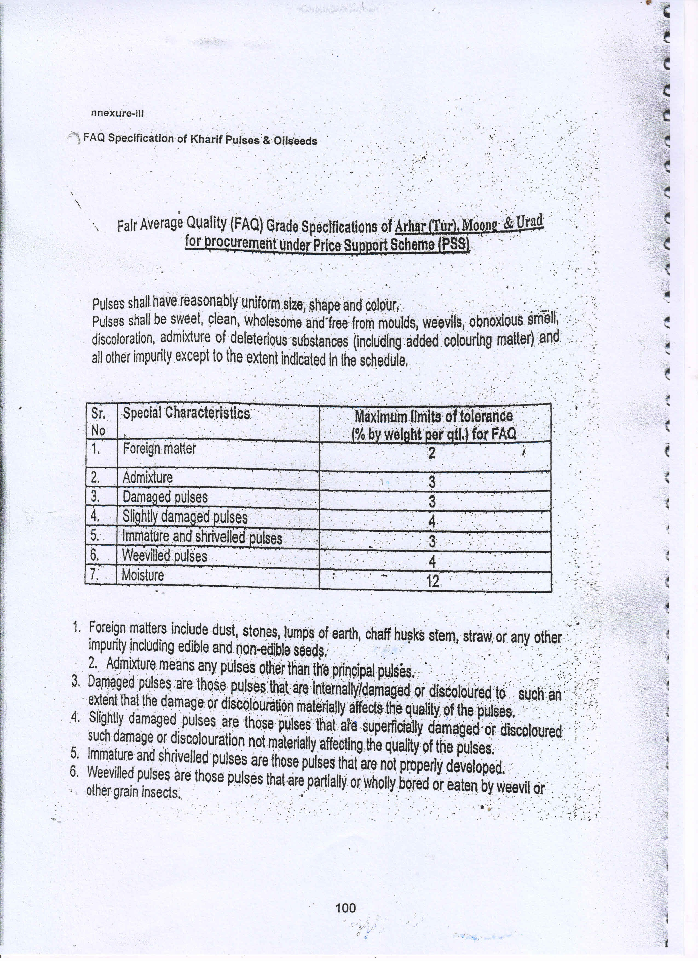

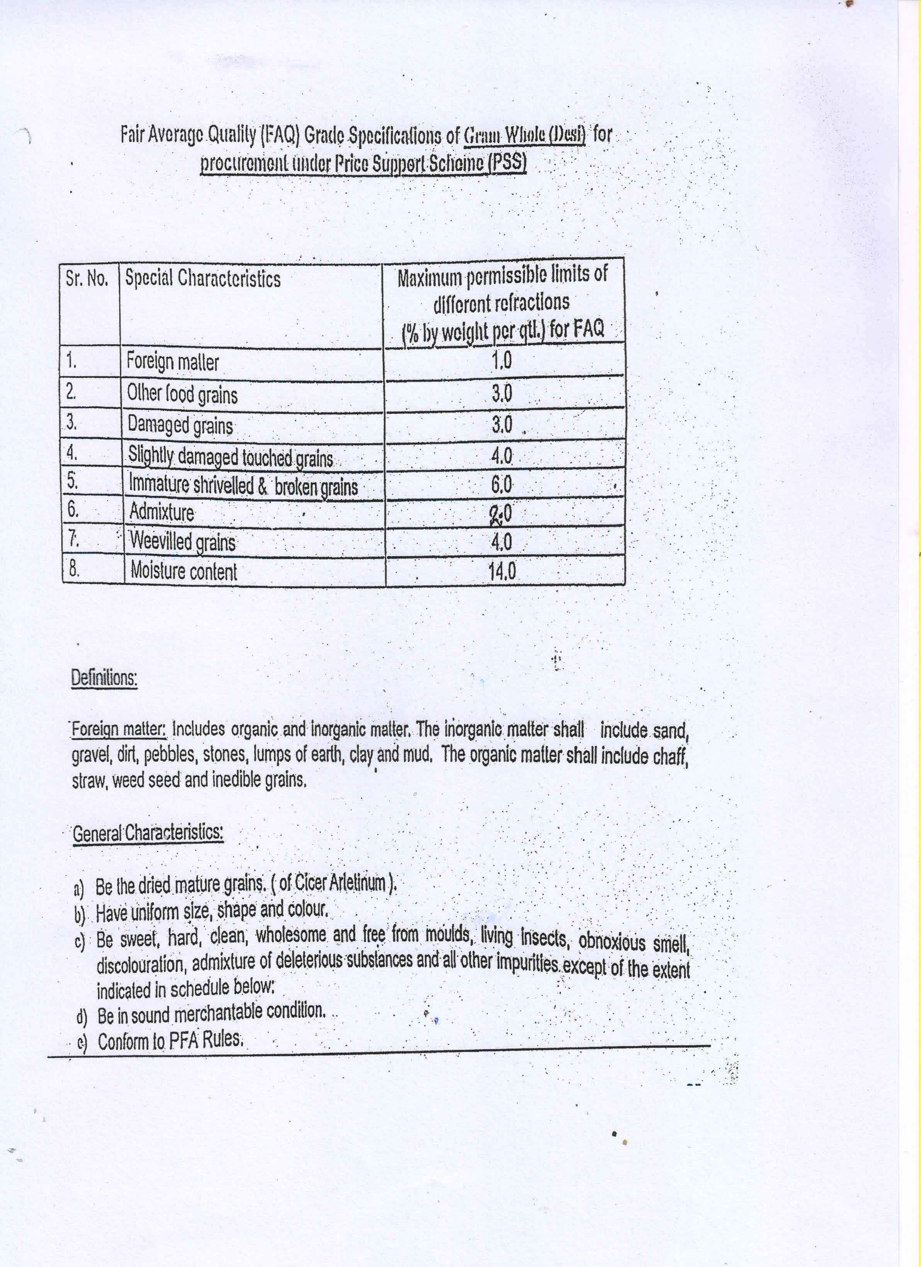

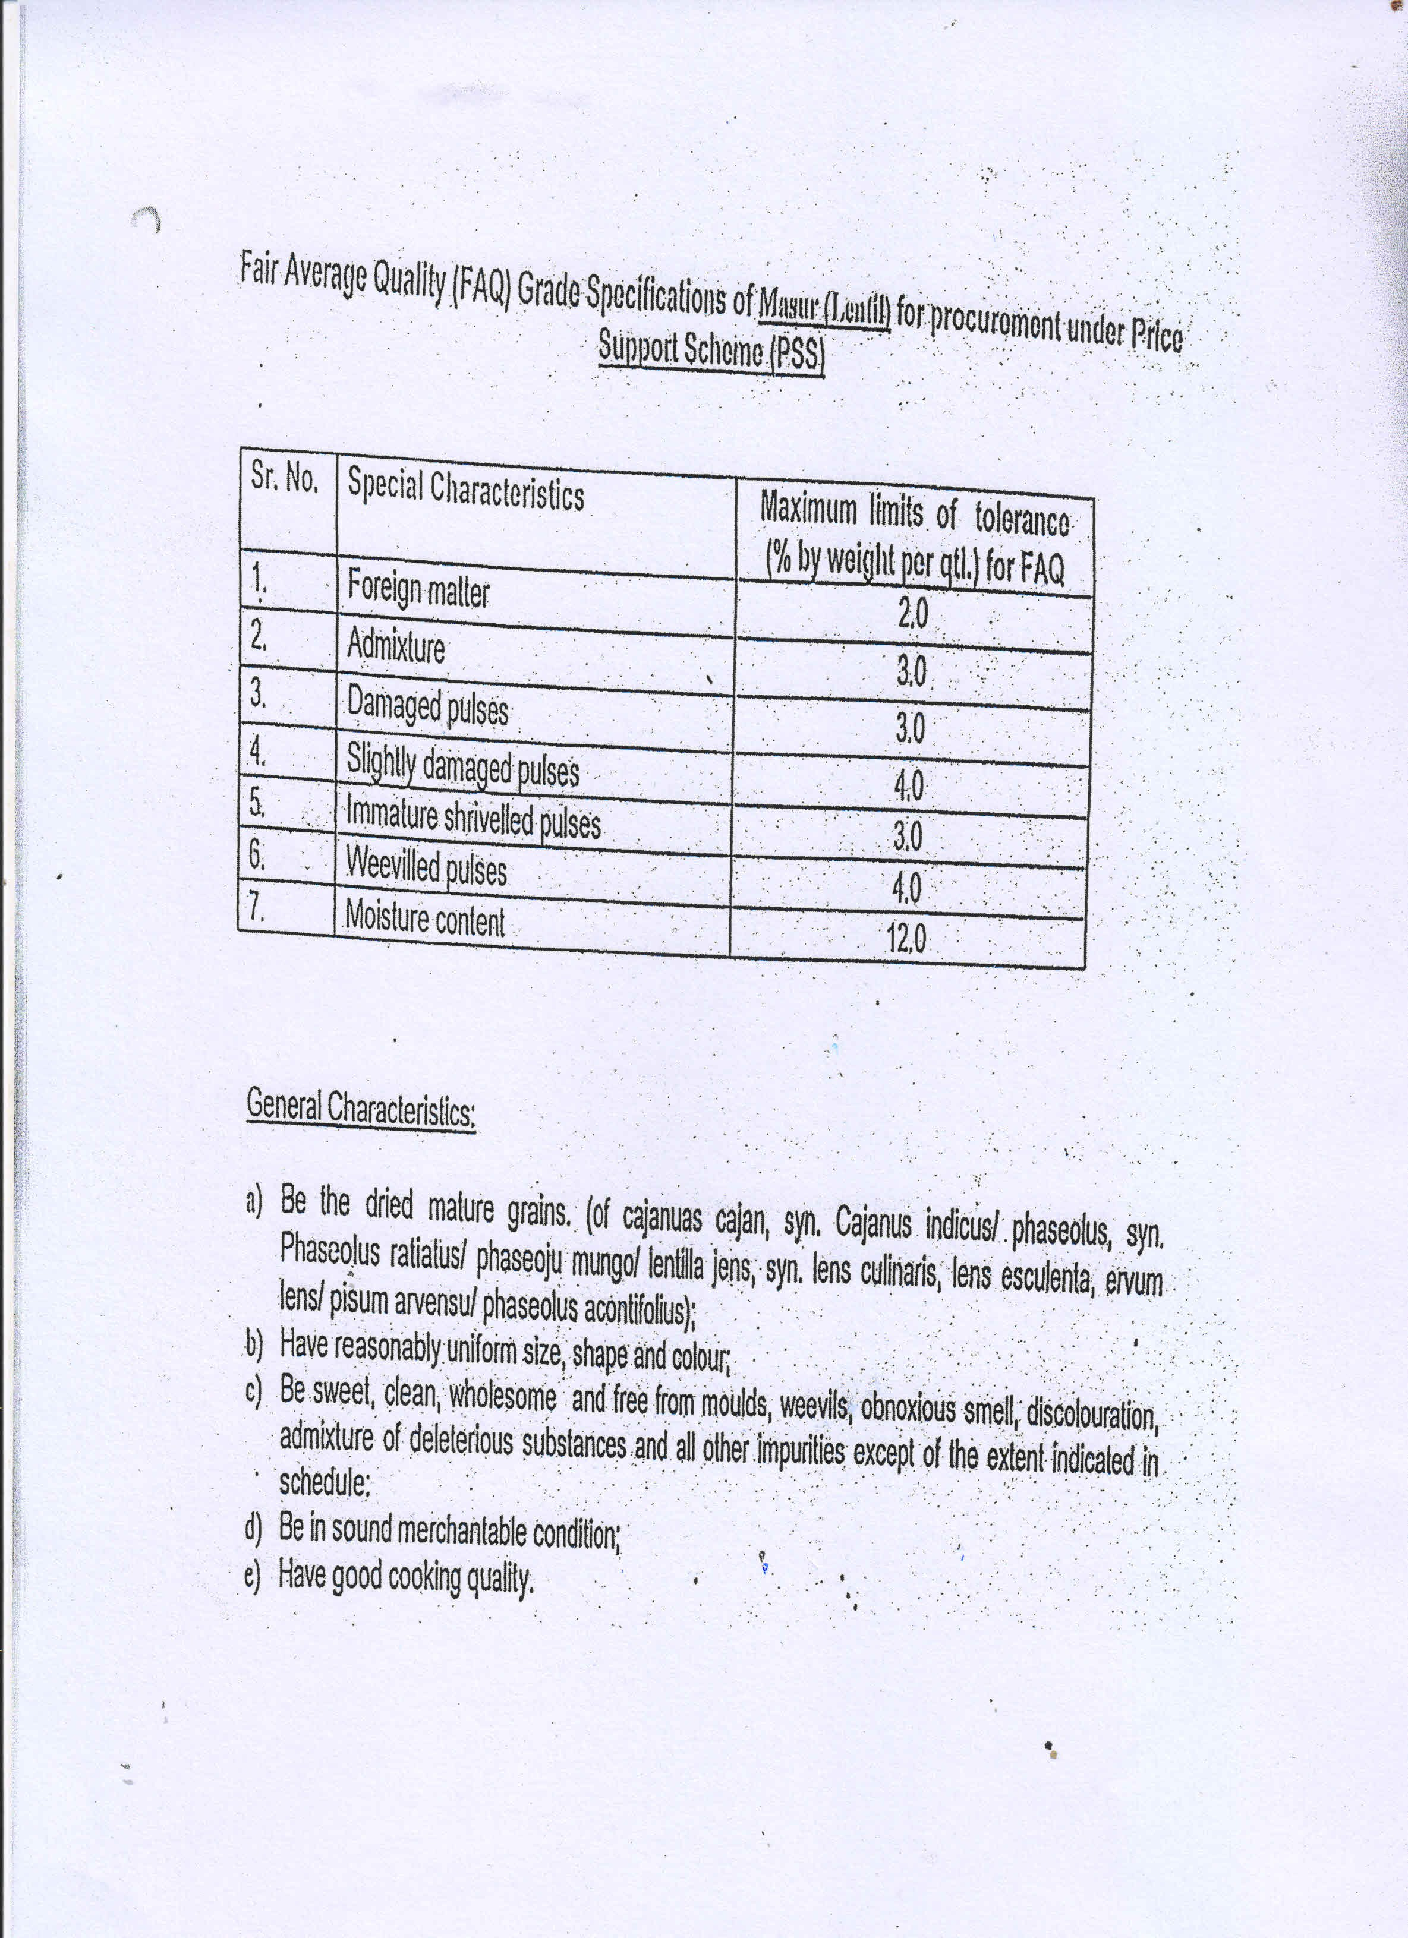

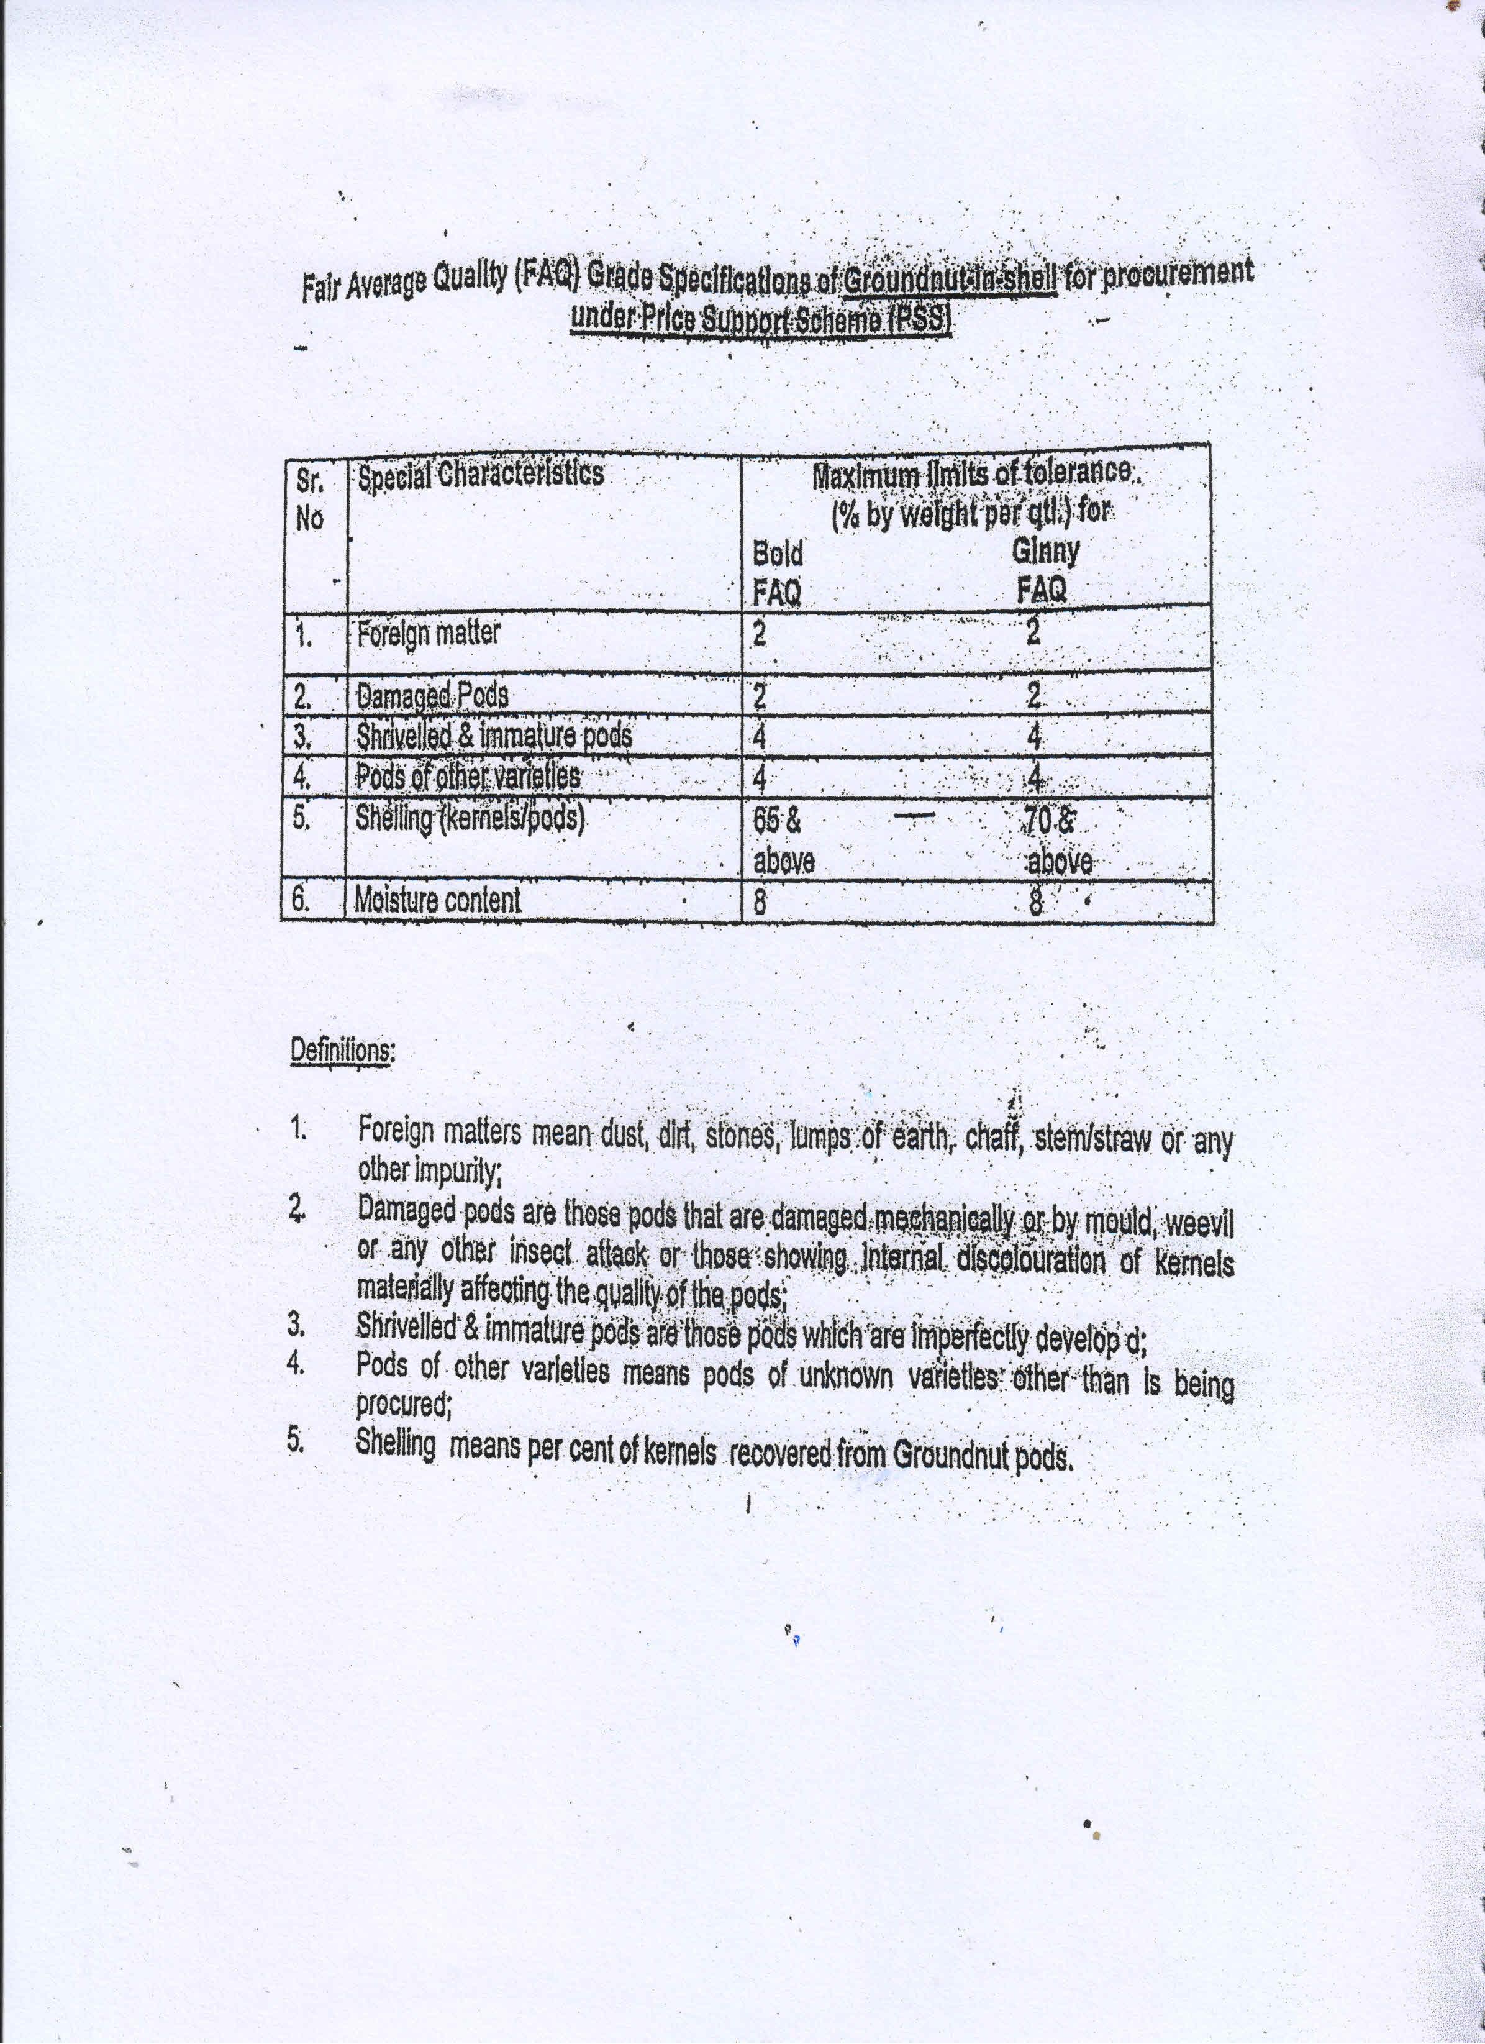

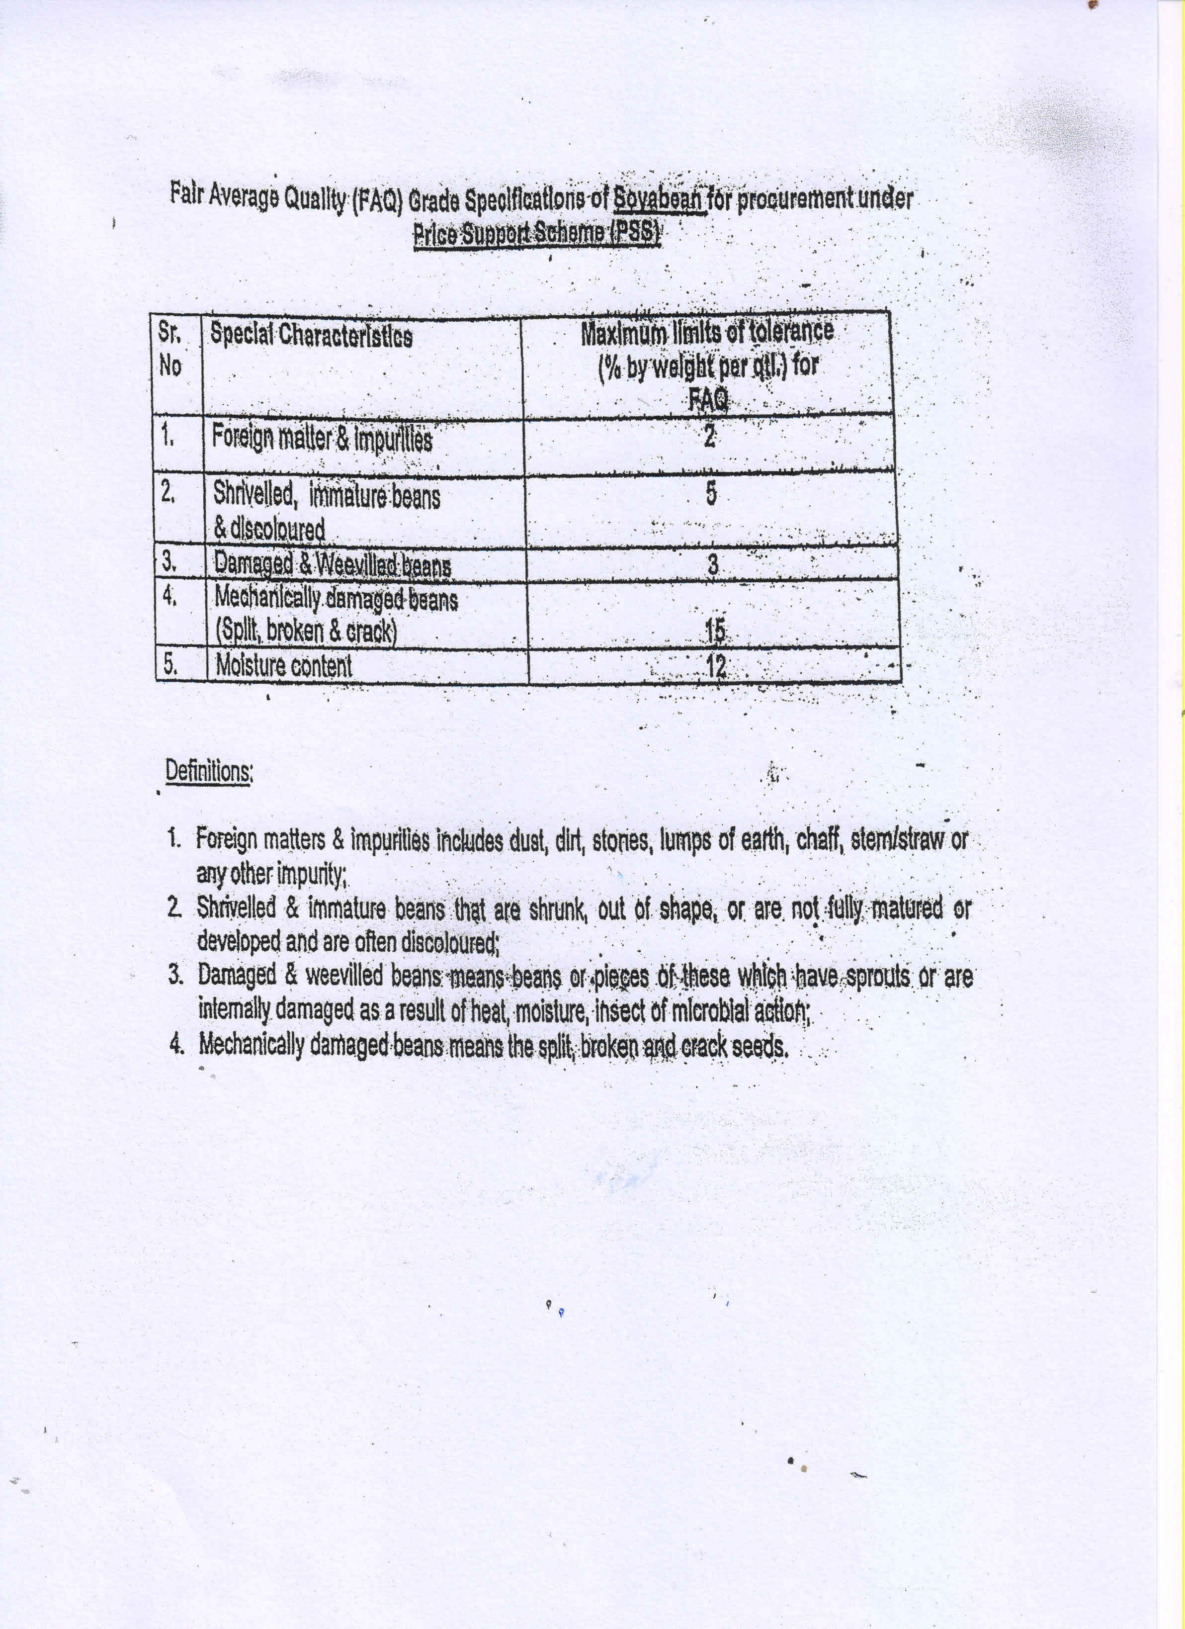

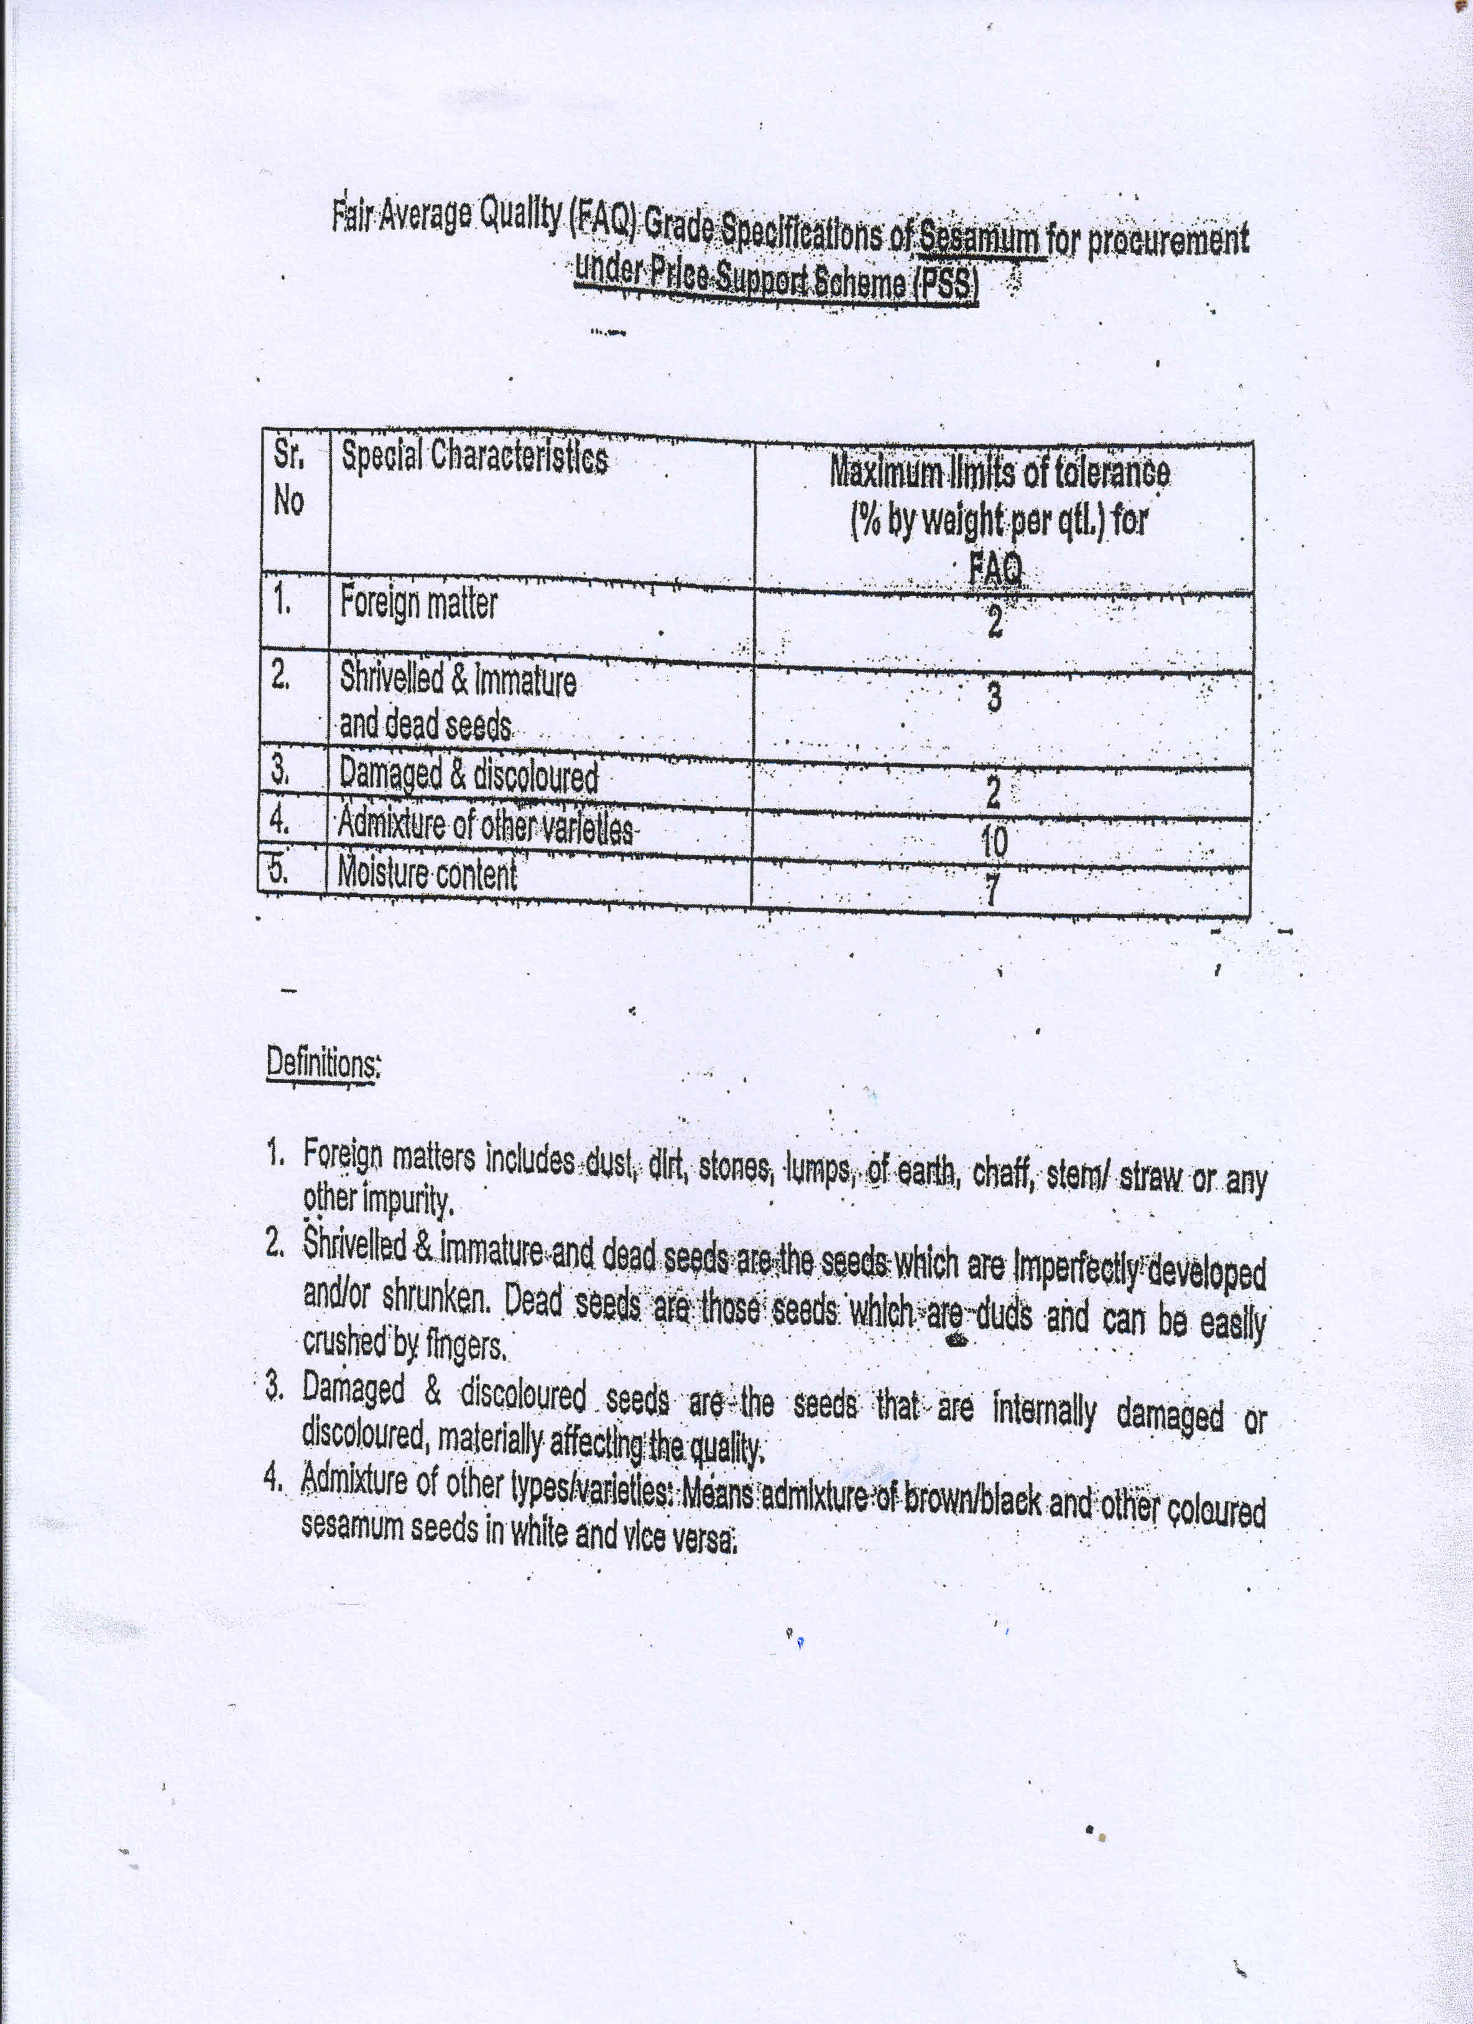

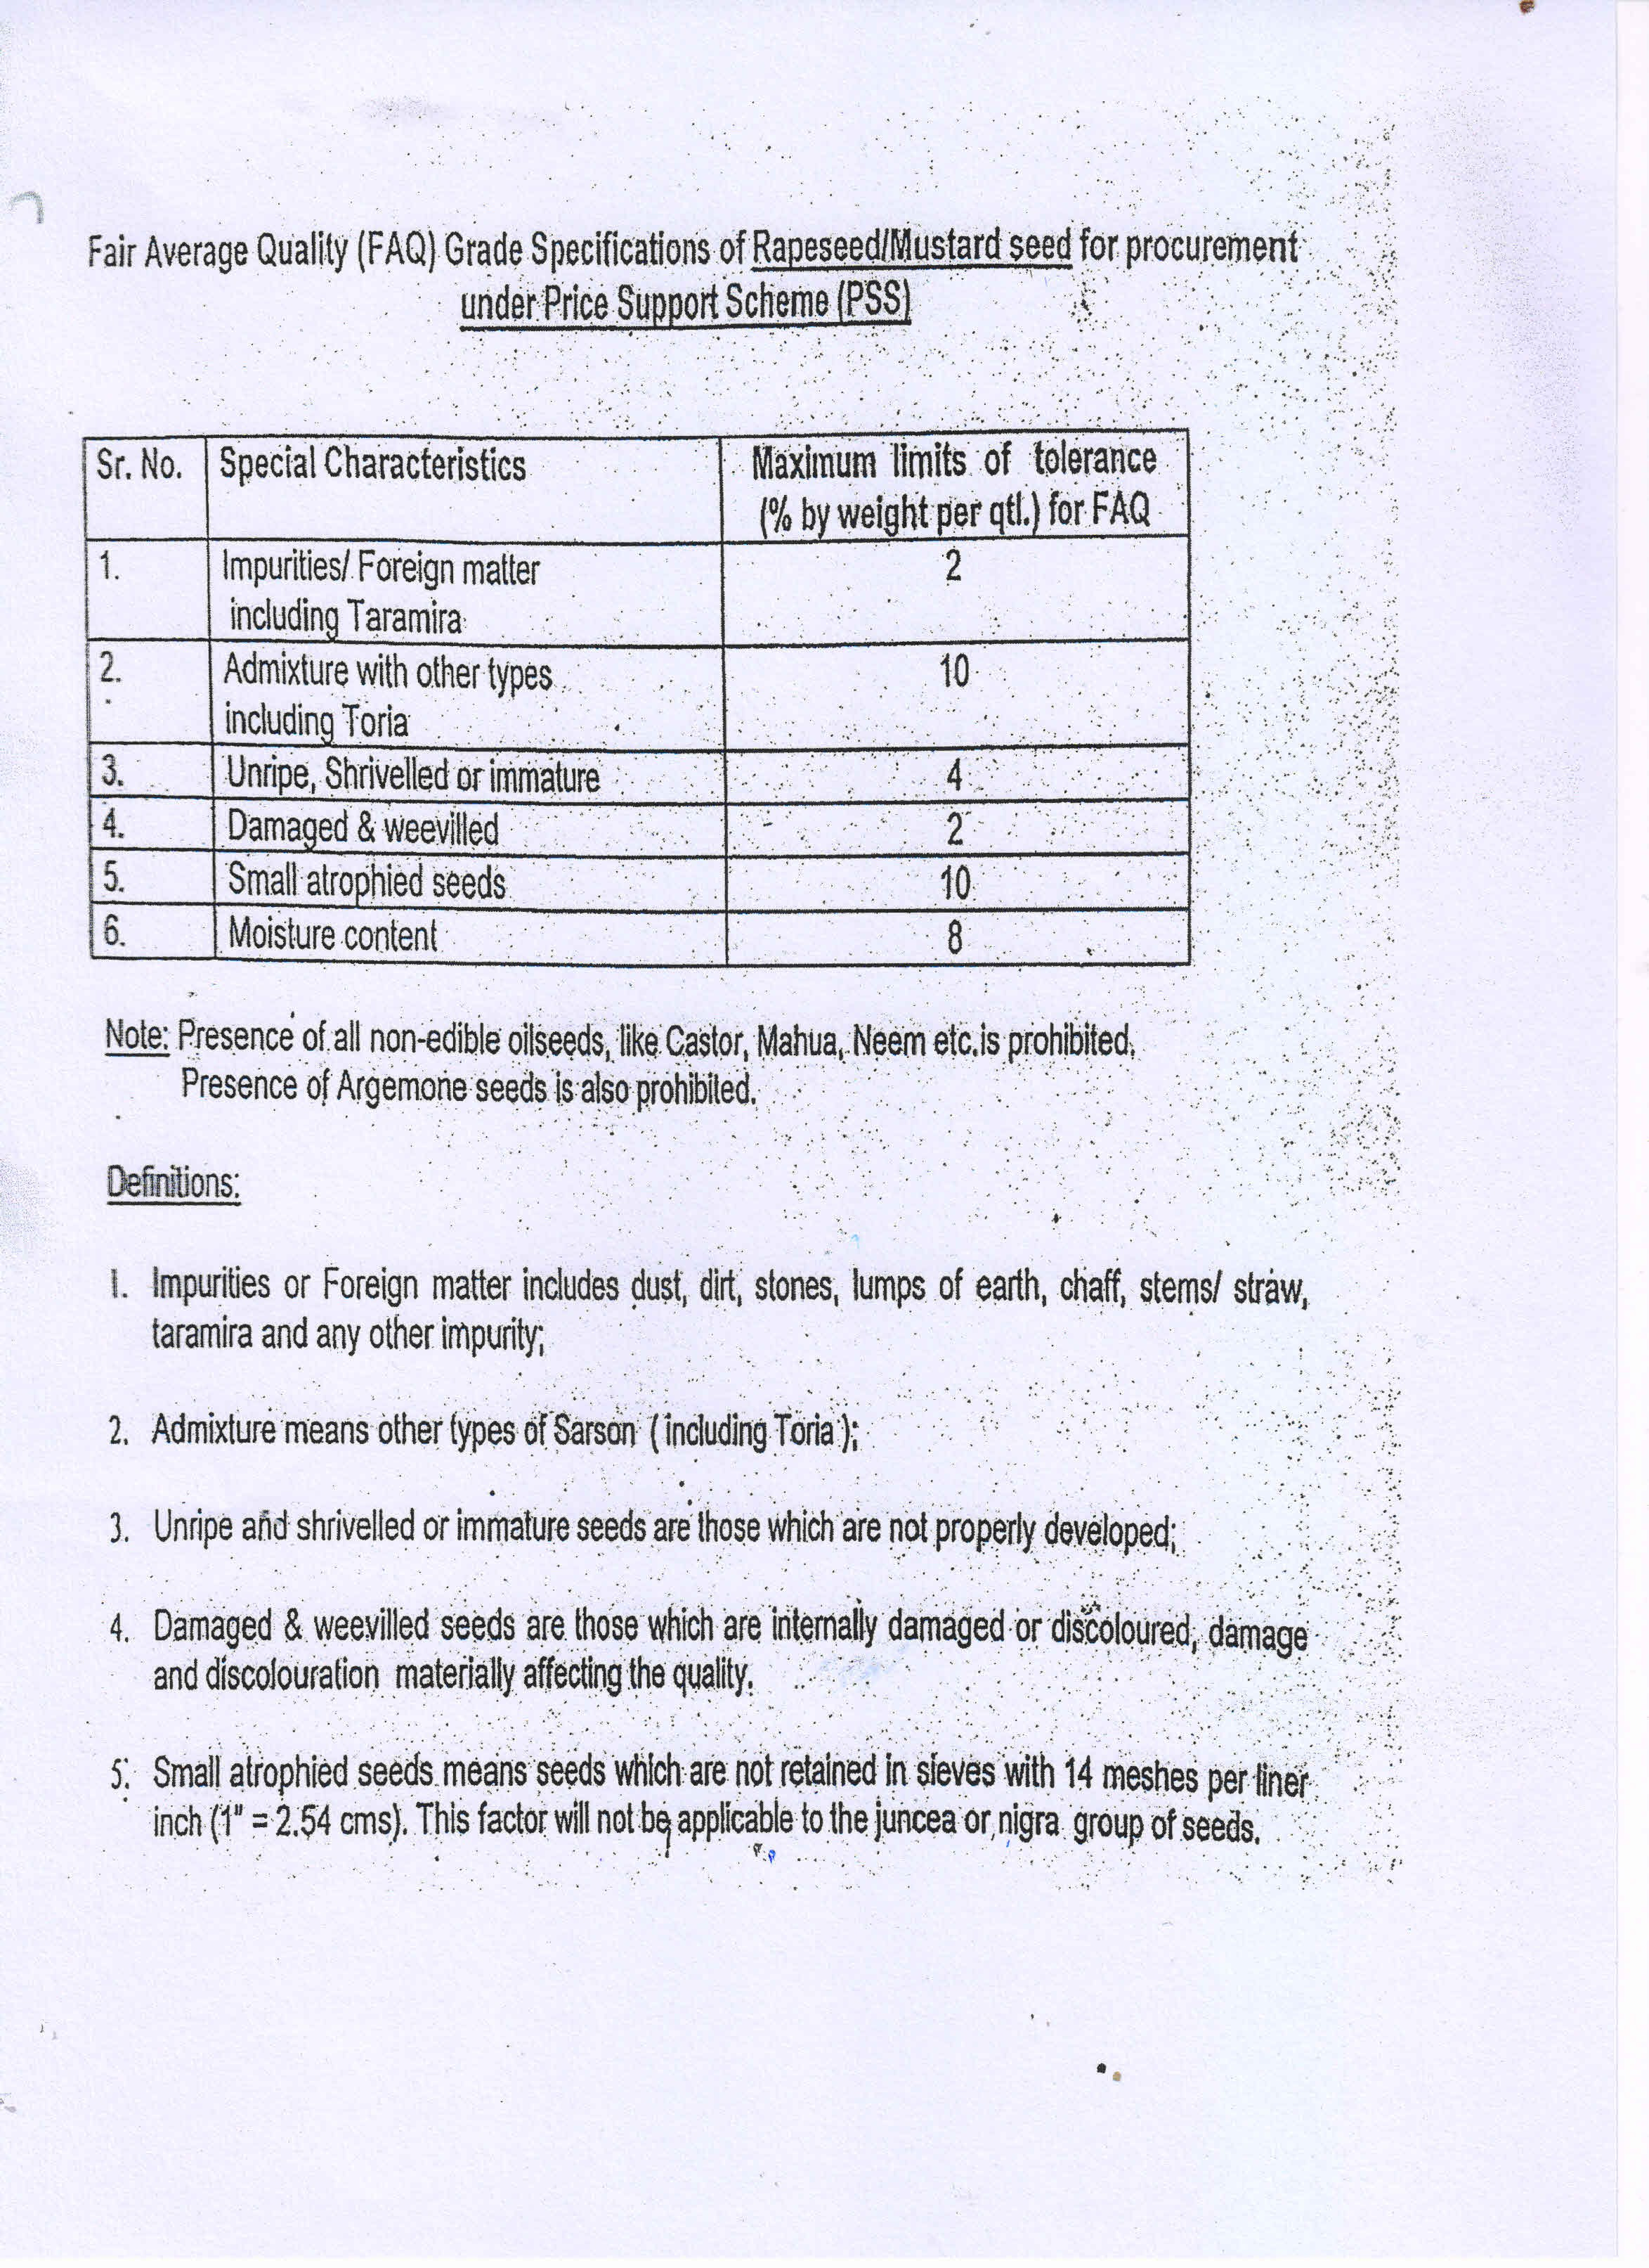

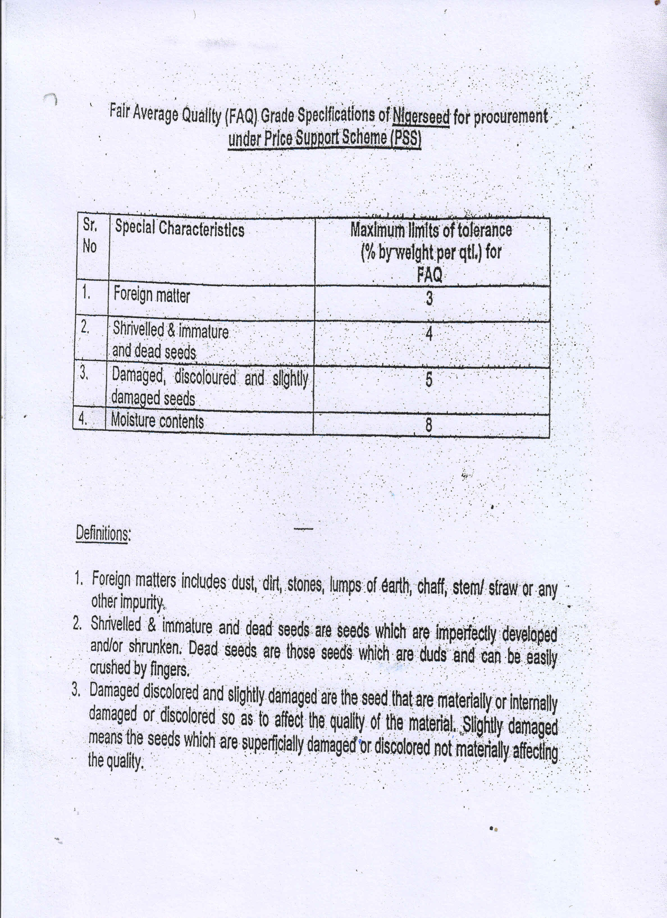

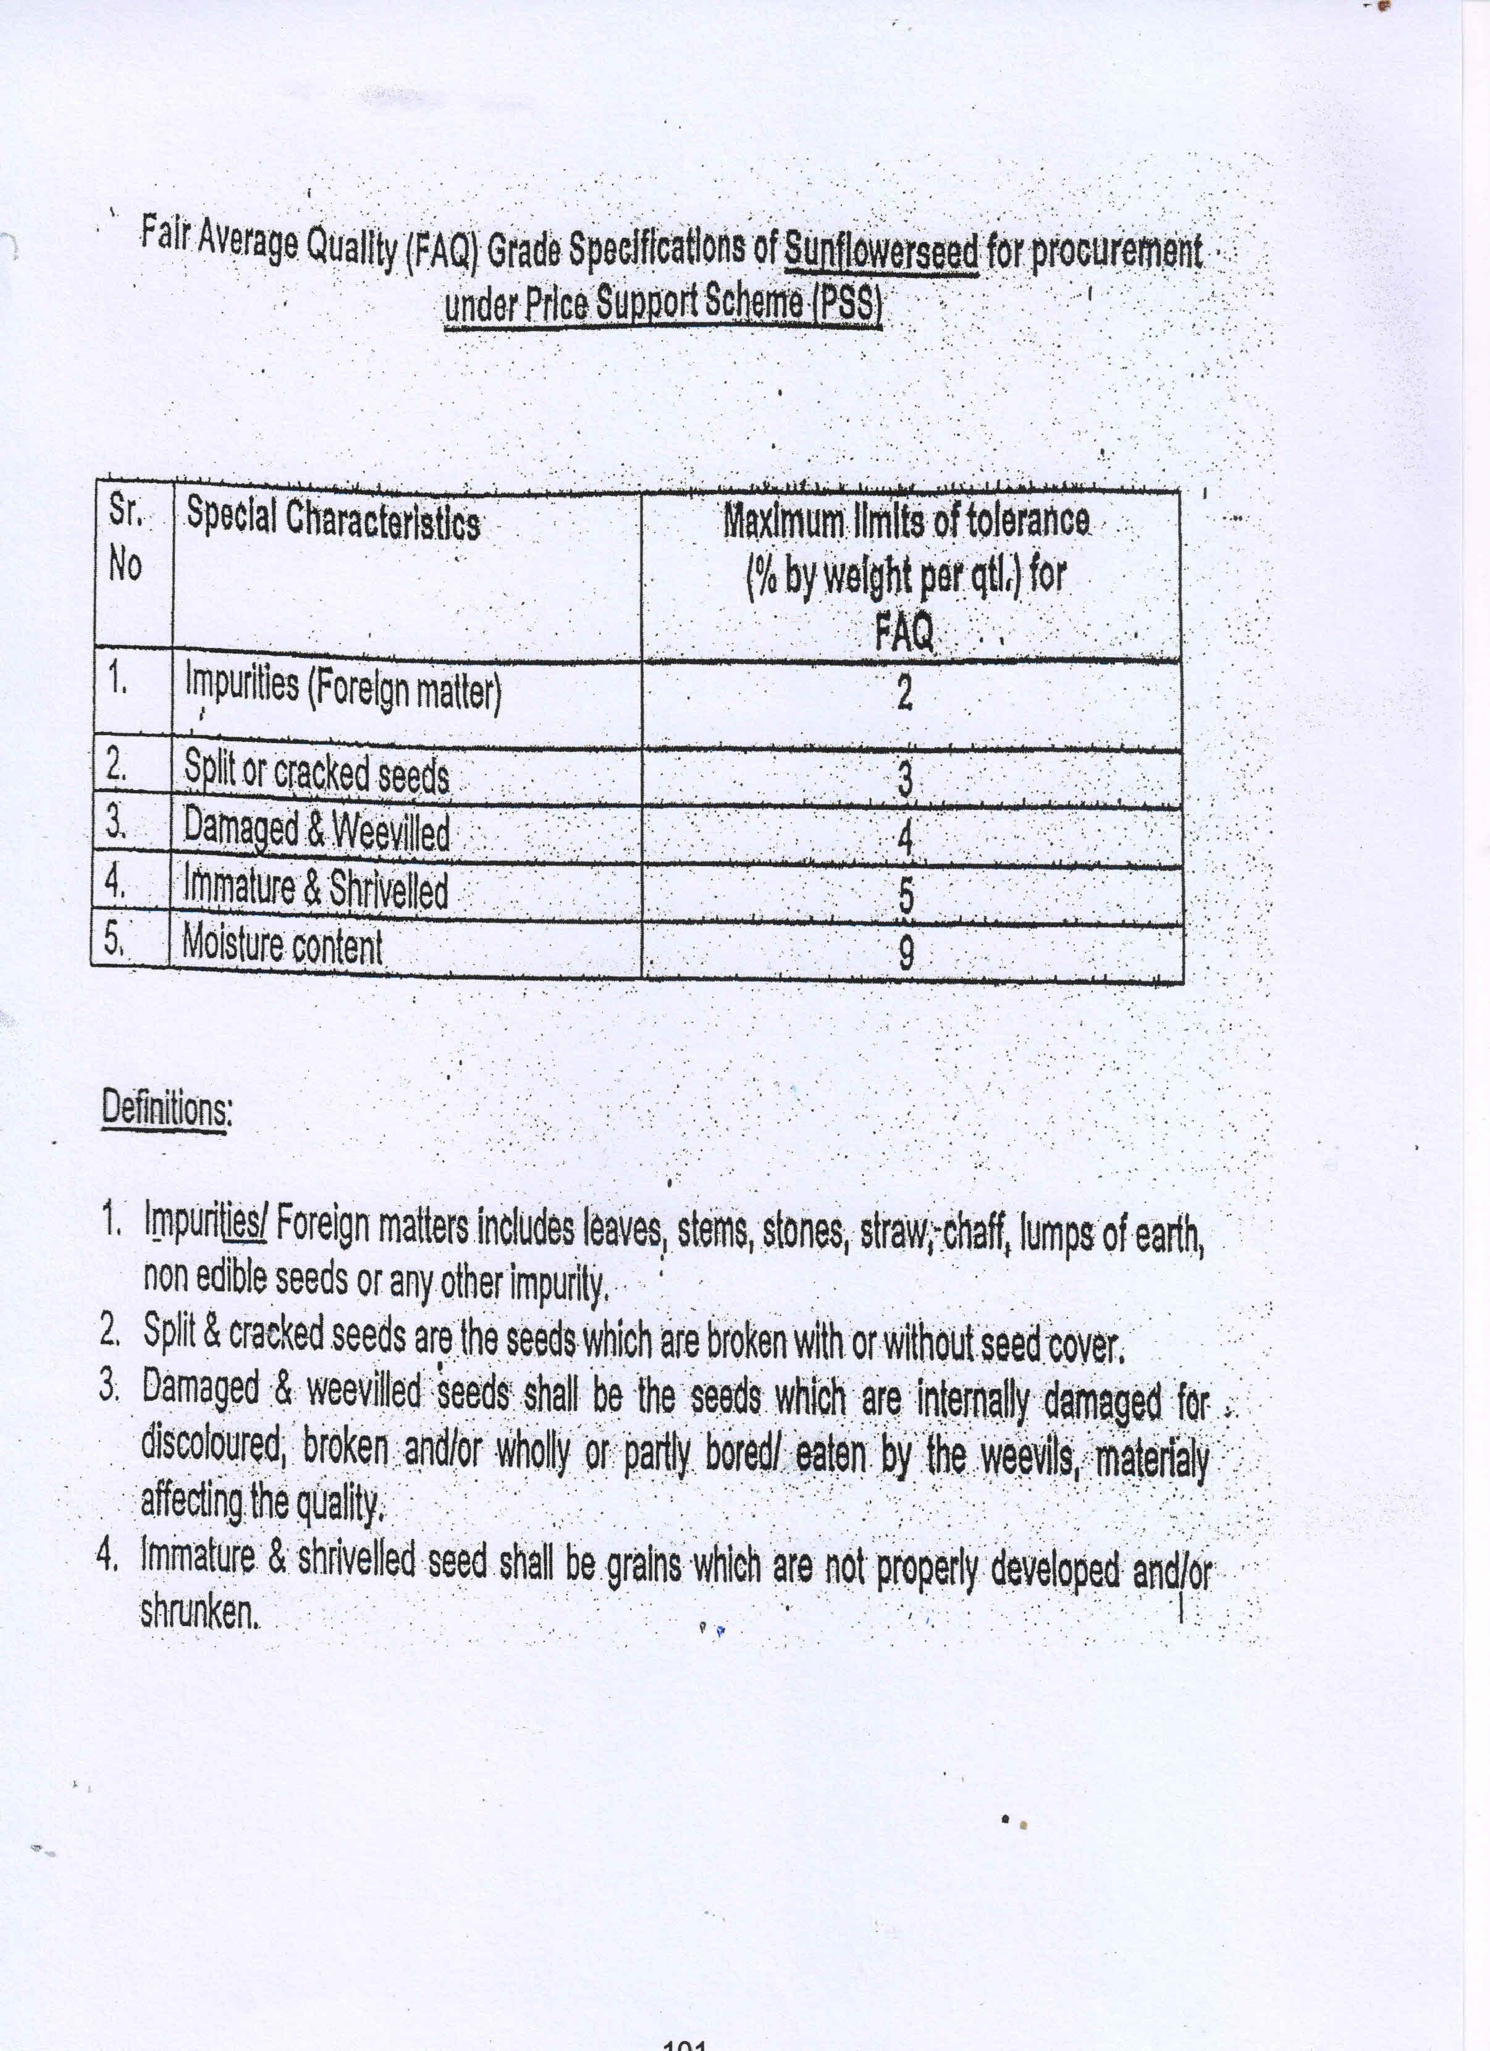

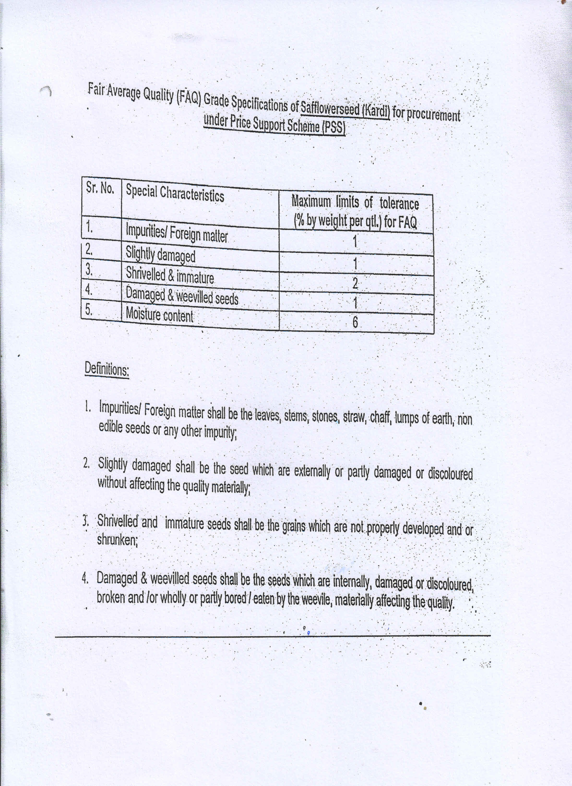

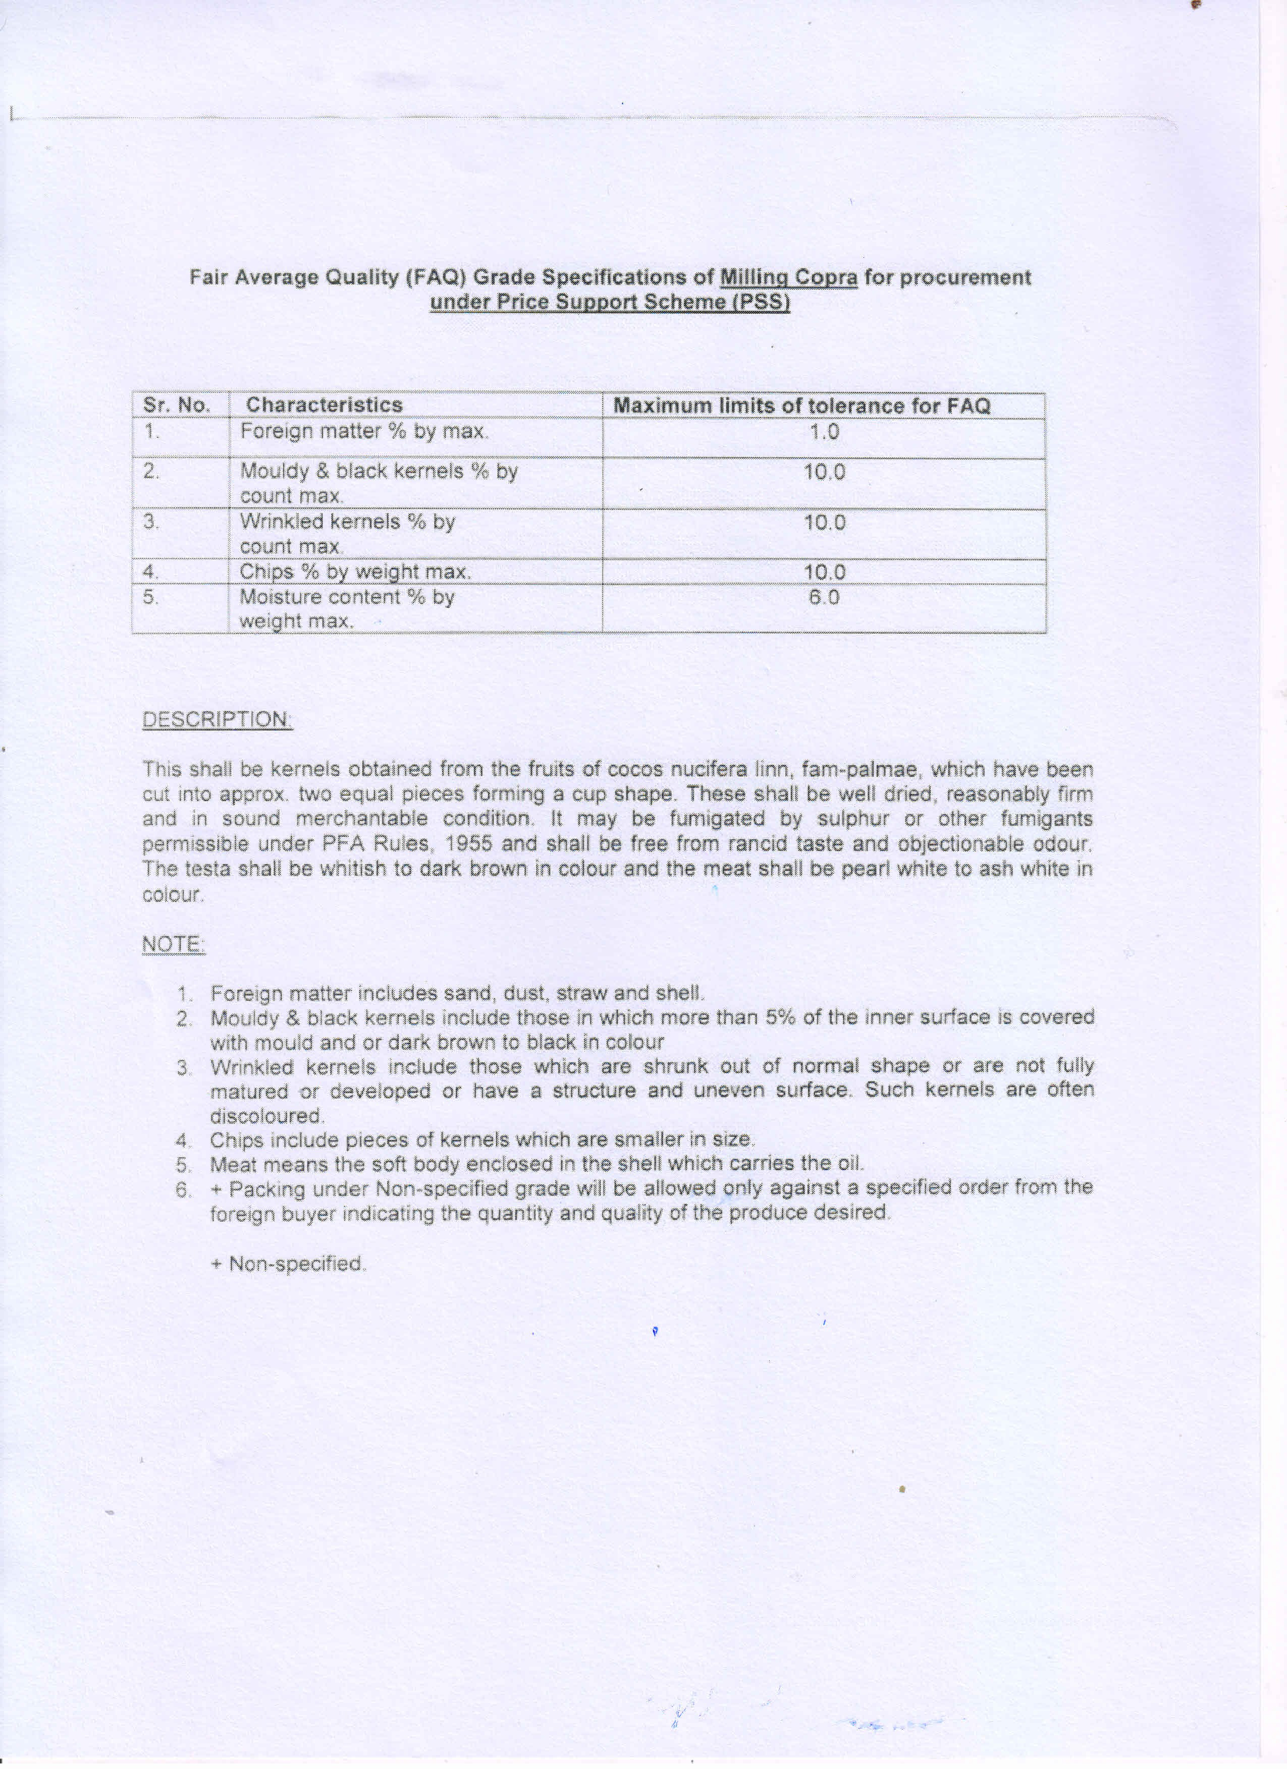

Annexure-II

Quality Specification for Pulses
