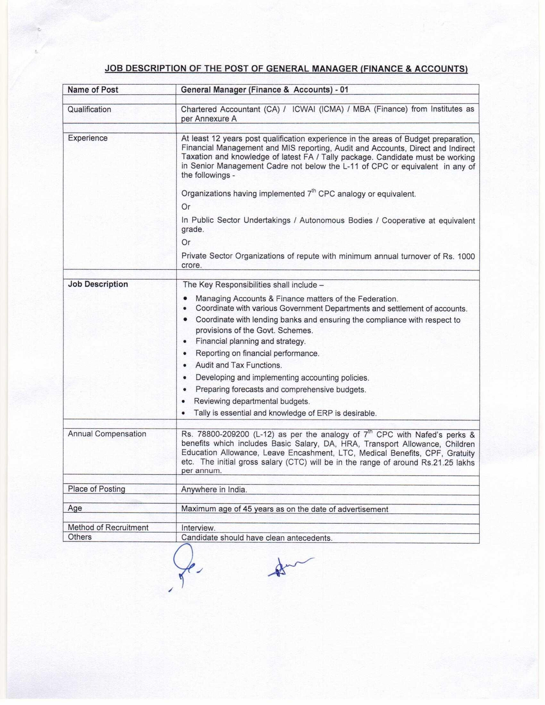

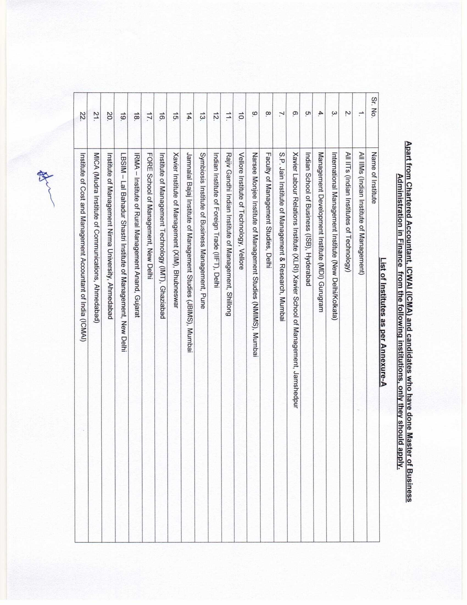

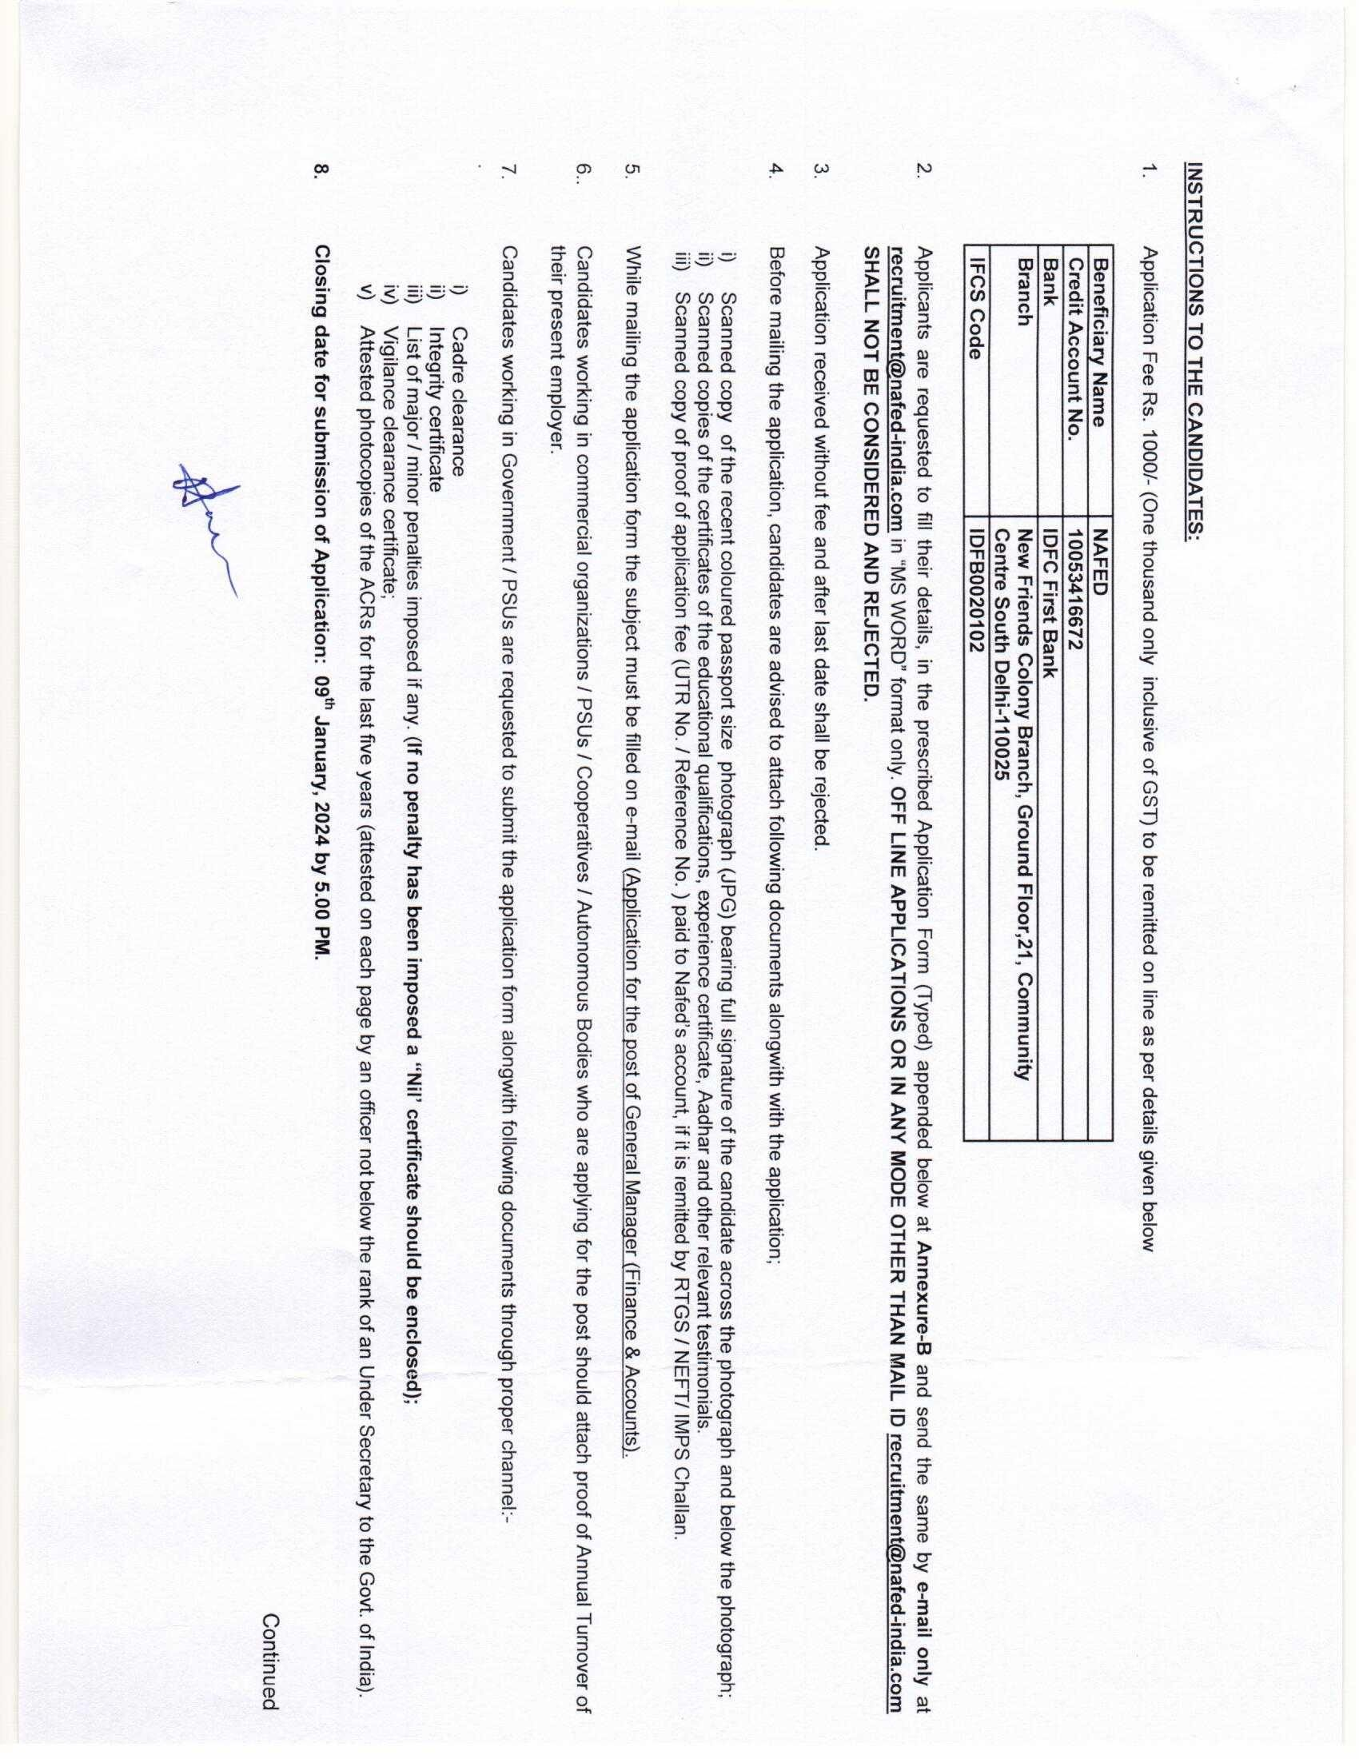

ANNEXURE-B

APPLICATION FORM

APPLICATION FOR THE POST OF _ _

1. Name of the candidate
2. Father’s Name
3. Date of Birth (DD/MM/YYYY)
4. Religion
5. Nationality
6. Marital Status
7. Address / Contact Details:
8. E-mail ID for correspondence
9. Mobile No.
10. Application Fee details (UTR/ Reference No..)
- General Declarations:-
  - Have you ever applied to / worked for Nafed before? (Y/N)
  - Do you have any friends, relatives or acquaintances working in Nafed (Y/N). If yes, state name & relationship

Continued

- Academic / Professional Education Summary: (Starting from most recent)

From (MM/YY) | To (MM/YY) | Degree / Diploma | University / Institute | Specialization / Subjects | Percentage / Grade

- Work / Experience Summary): (Starting from Current/most recent) – for applicants from Private Sector / PSUs / Autonomous / Cooperatives, etc.

Name of Employer | Designation | From (MM/YY) | To (MM/YY) | Nature of duties in detail | Annual Turnover of Employer (Attach the proof)  Rs. in Crore
- Total Experience (In Years & Months):
- Relevant Experience to the post applied (In Years & Months):

- Work / Experience Summary) : (Starting from Current/most recent) – for applicants from Govt. Sector.

Office / Organization | Post held on regular basis | Period of Service |  | Pay Band and Grade Pay / Pay scale of the post held on regular basis |  |  | Nature of appointment whether regular / adhoc /  deputation | Nature of duties in detail
 |  | From | To | Pay in PB | G.P. | Basic Pay & Level as per 7th CPC
Experience to the post applied (In Years & Months):

Annual Gross Salary of Rs. _ _

Continued

  - Declaration:

I hereby declare that all statements made in the application are true, complete and correct to the best of my knowledge and belief. I understand that in the event of any information being found untrue/false/incorrect or I do not satisfy the eligibility criteria my candidature will be cancelled, without assigning any reason thereof. I have read the content of the advertisement and agree to abide by the rules, regulations and procedures for appointment to the post applied for.

Name:

Place :

Date :

  - Disclaimer:

The applicants are required to submit the duly filled application on or before the due date and time, failing which the application of the said applicant shall be treated as non-responsive. Nafed shall not be responsible for late receipt or non-receipt of application/s for any technical reason or whatsoever. The applications received after due date and time shall not be considered.

****************

