Mundeshwari Fed Farmers Producer Company Limited (MFFPCL)
Mundeshwari FedFarmers Producer Company Limited (MFFPCL) was registered on 25/03/2021 under the Companies Act 2013 and has its registered office at village Lalganj, panchayat-Uchitpur, block-Sasaram, district-Rohtas,Bihar-821115. MFFPCL is being promoted by PwC which is empanelled as CBBO under NAFED for supporting CSS schemeimplementation of formation and promotion of FPO in Bihar. The MFFPCL has a strong back up of committed promoters and directors who have farming as the key livelihood activities and ready to engage further into various business activities related to agriculture sector. With proper handholding support the FPC BoDs has been further skilled in terms of marketing and financial aspects of operating an organization or institutional managementthrough comprehensive training and capacity building. The Company has been facilitated for various revenue generative activitiesby facilitating them in undertaking input basedbusiness activities such as seeds & fertilizers; and output marketing as- product aggregation and marketing of produce. The FPC has also planned to undertake primary processing of agricultural produce i.e. cleaning, sorting and grading of the produce, as value addition activities and maximize its revenue in coming days.
Year of Registration | 2021
State | Bihar
District | Rohtas
Block | Sasaram
CBBO | PwC
Shareholder Farmers (Nos)
 | Small Farmers: 113 Marginal Farmers: 293
 | Women Farmers: 32 Tribal Farmers: None
State Category | Plain Area( √) /Hilly Area ( )
Share Capital (INR- Lakh) | 3.87
Business Activities (Summary) | 1. Input Output Business (Wheat seed marketing and procurement and fertilizer sale, black wheat atta marketing, onion marketing)  2. Linkages with Dehaat, ITC, Yara, Adani (under process), IFFCO and local market traders for marketing of input and output.  3. Opening of AC Retail Outlet under process
Area of Success*: | - Black wheat processing and marketing  - Wheat procurement and marketing through linkage with ITC  - Easy availability of quality seeds & fertilizers through input centre of FPC  - E-Commerce sale of agri inputs through Amazon platform
Board of Directors | Male: 4 Female: 1

*Area of Success:Since inception, FPC has been actively involved in supplying of agri inputs and marketing of wheat through ITC based platform. Some of the key areas of success for the FPC has been listed below:
- Black wheat processing and marketing
- Wheat procurement and marketing through linkage with ITC
- Easy availability of quality seeds & fertilizers through input centre of FPC
- E-Commerce sale of agri inputs through Amazon platform

Background
MFFPCL was formed in Lalganjvillage at Sasaram block in Rohtas district. The major crops cultivated within the project cluster are- wheat, paddy, mustard, onion, potato, seasonal vegetables, etc. The cluster covers08 villages with more than 2000 HHs. The total cultivable land in the project cluster has been assessed to be 12550 Ha, largely under cereal crops which are primary crops and seasonal vegetables as secondary crops.

Focus Areas
The project cluster has been dealing with key challenges for small holding agriculture, the most critical being imperfect markets for inputs/product leading to smaller value realizations. This has resulted in higher cost of production and lower viability of small and marginal farms. The lack of easy access to market and authorised dealers and distributors of reputed agricultural input and output companies has been also some of the issues faced by farmers in the project cluster. The FPC will be primarily engaged in 3 key business lines – procurement of farm inputs, marketing of farm produce and extension support services for member farmersConsidering these need gaps, FPC has given prime focus on following potential areas for the betterment of farmers members and also create a sustainable business operation for the FPC.
- Supply of quality and affordable inputs to farmers members
- Produce marketing though aggregation of produce and linking with major players
- Financial linkage development
- Value addition and processing
- Micro-enterprise development

Strategic Interventions undertaken
Keeping this in view FPC has designed following key interventions:

S. No. | Intervention Design | Year of intervention | Solution provided by FPO to the farmers | Systems established in FPO regarding interventions | Stakeholders associated with the interventions
 | Kisan Seva Kendra | 2021-22 | - One stop platform for aggregation of produce and supply of agri inputs- seeds, fertilizers, credits, agro-advisory, etc.  - Quality & timely supply of agri inputs and advisory services  - High quality genuine product from authentic source.  - Fair price of product even during the time of black marketing  - Transparent farmers institution led system  - Live business training ground for PG office bearer and BoDs of proposed FPCs. | - SOP development for input output procurement; handling of day-to-day activities  - Operated through FPC identified personnel with basic training of record keeping and undertaking business activities through KSK  - Monetary benefits identified for the resource person identified to operate the KSK | - Shareholders  - BoDs  - CEO  - CRP/Resource Person  - Company representatives
 | Linkage with major market players | 2021-22 | - FPC has been linked with major market players such as- IFFCO, Yara, ITC, Harvest Plus, etc. for timely and quality delivery of seeds and fertilizers  - Removal of any intermediary through direct sourcing, thus saving of margins  - Reduced risks | - Pre-sowing indent creation for inputs  - Pre-harvest crop volumes determination with output market players  - SOP for aggregation and output marketing  - Proper record maintenance (Online system installation under process) | - Shareholders  - BoDs  - CEO  - CRP/Resource Person  - Company representatives
 | Subsidiary business portfolio | 2021-22 | - For enhancing the revenue portfolio, FPC has divested into subsidiary activities- black wheat flour marketing; fortified seed production; marketing of vegetables under chemical free tag (under process) | - Assessment of market demand for various health orientedproducts such as- fortified grains & flour  - Undertaking key licenses | - Shareholders  - BoDs  - CEO  - CRP/Resource Person  - Wholesalers/ Distributors/ retailers in key markets
 | Value addition Activities | 2022-23 | - FPC has planned for development of AC retail outlet and warehouse (It is under process and will come up by Oct in FY 2022-23) | - Training of key resources to handle the operations of such infrastructure  - SOP development  - MoU with major market players | - Shareholders  - BoDs  - CEO  - CRP/Resource Person
 | Nano enterprise development | 2022-23 | - FPC has planned to identify key women entrepreneurs in the project cluster for undertaking nano enterprises- flour units, mushroom production units, Agarbatti making units, etc. to give income generating opportunities for women-farmers | - Establishment or access of key infrastructure  - Training of key resources to handle the operations of such infrastructure  - SOP development  - MoU with major market players  - Liasioning with govt. institutions | - Shareholders  - BoDs  - CEO  - CRP/Resource Person

Success Mantra
The above interventions has led to various benefits directly or indirectly for the farmers members and FPCs.
S. No. | Intervention Design | Number of farmers benefitted from interventions | Impact - change in income/productivity/cost effectiveness etc | Quote from the farmers benefited through interventions
 | Kisan Seva Kendra&Linkage with major market players | 400 (Share members and other members) | - These multiple and interrelated initiatives have resulted in lowering down the cost of farmer due to bulk procurement and direct sale to FPCs.  Direct Benefits:  - Farmer has earned additional margin of 15%-20% in direct procurement and sale to companies.  - This resulted in additional return to the tune of Rs.2.25 per Kg onwheat marketing  - Availability of quality seeds at Rs.1 to Rs.1.15 lower  Indirect Benefits  - Reduced risk of access to scrupulous agri inputs  - Access to quality inputs would result in enhancing the production by 10%-15%  - Knowledge creation of value addition and quality parameters  - Reduced travel would led to more time availability for farmers and they can be further engaged into other income generating livelihood activities  - Information dissemination on improved technologies and its benefits to enhance production activities

Recognition

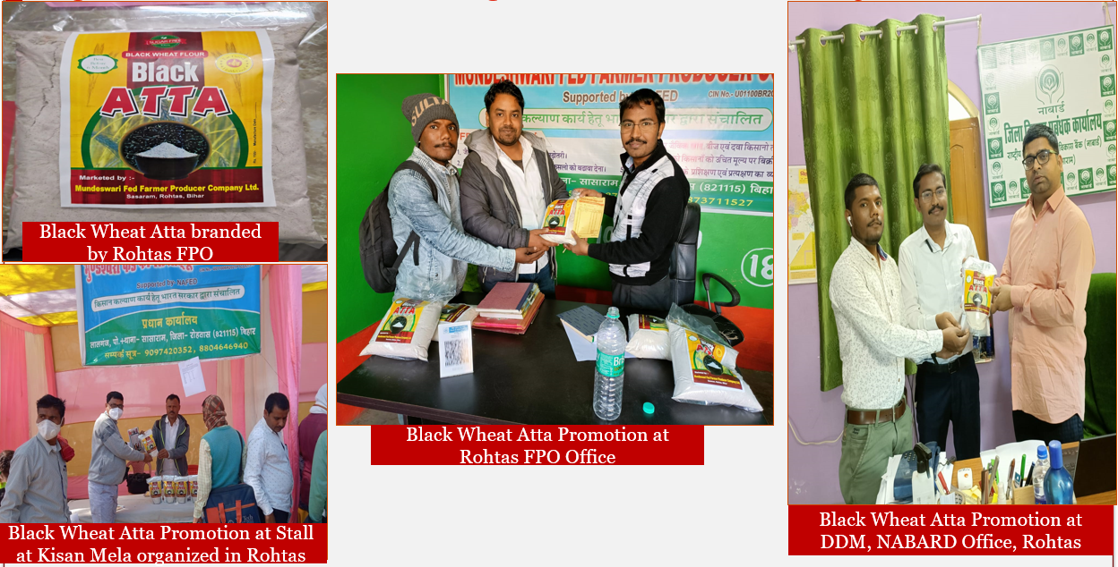

Benefits of the scheme
Promoted under the “Central Sector Scheme for Formation and Promotion of 10,000 Farmer Producer Organizations (FPOs)”the FPC has gained benefits such as- management cost for carrying out day to day activities, recognition by different State Govt. Agencies and private market players and easy financial linkage through banking sector.

Convergence with other Central and State government schemes
The FPC has been linked with existing State Govt. schemes under Department of Agriculture such as- training and capacity building on GAPs, access to quality planting materials from Centre of excellences, promotion of micro irrigation under PMKSY scheme and development of Post-harvest Management infrastructures.

Lessons learnt
The pandemic has invariably provided a key lesson on robust supply chain development for not only easy supply of inputs to the farmers but also transact directly to companies at consumer end. Though the FPC is one year old, but it has envisioned to create an ecosystem of sustainable organization with positive net-worth and a basket of revenue generating activities.

Way forward
The FPC plans to replicate the model at PG level and make an integrated system of supply chain led input -output marketing, develop key Post-harvest management infrastructures and digitise its business activities from end-to-end. This would not only create an effective and efficient system but also a sustainable organization that can serve the farmers in long run and ever changing agriculture market environment and also reduced risk at farmers level. The FPC also plans to develop incubation centres to encourage local entrepreneurs including women for nano and micro level enterprises to make them more empowered.

High Quality Imageswith caption
Kisan Seva Kendra-One Stop Platfrom
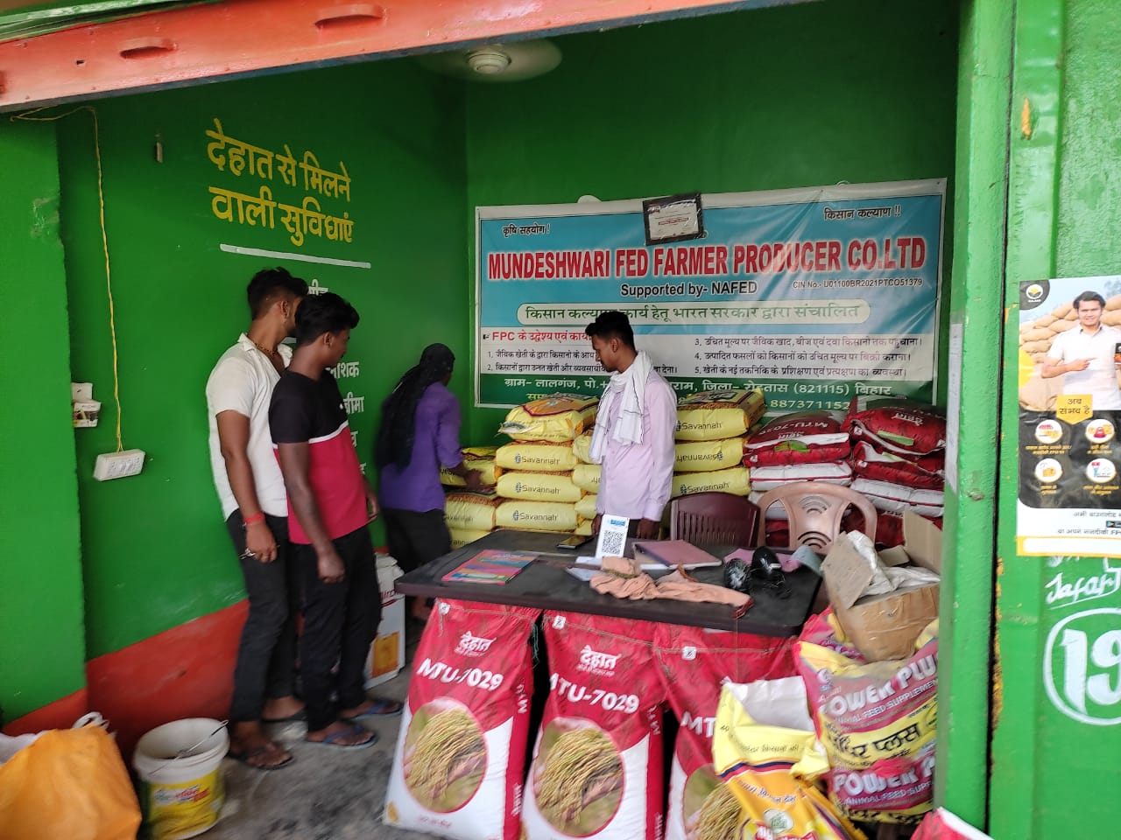
Reach on input to farmers end trough Home delivery system
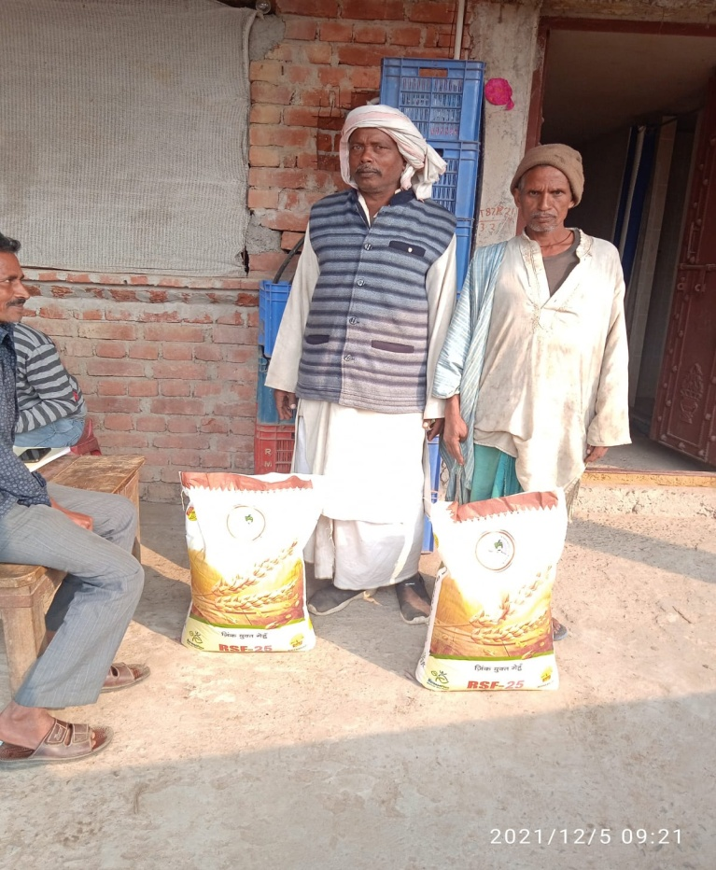 |  | 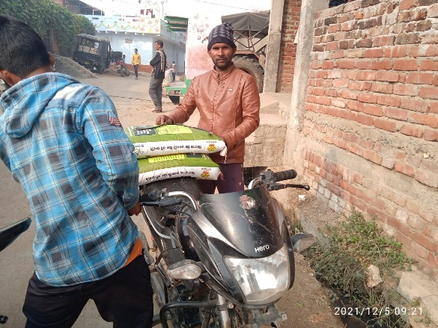  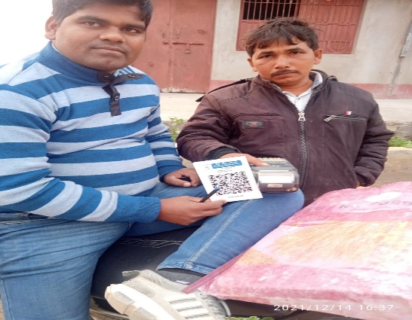
E-Commerce for Agri-Inputs
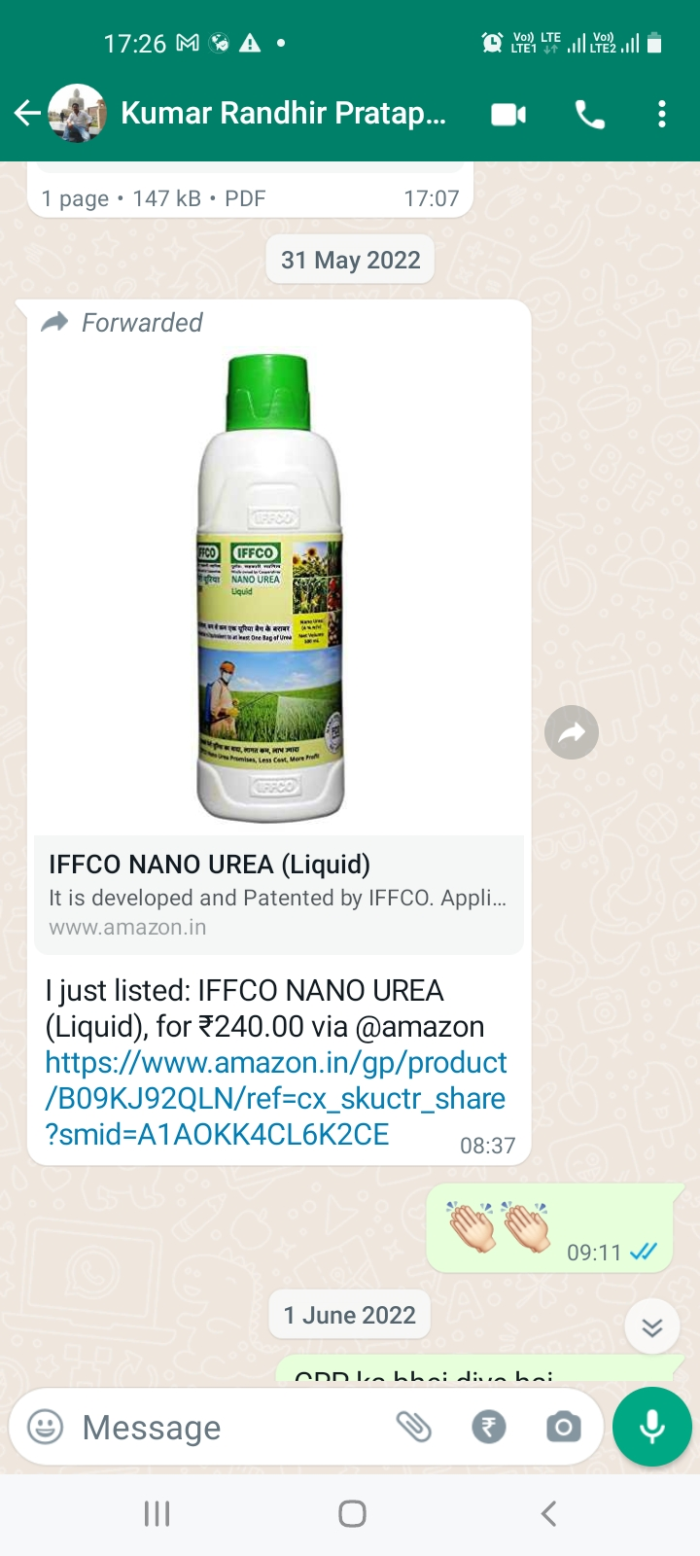 | 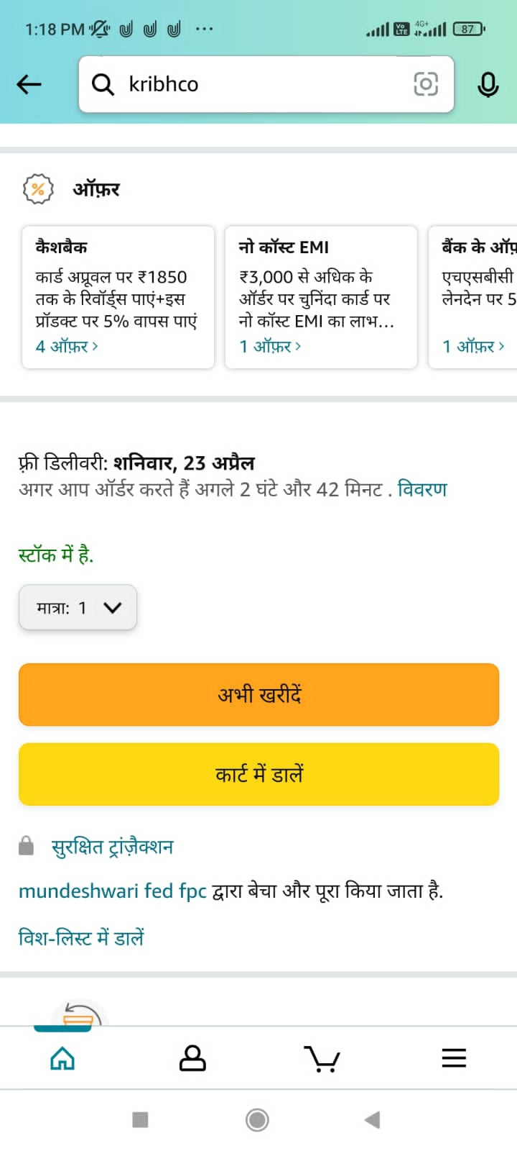
Women operated integrated agriculture system
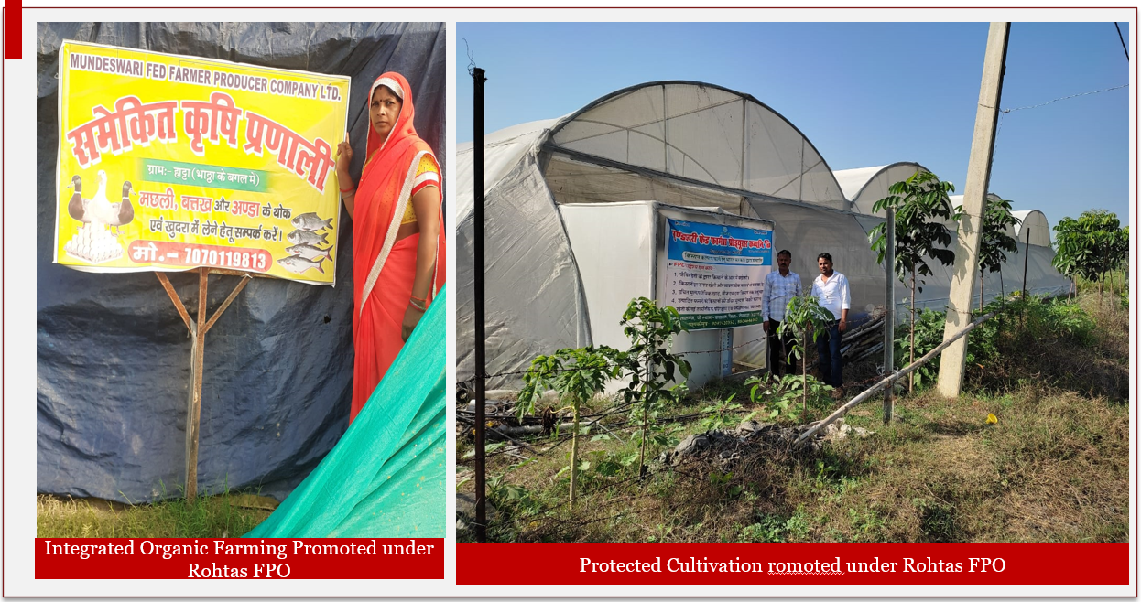

Name and Contact Number
- Chairman BoD, FPO:KUMAR JYOTI PRAKASH; 9097420352
- CEO, FPO: HIMANSHU KUMAR; 6207050162
- CBBO Point of contact:Vikash Ranjan

