MALANADAN FARMERS PRODUCER COMPANY LIMITED
Malanadan Farmers Producer Company is Spices based FPO situated in Nedumkandam block in Idukki district. It is promoted by Bharath Agro Processing and Marketing Co-operative Limited (CBBO) and NAFED and aims to improve the production of organic spices and spices market.
Year of Registration | 1st June, 2021
State | Kerala
District | Idukki
Block | Nedumkandam
CBBO | Bharath Agro Processing and marketing Co-operative Limited (BAMCO)
Shareholder Farmers (Nos)
 | Small Farmers: 360 Marginal Farmers:
 | Women Farmers: 61 Tribal Farmers:
State Category | Plain Area
Share Capital (INR- Lakh) | 3100000
Business Activities (Summary) | Trading of spices like cardamom, black pepper, nutmeg etc.
Area of Success: | Access to Production and Post-Harvest Machinery, Access to Value Addition Facilities, Access to Market Intelligence, Credit Linkages and Market Linkages
Board of Directors | Male: 4 Female: 1

Background
Malanadan FPC is a special product FPO which is based in Nedumkandam block in Idukki district. It is popularly known as “Land of Spices”. The primary product of this FPO is spices. The FPO aims to improve the production of organic spices and spices market. They wish to bring the brand name “MALANADAN SPICES” into the lap of the world. Among the spices, cardamom, black pepper, clove and nutmeg are the focused commodities.

Focus Areas
MFPCL was established in 2021 with a sole goal of producing organic spices and enhancing the spices market inside and outside Kerala. It currently has 360 shareholders and 21 FIGs who are all engaged in spices production.

Strategic Interventions undertaken
- The FPO has successfully engaged all its members in production of spices. They also aim at becoming completely organic spices producers soon. Nedumkandam being a rural and hard-to reach area, this FPO is the ray of hope for the spice producers residing there. This FPO provides a common platform for its members to sell their produce. The FPO is also involved in trading across India and has already sold its products in states like Uttar Pradesh, Rajasthan, Delhi etc.
- The FPO has also started a crop insurance programme under Spices Board and Agriculture Insurance Company of India Limited and has given 45 of its members the opportunity to avail the insurance.
- The FPO is in constant touch with Spices Board and avails all the benefits provided by the board for its members.
- The FPO has constructed a cardamom processing unit and bought machines worth 28 lakhs for the post harvest processing of cardamom.

Success Mantra
Within the span of 1 year, the FPO has clubbed with Spices Board and availed subsidies under the scheme. The main reason for this successful venture is the combined effort of all the farmer members and efficient handling of the FPO by the board members. The FPO is very enthusiastic and always is engaged in some or the other trainings and workshops. The FPO has just started the trading which has benefitted all the 360 farmer members. They had a net surplus of around 7 lakhs in the last few months through trading alone. Almost all the farmers in the FPO are progressive and are ready to take up new challenges.

Recognition

FPC has shared the success story in the Regional Conference of FPOs and CBBOs held at Bangalore to showcase the progress of FPC.

Benefits of the scheme
The FPO has so far availed an Equity Grant of ₹7,20,000 under the Central Sector Scheme for Formation and Promotion of 10,000 FPOs on 1st January, 2022. The FPO is preparing a project report for availing the credit guarantee fund.

Convergence with other Central and State government schemes
- The FPO has availed a scheme called “Quality Gap Bridging Group Programme” under Spices Board in which they can avail a total of 24 lakhs as the project cost.
- They have also availed for a scheme under National Horticulture Mission for an amount of 25 lakhs.

Lessons learnt
The Formation of FPO has helped the farmers of Nedumkandam to come forward and play a key role in the spices market of Kerala. They are now aware of the different central and state schemes and benefits which have been unknown till now.

Way forward
The FPO plans to shift to a completely organic cultivation of spices. It also aims at adding more shareholders and diversifying the products for trade and marketing.

High Quality Images with caption
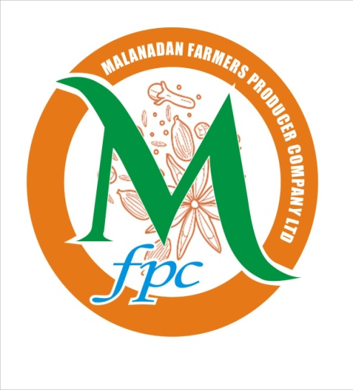
Company Logo and Office of MFPCL

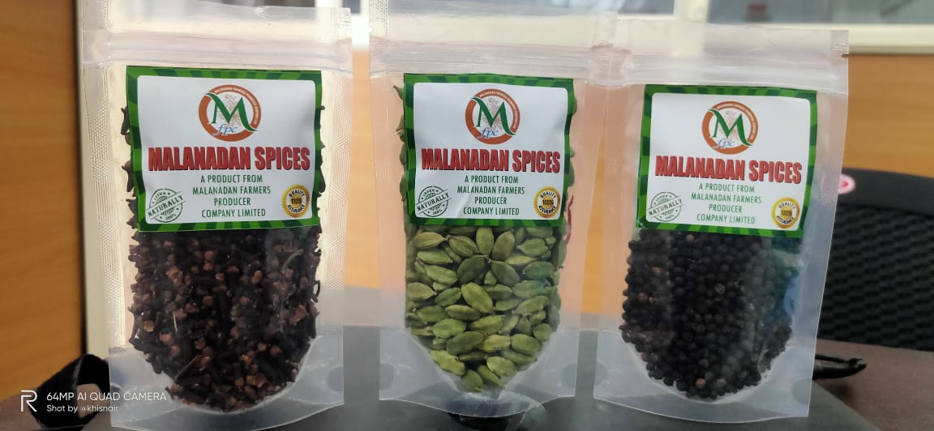
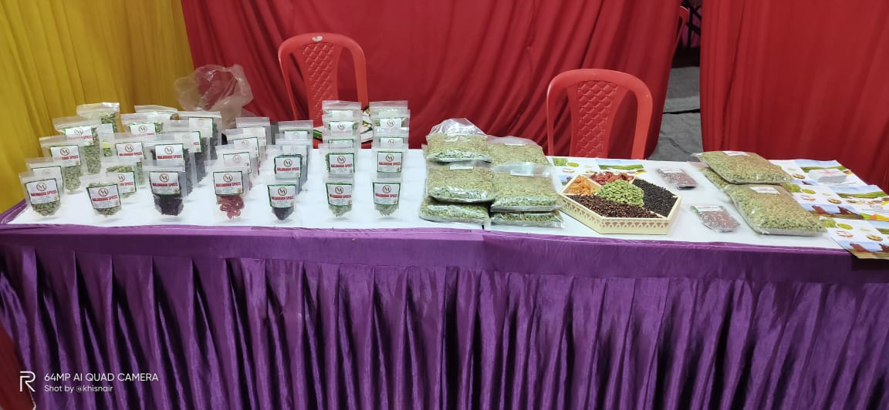
Products of MFPCL for sale

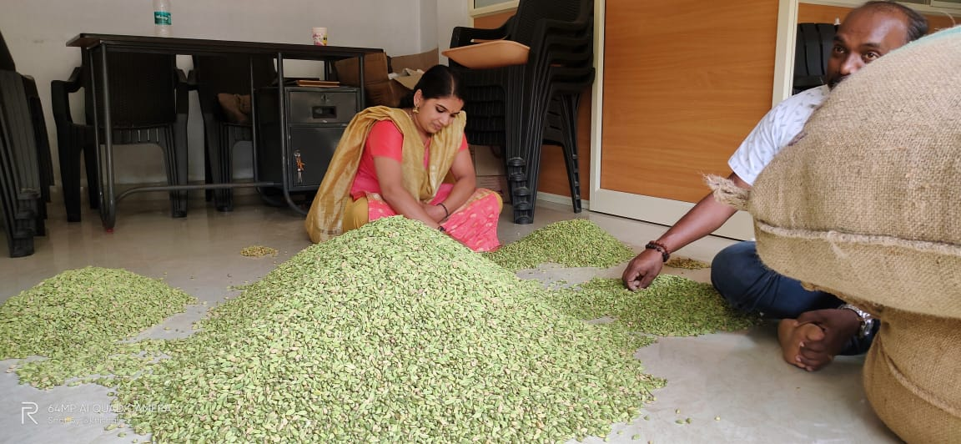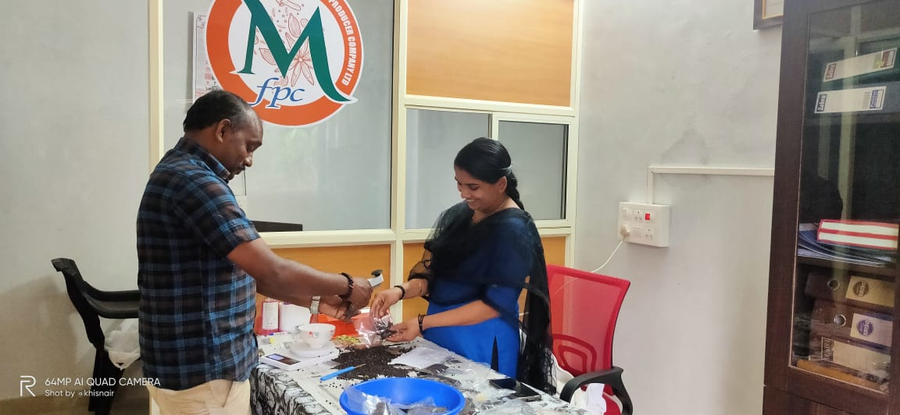
Manual sorting of spices at MFPCL office

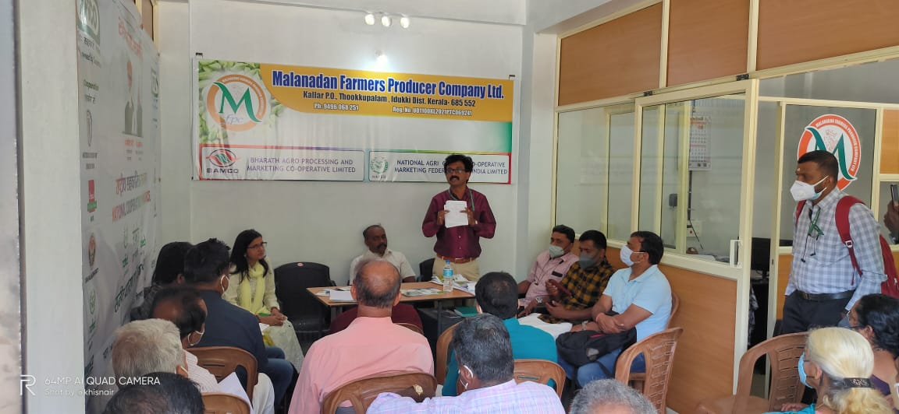
Various trainings conducted at MFPCL
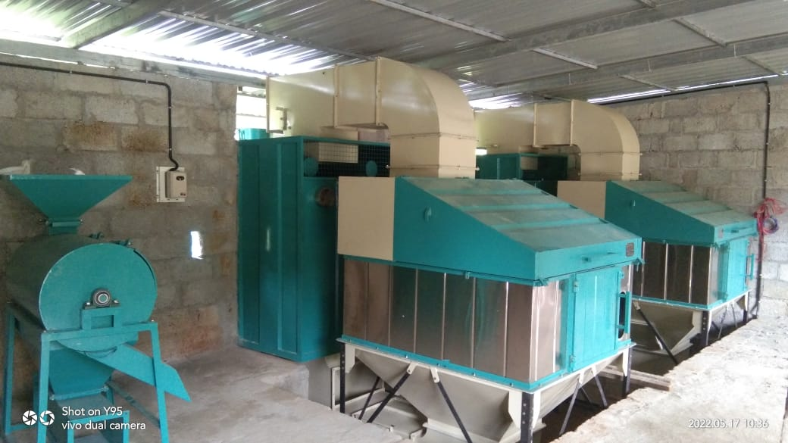
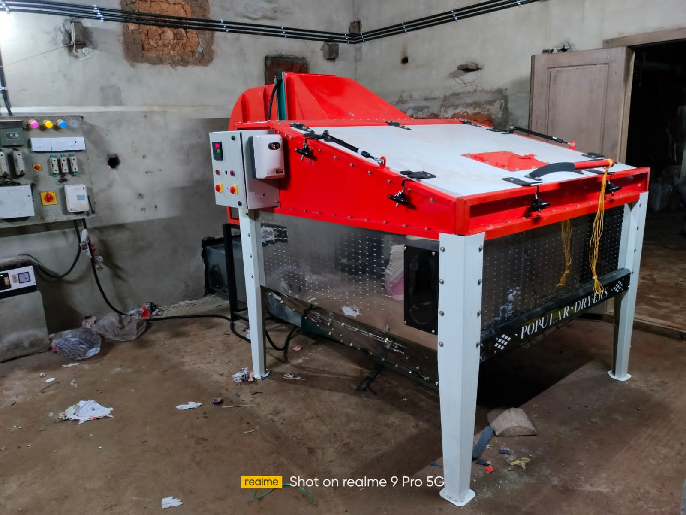
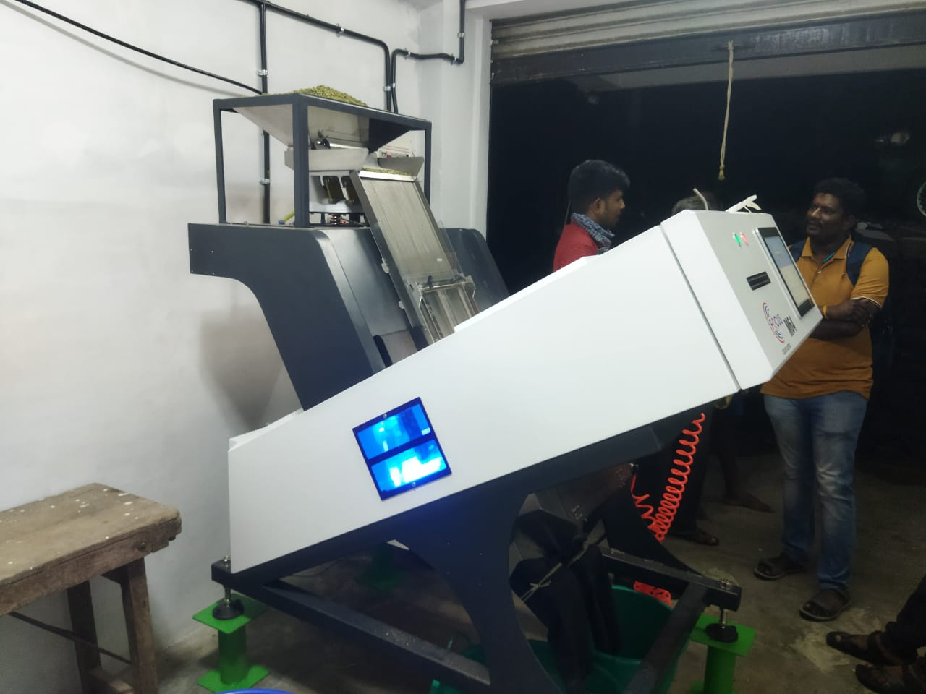
Cardamom Processing Unit

Name and Contact Number
Particulars | Name | Phone Number
Chairman | Mr. Prasannan P.K. | 9567460916
CEO | Mr. Akhilesh Nair | 9746790200
CBBO Point of Contact | Mr. Akhilesh Nair | 9746790200

