IB Agrofed FPC Ltd.
Bankinadi Agrofed Farmer Producer Company Limited promoted by Talento Consulting Private Limited and NAFED is working with the main objective to provide member farmers with better market access opportunities according to their needs.
Year of Registration | 2021
State | Chhattisgarh
District | Jashpur
Block | Jashpur
CBBO | Talento Consulting Pvt. Ltd.
Shareholder Farmers (Nos) | Total Farmers - 389
 | Small Farmers: 80% Marginal Farmers: 10%
 | Women Farmers: 10% Tribal Farmers: -
State Category | - Plain Area
Share Capital (INR- Lakh) | 10,00,000
Business Activities (Summary) | Input Sales, Output Sales, Machinery Services
Area of Success*: | Supply of Quality Agri Inputs, Access to Production and Machinery made available for better post-harvest management, Credit Linkage
Board of Directors | Male: 04 Female: 01

Background
Jashpur block is in the North-eastern corner of the state of Chhattisgarh. The general Climate of Jashpur District is ideal with a beautiful monsoon, a mild summer, and a bearable winter and is surrounded by Gumla, Raigarh and Ambikapur districts. Nagar panchayats of Jashpur are Kunkuri,Jashpur, Patthalgaon and Kotba. Marginal and Small Farmers are dependent on Agriculture in this block.The total Tehsil Agriculture farmers percentage is 17.19 per cent in Jashpur. IB Agrofed FPC Ltd. Deals with different products in Jashpur Block like Fragrant Rice, Ramtil, Arhar, Urad, Peanuts etc

Focus Areas
The focus areas of the Jashpur block are supplying Agricultural Inputs, Processing Crops (Arhar, Urad, Paddy, Maize etc) and is to provide knowledge to farmers about the actual prices of the product

Strategic Interventions undertaken
Farmer Producer Company is bringing to its member farmers the benefit of direct procurement from the market players in Fragrant Rice, Arhar, Urad and Peanuts. Under the leadership of the Board of directors, Farmer Producer Company has developed strategies, planning, and forecasting system.
CBBO has provided Bio-fertilisers for trials on different crops of the block through their input shops and also provided seeds varieties which give high yield, agriculture machinery like – Tractors, Power tillers etc.

Success Mantra
- The number of farmers who benefitted from interventionsis200 member farmers and 100 non-member farmers.
- Farmers’ income increased by 6-8%.
- Improve Quality produce and market linkages.

Benefits of the scheme
FPC has applied for the matching equity grant of 7,74,000 Lakh under the “Central Sector Scheme for Formation and Promotion of 10,000 Farmer Producer Organizations (FPOs)” in 2022. FPOs evolved as new generation producer-led organizations, to help them receive the benefits of cluster development and economies of scale. This ecosystem can be improved with various types of services made available for farmer members at the right time and a reasonable price. The FPC has started their outlet for the produce to help the farmer member of the FPO.

Convergence with other Central and State government schemes
FPC is planning to apply for different Schemes like Agriculture Infrastructure Fund (AIF) and Scheme of Fund for Regeneration of Traditional Industries (SFURTI),State Agriculture Marketing Infrastructure Fund (SAMI)

Lessons learnt
Small and Large Farmers are getting benefits from these FPO models and having improvement in their socio-economic circumstances. Farmers are receiving reasonable rates for their products.

Way forward
The FPC is planning to set upa processing plant under different schemes to avail credit guarantee fund.

High-Quality Imageswith the caption
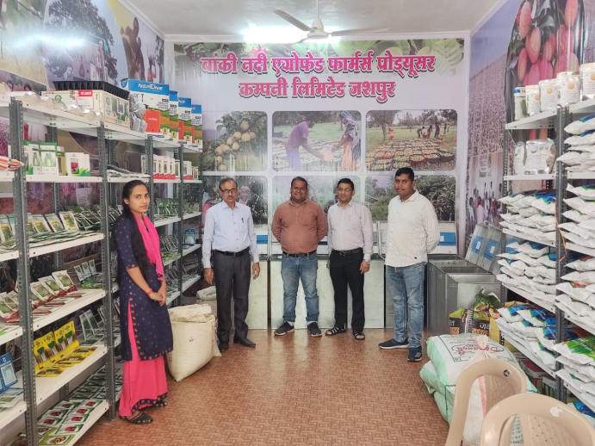

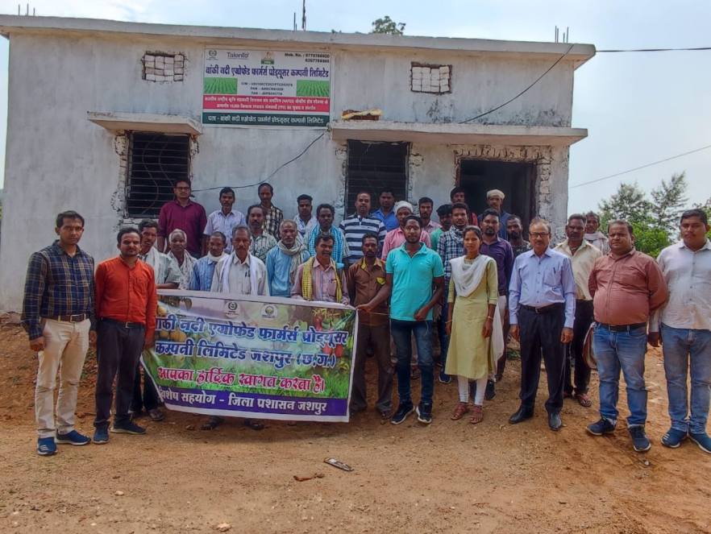
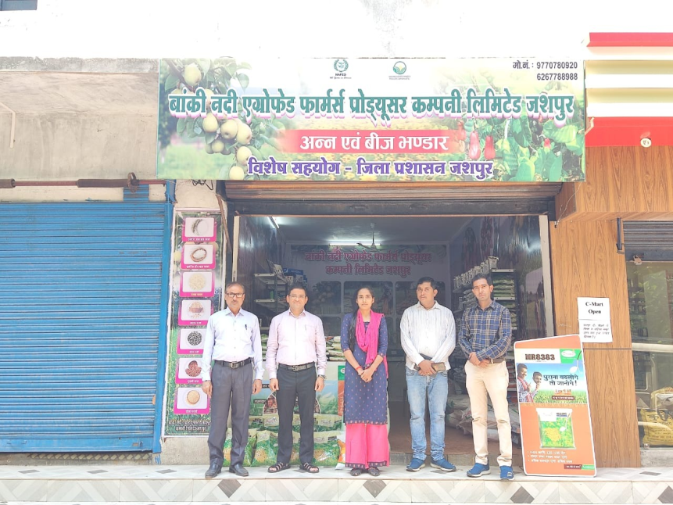

Name and Contact Number
- Chairman BoD, FPO: Sevak Ram Bhagat, 6267788988
- CEO, FPO: Bhagwat Upadhyay1991@gmail.com
- CBBO Point of contact:Birendra Singh Gusain, 9599369933

