Annexure-I
Achievements and Contribution of Krishi Vigyan Kendra, Ujwa to the farming community of NCT, Delhi during the last 21 years
Introduction
To address the issues related to technology dissemination in agriculture, the Krishi Vigyan Kendra (KVK) is also known as an Agriculture Science Centre; a grass root level scheme has been designed and nurtured by ICAR for the past 6 decades. So far, ICAR has established 735 KVKs across the country under different host organizations like SAUs, ICAR Institutes, Central institutes/Deemed Universities, State Government, and NGOs. The Krishi Vigyan Kendra at Ujwa (Delhi) was established in the year 1995 under the administrative control of National Horticultural Research and Development Foundation (NHRDF), New Delhi. About 40 acres of land available with the KVK and is under instructional farm including crops, orchard and the demonstration unit. KVK is about 50 km from New Delhi railway station and 25 km from IGI airport. The Kendra started functioning in 1996.
Mandate
Krishi Vigyan Kendra is an institutional project of Indian Council of Agricultural Research (ICAR) to demonstrate the application of science and technology input of agricultural research and education on the farmer’s field in the rural area of Delhi with the help of multi-disciplinary team of scientists. It is therefore also called the Front Line Transfer of Technology and Extension system. KVKs are of national importance and are expected to look after the empowerment of the farming community through trainings and as such improving their socio-economic conditions. Taking into account the essence behind the establishment of KVKs, its mandate is assessment, refinement and demonstration of technologies/products to cater the needs of farming community, extension personnel and other stakeholders in the Delhi. In order to accomplish this, KVKs are carrying out the following:-

- On-farm testing to assess the location specificity of agricultural technologies under various farming systems.
- To organize Frontline Demonstrations to establish production potential of technologies on the farmers' fields.
- Capacity building development of farmers and extension personnel to update their knowledge and skills on modern agricultural technologies.
- To work as knowledge and resource centre of agricultural technologies for supporting initiatives of public, private and voluntary sector in improving the agricultural economy of the district.
- To provide farm advisories using ICT and other media means on varied subjects of interest of farmers.
Achievements under each of the mandate carried out by the KVK, Delhi are described below:
- On-farm Testing of Technologies (OFT’s):
- This activity is mainly focused to validate technologies which might be helpful to solve the problems of farmers in a Delhi area.
- Implementation of OFT programme has benefitted about 469 direct beneficiaries belonging to 12 villages of South-West district of Delhi.
- The major objective of the programme is to provide tailor-made recommendations to the farmers by testing the location specific technologies to solve their field problems.

- Front Line Demonstration (FLD) :
- The primary objective of demonstration is to demonstrate under real farm situation, the
productivity potential and profitability of the latest crop production technologies, improved varieties, seed treatment, fertilizer, plant protection and feed management etc. recommended for different agro-ecological and crop growing situation v/s prevailing farmers’ practices.

- During the above said period, 2446 demonstrations covering 2314 acre area were laid out in farmers’ field in South-West district of Delhi.

- Transfer of Technology (TOT):
The appropriate information regarding package of practices and its dissemination is equally important. It is not enough to generate information but also to see that the required information is delivered to the end users at the earliest and with least dissemination loss.
- Training Programme:
The major objectives of training are to generate the opportunities for income and employment, to provide technical know-how to the practicing farmers & farm women and to update the knowledge of in-service personnel, about 1192 Training programme was conducted.
- Vocational Trainings for Rural Youth:
After taking over the infrastructural facilities, laboratories and establishment of demonstration units at the campus the vocational courses were started. The 146 vocational courses on the subject viz. Bee keeping (24), Preservation of fruits & vegetables (20), Nursery Management (18), Mushroom Production (16), Seed Production Technology (10), Dairy Farming (7), Poultry Production (6), Vermi-compost Production (7), Integrated Farming System (3), Pig Farming (3), Goat Farming (2) and rest in cultivation of exotic vegetables, Fruit Cultivation & Commercial Flower Production. Through these trainings 3076 persons were benefitted.
- Trainings for practicing Farmers and Farm Women:
The KVK have organized both on and off-campus training programmes for the practicing farmers, farm women & farm youth. The trainings were imparted on crop production, plant health care, Animal Husbandry, horticulture and home management. During the period 793 day long (on/off campus) training programmes were organized in different villages of Delhi. Through these trainings 15828 persons were benefitted.
G) In-service Trainings:
The field extension personnel played an important role in transferring the latest agricultural technologies to the end users. For updating their knowledge, 227 in-service trainings were organized for the village level workers, officers of agriculture department, Govt. of Delhi, Anganwadi workers & supervisors of Women &Child Development Department, Govt. of NCT Delhi.
- Agricultural Extension Activities &Farm Advisory Services:
- For speedy dissemination of technologies in the farmers’ field, the KVK celebrated/organized various extension activities in the villages and at the KVK campus. During the period,12972 activities were organized. Through these activities, KVK has extended direct services to more than 290629 people in the Delhi region.
- Seed production at KVK farm: KVK has also been involved in seed production of recommended varieties of different crops so as to provide quality seeds to the farmers of Delhi State. So far KVK has produced 3550 qtl. seed and distributed to 7939 farmers on marginal cost.
I) Distinct Socio- economic Impact of KVK activities:
KVK Activity | Distinct Socio- economic Impact
Training programmes for different target groups  Day long on/off campus training for practicing farmers | - The trained farmers/farm women are known as leaders and torchbearers for their fellow farmers in own and neighbouring villages.  - Positive attitude, better knowledge and acquired scientific skills have made them perfect in managing their farming & animal wealth.  - A few trained farmers have also taken up quality seed production and custom service by acquiring skills in related fields.
Vocational training courses for the rural youth | - By adopting the vocation of bee keeping 36 farmers are engaged in the vocation and getting Rs.30000 – 40000 net returns from one year old unit and Rs.1.5 to 2.0 lakh/year from 4-5 year old bee keeping unit.
 | - From food processing, about 65% of the participants have adopted different processing technologies at household level and 5% have adopted at commercial level. M/s Krishna Pickles, M/s Kamal Pickles, M/s Krishna Foods, M/s Savior Pickles & Murrabba, M/s.Gramin Mahila Bakery Unit, M/s Mangla Achaar, M/s.Poorti Achaar, BAWWA (BSF ), group &SHG group Nangloi and earning income of Rs.5.0 Lakh to Rs.4.0Crore per annum. These enterprises are generating about 2000 man days of work.
 | - Dairy farmers are getting 15-20% more net returns from their dairy business by adopting appropriate low cost dairy management technologies and animal disease preventive measures. After getting training 26 small dairy units (2-3 animals) are established and earning net income of Rs.80,000/annum and 8 big units (10-15 animals) are established and earning net profit of Rs. 1.50 – 2.0 lakh per annum.
 | - After getting the training on mushroom cultivation, 12 growers have come out with the unit size of 200 – 4000 sq. mt in different locations of Delhi with income of Rs.6.0 Lakh to Rs.8.0 Lakh /season.

 | - After getting training of gardeners, 26 rural youths have got govt. & private jobs in different organizations.
In-Service training for farm women & child development officials | - They got a new dimension to their knowledge bank for use in operational areas through advisory services to farmers/farm women.  - Helped field functionaries from grass root level in updating their knowledge & skill on the subject and getting exposure to new technologies available.
Front line demonstration programmes | - After 20 years, the average productivity of major crops – Mustard, wheat and paddy in operational areas has registered an increase of 70%, 114% and 150% respectively.  - The most distinct impact of crop demonstration programme in the area is a creation of sense of security and self reliance among the poor farmers resulted in increase in socio-economic status in the area.
On Farm testing | - By adoption of tailor made recommendations, the farmers are getting more profit through their farming.  - By effective weed management, the farmers are getting higher production.
Dairy development programmes | - Livestock owners are growing nutritious fodder crops for higher milk production and minimizing cost of milk production.  - Through trainings and campaigns, livestock owners have become aware about animal health, balanced nutrition, clean milk production.
Extension activities and farm advisory services | - By organizing various agricultural extension activities, the farm technologies are being disseminated in wide area throughout the district.
Recognition of successful entrepreneurs with prestigious Award | - Published a book “Successful Entrepreneurs – A KVK Initiative.”

---***---

Annexures-II & III
During 42 years span, NHRDF has developed 14 and 17 lines / varieties of onion and garlic respectively for different agro-climatic zone and seasons. Out of these, 6 varieties of onion and 11 varieties of garlic have been notified by the Sub-Committee of Variety Release, Seed Division, Dept. of Agriculture, Co-op. & Farmers Welfare, Ministry of Agriculture & Farmers Welfare, Govt. of India.
Around 250 technologies developed for Maharashtra and Haryana in different segment for onion and garlic. The variety-wise specification of both crops is given below:

A-Onion varieties/Lines
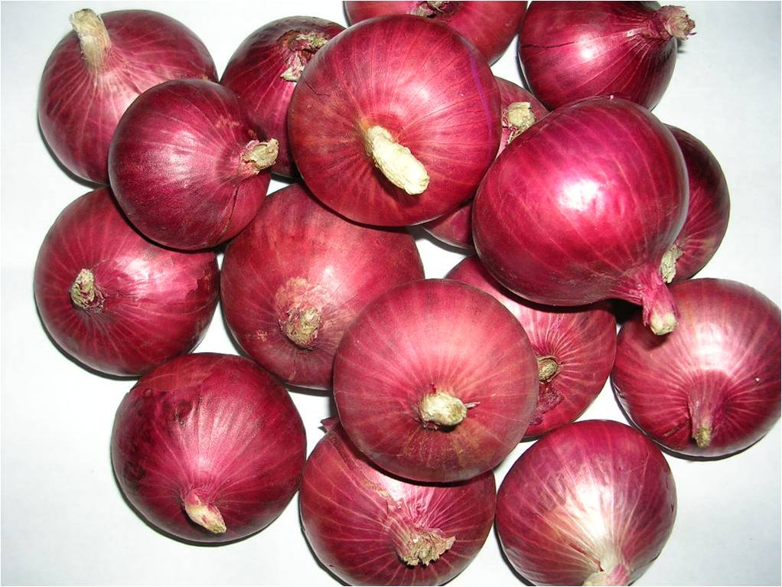
1. Agrifound Dark Red:
Bulbs are dark red, globular round in shape 4-6 cm in size with tight skin and moderately pungent. Bulbs mature 90-100 days after transplanting. Total soluble solid (12-12%), dry matter (13-14%) and pyruvic acid 10.07 micro mole/g. Average yield is 300 q/ha. Notified by Govt. of India for growing in kharif season in the country vide notification number 1135(E) dated 01/12/1998.

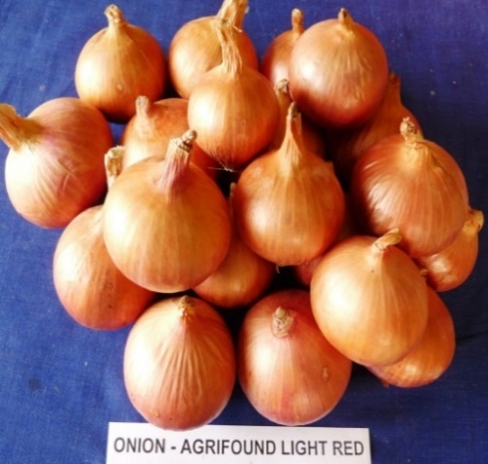
2. Agrifound Light Red:
Bulbs are attractive dark, globular round in shape, reddish thick inner scales. Bulb matures 110-120 days after transplanting. Keeping quality is good. Total soluble solid (13%), dry matter (14-15%) and pyruvic acid 12.20 micro mole/g. Average yield is 300-350 q/ha. Notified by Govt. of India for growing in rabi season in the country vide notification number 1135(E) dated 10/02/1996.

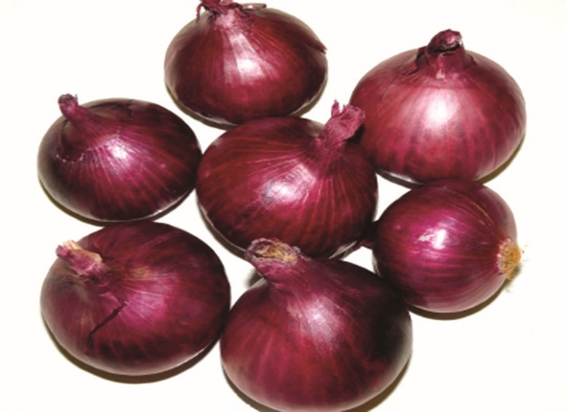
3. NHRDF Red (L-28):
Bulb are attractive dark red, globular round in shape, reddish thick inner scales. Bulb matures 110-120 days after transplanting. Keeping quality is medium. Total soluble solid (13-14%), dry matter (14-15%) and pyruvic acid 12.0 micro mole/g. Average yield is 250-300 q/ha. Notified by Govt. of India for cultivation in Northern, Central and Western India in rabi season vide notification number SO-2035(E)
dated 28/10/2001.
-2-

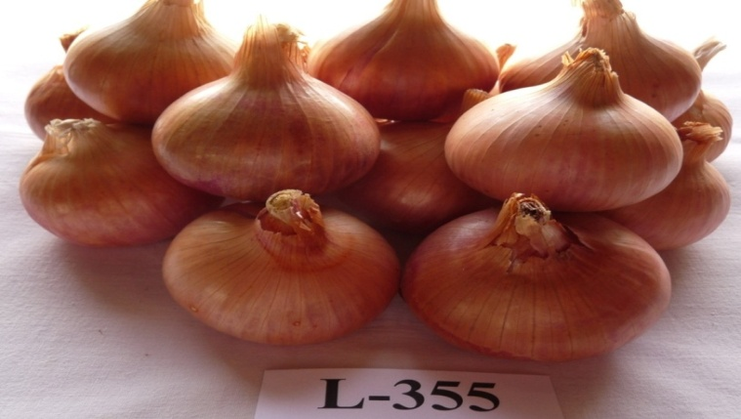
4. NHRDF Red-2 (L-355):
Bulb are attractive light red in colour, globular round in shape, thin neck and 5.0-6.0 cm in diameter. Bulb matures in 100-120 days after transplanting. Keeping quality good. Total soluble solid (13-14%), dry matter (14-15%) and pyruvic acid 12.0 micro mole/g. Average yield is 350-375 q/ha. Notified by Govt. of India for rabi season in zone III (Delhi, Uttar Pradesh, Haryana and Gujarat) and Zone VI (Maharashtra, Karnataka and Andhra Pradesh) vide notification number SO-2363(E) dated 01/10/2012.

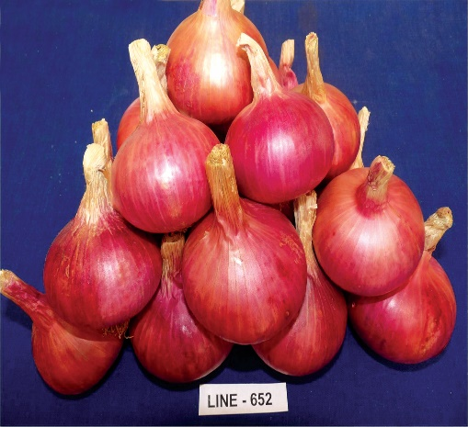
5. NHRDF Red-3:
Bulbs are light bronze in colour, globular round shape, thin neck and 5.5-6.0 cm in diameter. Bulb matures in 120-130 days after transplanting. Keeping quality is good. Total soluble solid (12-13%), dry matter (13-14%) and pyruvic acid 12.50 micro mole/g. Average yield is 350-400 q/ha. Recommended for rabi season in Maharashtra, Madhya Pradesh, Gujarat, Delhi, Uttar Pradesh, Bihar, Punjab, Haryana and Rajasthan.

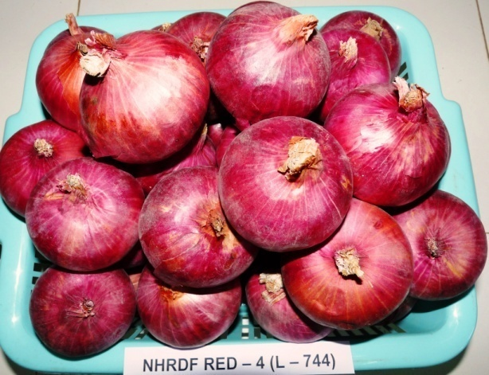
6. NHRDF Red-4:
Bulbs are dark red in colour globular round shape, thin neck and 5.5-6.25 cm in diameter. Bulb matures in 110-120 days after transplanting. Keeping quality is good. Total soluble solid (12-14%), dry matter (13-14%) and pyruvic acid 13.0 micro mole/g. Average yield is 350-400 q/ha. Notified by Govt. of India for rabi season in zone III (Uttar Pradesh, Bihar, West Bengal and Imphal) vide notification number SO-3666(E) dated 06/12/2016.

-3-

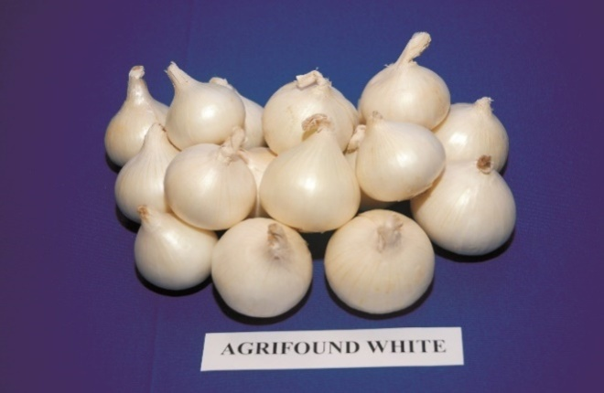
7. Agrifound White:
Bulbs are white, globular in shape with tight skin and silvery attractive. Bulb matures 110-120 days after transplanting. Keeping quality is Medium to good. Total soluble solid (14-15%), dry matter (15-16%) and pyruvic acid 12.0 micro mole/g. Suitable for dehydration. Average yield is 250-300 q/ha. Recommended for late kharif and rabi season for Maharashtra, Madhya Pradesh, Gujarat and Rajasthan.
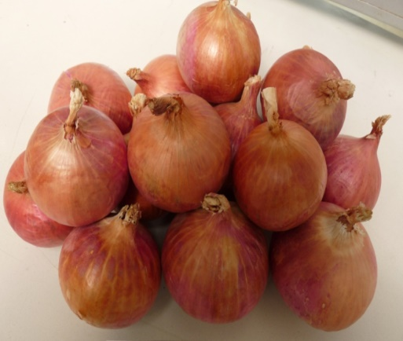
8. NHRDF Fursungi (L-719)
Plants are erect, strong, red coloured bulb, round shaped 5.80 to 6.25 cm in diameter, bulb matures in 110-120 days after transplanting. Total soluble solid (12-14%), dry matter (13-15%). Average yield is 380-400 q/ha with good keeping quality. Tolerance for Stemphylium Blight. Variety is recommended for cultivation in Zone-II (Delhi, Rajasthan, Haryana, Jammu & Kashmir & Punjab), Zone – V (Gujarat & Maharashtra) during the 8th Group Meeting of AINRPOG organized at Rajasthan Agriculture Research Station, Durgapura, Jaipur on 1-2, July, 2017 and same is under notification process.

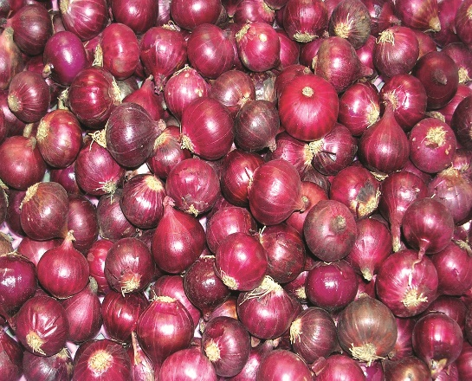
9. Agrifound Rose:
Bulbs are deep scarlet red, flattish round in shape, 2.5-3.5 cm in size and pickling type. Matures in 95-110 days after sowing. Total soluble solid (16-18%), dry matter (17-19%) and pyruvic acid 10.27 micro mole/g suitable for dehydration. Average yield is 250-300 q/ha. Recommended for growing in kharif season in Cuddapah (AP) and in all the three seasons in Karnataka.

-4-

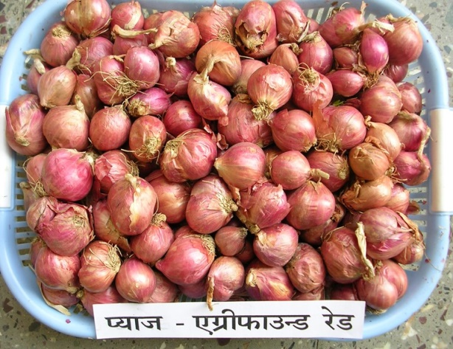
10. Agrifound Red: Bulblets light red, size of bulblets is 3.64 cm, number of bulblets per cluster 5-6 and weight of single bulblets is 8.85 g. Average weight of cluster is 65-67 g. Bulblets matures 65-67 days after planting. Total soluble solid (17-19%), dry matter (18-20%) and pyruvic acid 10.13 micro mole/g. Average yield is 180-200 q/ha. Recommended for kharif and rabi season in zone VIII (Karnataka, Tamil Nadu and Kerala).

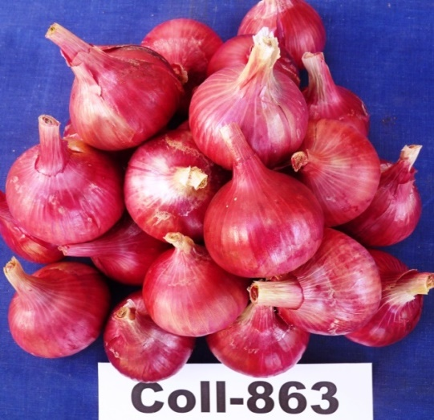
11. Advance Line – 863: Bulbs are dark red coloured, round shape, diameter 4-5-5 cm & keeping quality medium. Crop matures in 80-85 days after transplanting, Total soluble solid (12-13%), dry matter (11-12%) pyruvic acid (12.5-13 micro mole/g). Average yield is 280-300 q/ha. Variety is recommended for cultivation in kharif and Late kharif season.

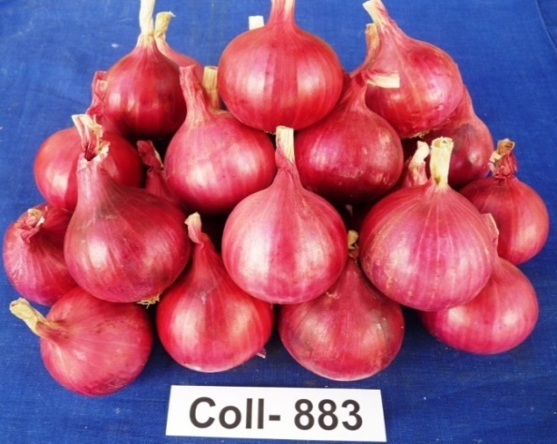
12. Advance Line – 883:
Bulbs are dark red colour, round shape, shiny skin, 4.50 – 5.50 cm diameter. Bulb are matures in 85-90 days after transplanting. Total soluble solid (12-13%), dry matter (13-14%) pyruvic acid (12.0 micro mole/g). Average yield is 300-325 q/ha. Variety is recommended for cultivation in kharif and Early kharif season all over India.

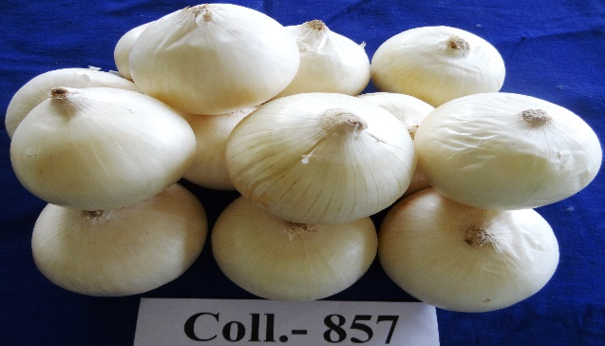
13. Advance Line-857: The bulb of this line is round globular and silvery white colour, mature in 110-120 day after transplanting, Average yield is 350-400 q/ha, TSS 14-15 % and good storage capacity. Suitable for cultivation in rabi season in central India. This line is under evaluation in network trial.

-5-
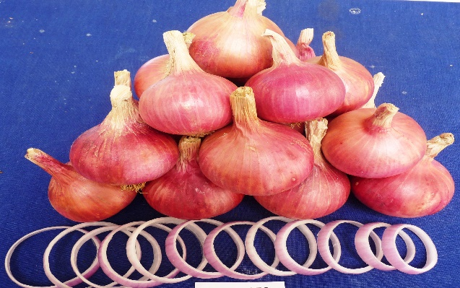
14. Advance line 849: The bulb of this line is globular round shaped with attractive red colour, mature in 105-115 day after transplanting. High yield potential is 375-425 q/ha. Suitable to grow in rabi season in central part of the India. Good storage capacity about 6 month and moderately tolerant to stemphyllium blight & purple blotch disease.

B-GARLIC Varieties/Lines
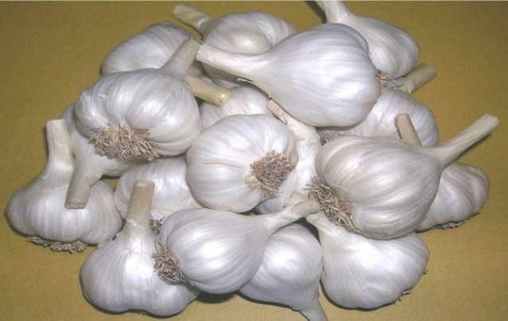
1. Agrifound White (G-41): Bulbs are compact, silvery and white with creamy flesh, bigger elongated clove with 20-25 in number and diameter of bulb is 3.5 to 4.5 cm, total soluble solids (41%), dry matter (43%) and pyruvic acid is 27 micro mole/g. Matures in 140-150 days, average yield 130 q/ha. Notified by Govt. of India for Maharashtra and Madhya Pradesh vide notification number 280(E) dated 13/04/1989.

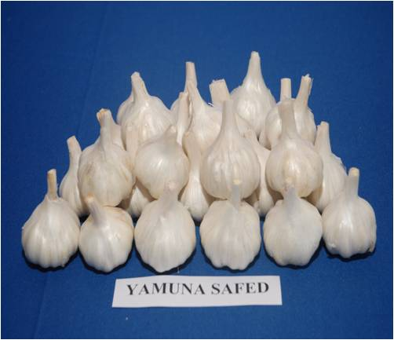
2. Yamuna Safed (G-1): Bulb are compact, silvery white skin with creamy flesh, diameter 4.0-4.5 cm. Sickle shaped cloves with 25-30 in number, total soluble solids (38%), dry matter (40%) and pyruvic acid (29 micro mole/g). matures in 140-150 days, average yield 150-175 q/ha. Notified by Govt. of India for cultivation in all over the country vide notification number 527(E) dated 16/08/1991.

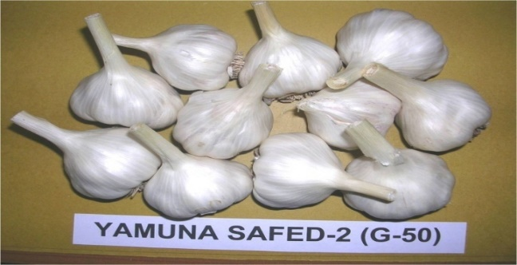
3.Yamuna Safed-2 (G-50): Bulbs are compact, attractive, while creamy flesh and average diameter is 3.5-4.0 cm. Number of cloves 35-40, total soluble solids (39%), dry matter (41.0%) and pyruvic acid (26 micro mole/g), matures in 140-160 days, average yield 150-200 q/ha. Notified by Govt. of India for cultivation in Northern India vide notification number 115(E) dated 10/02/1996.

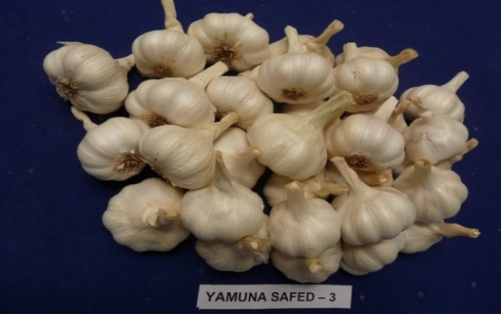
4. Yamuna Safed-3 (G-282): Bulbs are creamy white and bigger sized with 4.5-5.5 cm in diameter, number of cloves/bulb is 15-16, total soluble solids (40%), dry matter (42.0%) and pyruvic acid (25 micro mole/g), matures in 120-140 days, average yield 175-200 q/ha. Notified by Govt. of India for Madhya Pradesh, Maharashtra, Haryana, Gujarat, Punjab, Rajasthan, Uttar Pradesh and Chhattisgarh vide notification number 1052(E) dated 26/10/1999.
-6-
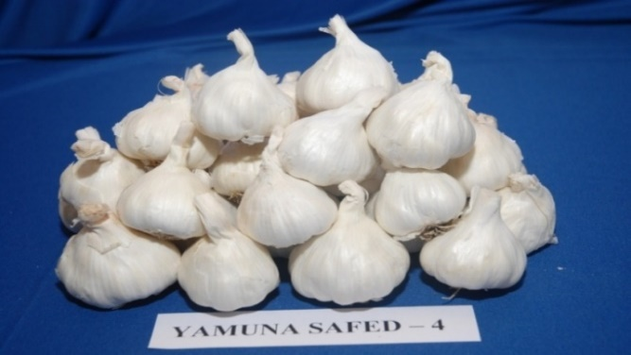
5. Yamuna Safed-4 (G-323): Bulbs are silvery white and average diameter is 3.5-4.0 cm, number of cloves 20-25/bulb, total soluble solids (42%), dry matter (44.5%) and pyruvic acid (25 micro mole/g), matures in 140-150 days, average yield 175-200 q/ha. Notified by Govt. of India for North and Central India vide notification number 597(E) dated 25/04/2006.

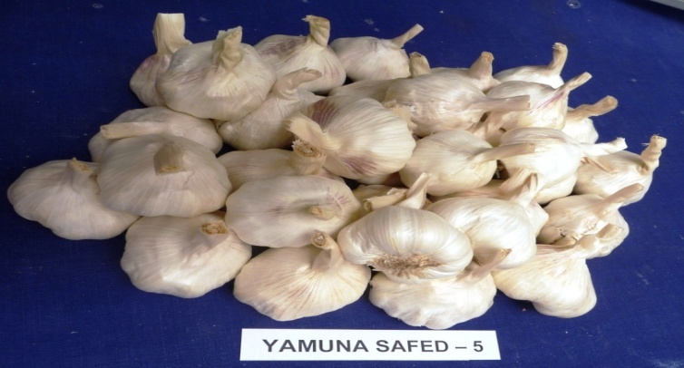
6. Yamuna Safed-5 (G-189): Bulbs are creamy white and bigger sized with 4.5-5 cm in diameter, number of cloves/bulb is 22-30, suitable for processing purpose, total soluble solids (42%), dry matter (44%) and pyruvic acid (26 micro mole/g), matures in 140-160 days, average yield 150-180 q/ha. Notified by Govt. of India for Zone III (Delhi, Uttar Pradesh, Haryana, Bihar and Punjab) Zone-IV (Rajasthan and Gujarat) and Zone VI (Maharashtra, Karnataka and Andhra Pradesh) vide notification number 2363(E) dated 10/04/2012.

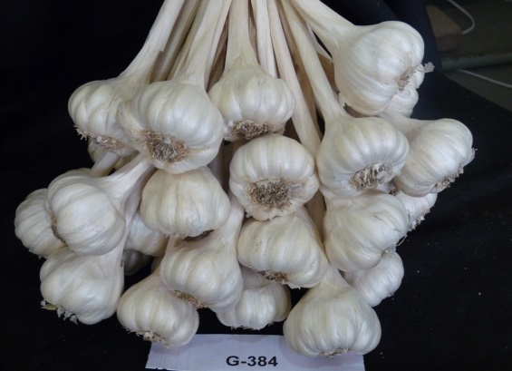
7. Yamuna Safed-8 (G-384): Dark green plant, straight erects leaves, average bulb diameter 4.30 to 5.00 cm, total soluble solids (40%), dry matter (42%) and pyruvic acid (26 micro mole/g), matures in 150-160 days, average yield 175-200 q/ha. Notified by Govt. of India for Zone II (Jammu, Ludhiana, Delhi, Karnal, Hissar and Durgapura) vide notification number 268(E) dated 28/01/2015.

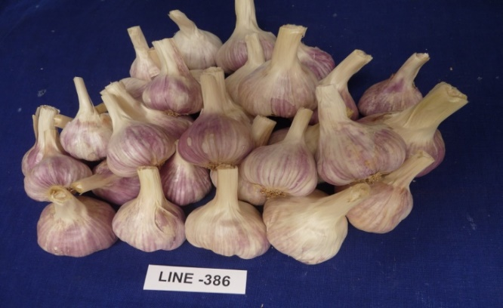
8. Yamuna Safed-9 (G-386): Dark green plant, plant straight, erect leaves; average bulb diameter 4.80 to 5.50 cm, average numbers of clove per 22-30 and clove diameter is 1.30-1.50 cm, total soluble solids (40%), dry matter(43%) and pyruvic acid (25 micro mole/g), mature in 150-160 days, average yield potential is 180-225 q/ha. Notified by GOI for Zone II (Jammu & Kashmir, Punjab, Delhi, Haryana and Rajasthan) vide notification number 3666(E) dated 12/06/2016.

-7-

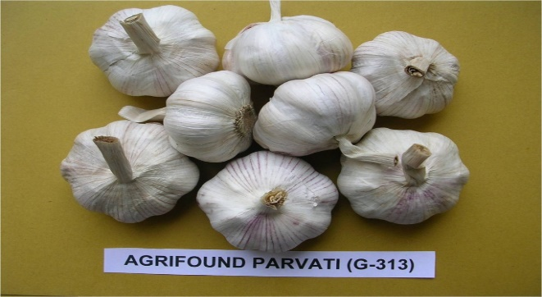
9. Agrifound Parvati (G-313): Bulbs are bigger size 5.0 – 6.5 cm in diameter, creamy white colour with pinkish tinge, 10-16 cloves/bulb, total soluble solids (36%), dry matter (38.5%) and pyruvic acid (23 micro mole/g), mature in 230-250 days, average yield 200-225 q/ha. Notified by Govt. of India for Zone-I (Jammu Kashmir and Himachal Pradesh) vide notification number 268(E) dated 28/01/2015.

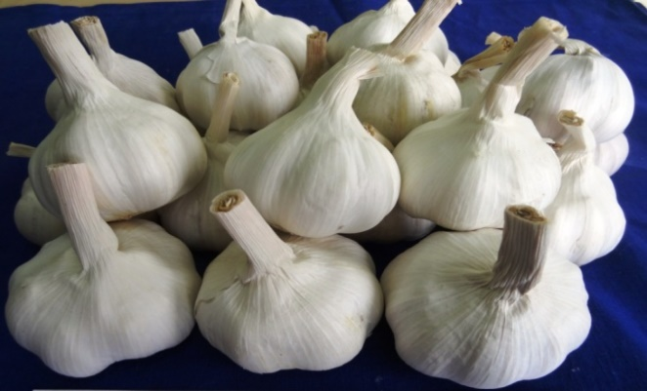
10. Agrifound Parvati-2 (G-408): Bulbs are bigger size 5.0-6.0 cm in diameter, creamy white colour, 12-14 cloves/bulb, total soluble solids (37%), dry matter (39.0%) and pyruvic acid (23 micro mole/g), mature in 240-260 days, average yield 200-225 q/ha. Notified by Govt. of India for Zone I (Jammu Kashmir and Himachal Pradesh) vide notification number 268(E) dated 28/01/2015.

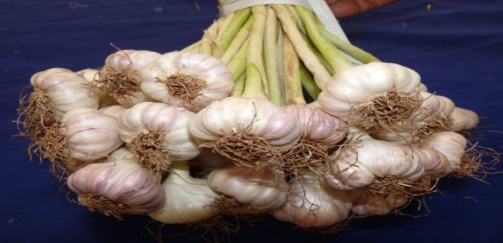
11. Advance line G-389
This is first variety which is cultivated in kharif season. Bulb diameter 3.0-3.50 cm. 20-25 cloves/bulb, total soluble solids (34-36%), dry matter (35-38.0%), mature in 75-80 days in kharif & 85-90 days in rabi season. Average yield during kharif is 40-60 q/ha & during rabi 60-70 q/ha. This line is under AINRPOG evaluation.

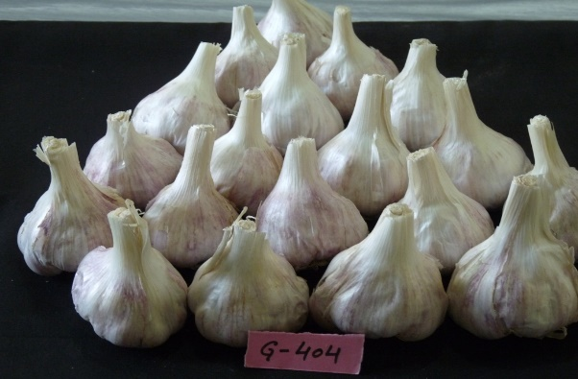
12. Advance line G-404
Plants are straight with broad dark green leaves. The bulbs are compact, attractive light purple colour, average bulb diameter 4.80 to 5.50 cm, average number of clove per bulb 25-30 with creamy flesh, bigger elongated cloves and clove diameter 1.00 cm to 1.18 cm, total soluble solids 39-40 %, Dry matter 42% and pyruvic acid 26.80 micromole/g, average weight of 50 cloves 80-100 g, mature in 160-170 days, average marketable yield 165-175 q/ha. This line is recommended by ICAR-AINRPOG for notification.

-8-
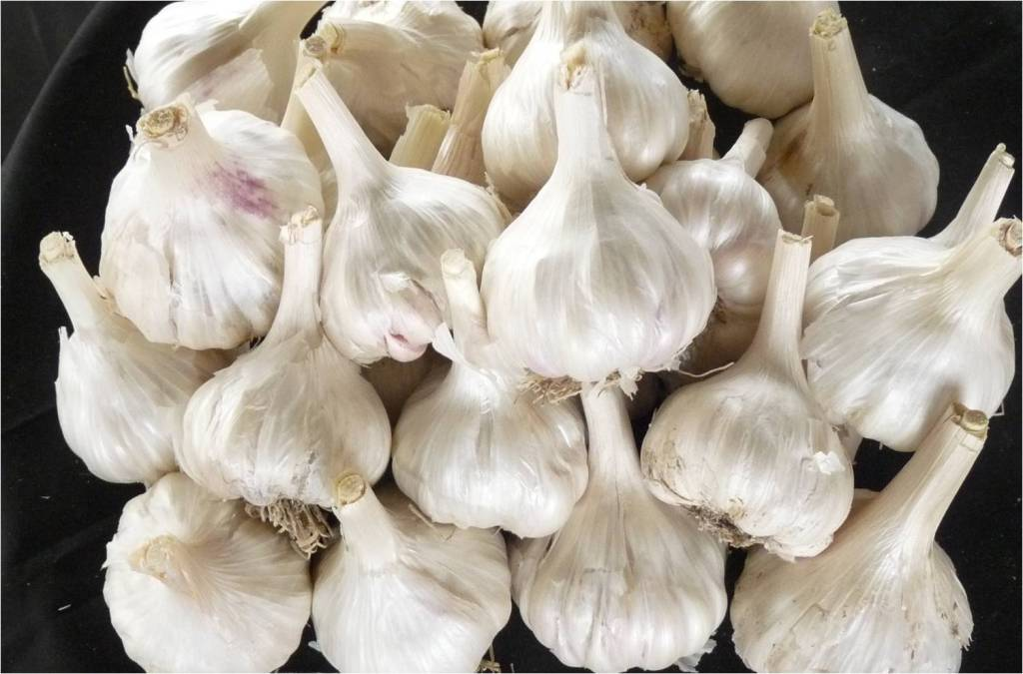
13. Advance line G-324
Plants are long straight with green leaves. Bulbs are compact, white colour, average bulb diameter 4.50 to 4.80 cm, average number of clove per bulb 27-30 with creamy flesh and clove diameter 0.8 cm to 1.0 cm, total soluble solids 39-40 %, Dry matter 42 % and pyruvic acid 25.5 Micromole/g, average weight of 50 cloves 45-50 gm, crop mature in 155-165 days, average marketable yield 145-150 q/ha. Storage keeping quality is good. This line is under AINRPOG evaluation.
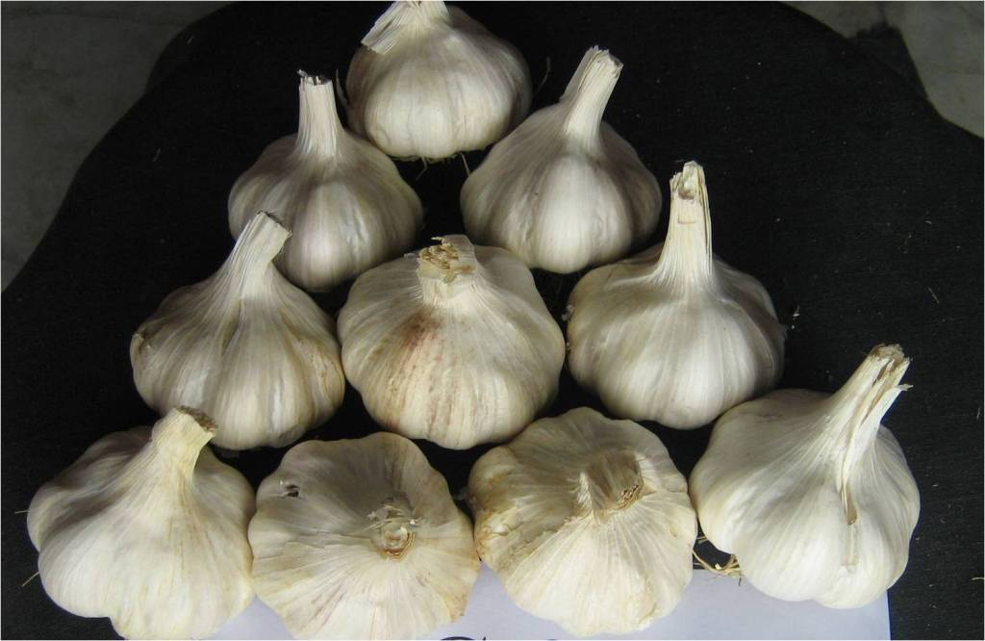
14. Advance line G-378
Plants are straight with dark green leaves. Bulbs are compact, bold white colour, average bulb diameter 4.50 to 4.80 cm, average number of clove per bulb 20-25 with creamy flesh, bigger bold cloves and clove diameter 1.0 cm to 1.2 cm, total soluble solids 38-39 %, Dry matter 41.0 % and pyruvic acid 25.0 micromole/g, average weight of 50 cloves is 80-85 gm, Early variety mature in 145-150 days, average marketable yield 155-165 q/ha. This line is under AINRPOG evaluation.
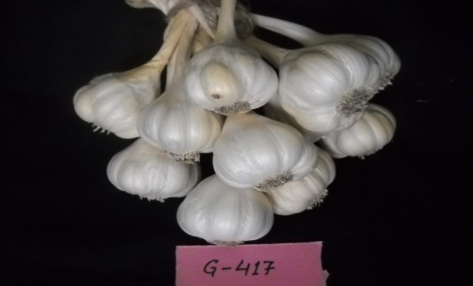
15. Advance line G-417
Plants are straight with broad dark green leaves. Bulbs are compact, attractive creamy white colour, average bulb diameter 4.50 to 5.00 cm, average number of clove per bulb 26-35 with creamy flesh, bigger elongated cloves and clove diameter 0.9 cm to 1.2 cm, total soluble solids 39-40 %, Dry matter 42.0 % and pyruvic acid 26. 0 micromole/g, average weight of 50 cloves is 85-90 gm, mature in 150-160 days, average marketable yield 160-165 q/ha. This line is under AINRPOG evaluation.

-9-
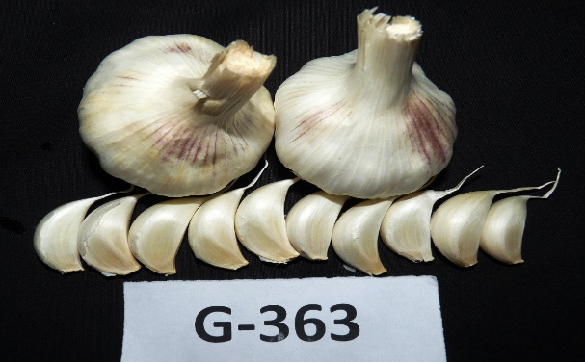
16. Advance line G-363
Plants are straight with moderate green leaves. Bulbs are compact, attractive white colour, average bulb diameter 4.50 to 5.20 cm, average number of cloves per bulb 27-30 with creamy flesh, bold cloves, total soluble solids 39-40 %, Dry matter 42.0% and pyruvic acid 26.0 micromole/g, average weight of 50 cloves is 70-78 g, mature in 150-160 days, average marketable yield 150-165 q/ha. This line is under AINRPOG evaluation.

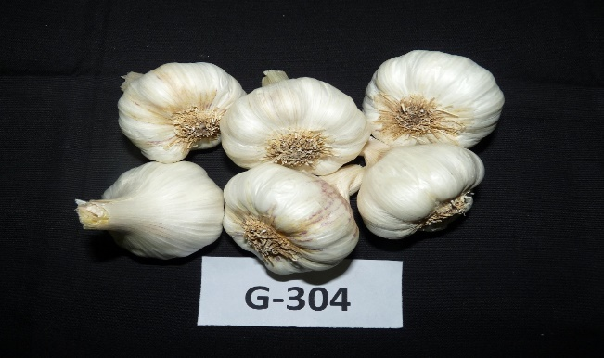
17. Advance line G-304
Plants are straight with broad dark green leaves. Bulbs are bold compact, attractive white colour, average bulb diameter 4.50 to 5.00 cm, average number of clove per bulb 24-30 with creamy flesh, bigger bold cloves and clove diameter 0.9 cm to 1.2 cm, total soluble solids 38-39 %, Dry matter 41.0 % and pyruvic acid 25.0 micromole/g, average weight of 50 cloves 75-78 gm, mature in 150-160 day, average marketable yield 160-170 q/ha. This line is under AINRPOG evaluation.

--- *** ---

